Rehabilitation Sciences Sector
Appointment Application Review Instructions for the Department Appointments Committee (DAC)

- Using the Firefox browser, go to the LaserFiche Web Client:
http://documents.med.utoronto.ca/laserfiche/
- Make sure that the Repository = Appointments.
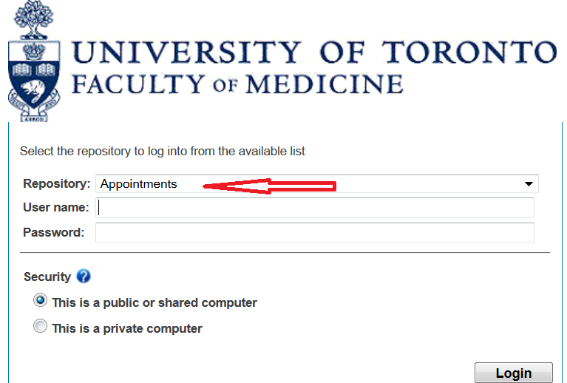
- Log in using the username provided by the Department Appointments Committee (DAC) Chair. Any questions should be directed to Annmarie Riley at rehab.sector@utoronto.ca

  - Expand the Department folder in the left side bar by clicking on the plus sign beside it.
  - Expand the *New Appointments folder in the left side bar by clicking on the plus sign beside it.
Note: There will also be a folder called *Re-Appointments. Please ignore this. Access to this folder is unnecessary for this type of review; therefore, access has not been granted.
  - Expand the folder called Rehab Other Academic in the left side bar by clicking on the plus sign beside it. There will be a list of blue folders pertaining to each of the candidates who have submitted an application form.
- Double click on one of the blue folders. In the frame on the right there will be a list of documents submitted by this candidate.
- Review the entries in the blue folder:
  - One of these entries (lastname_firstname_appointmentID#_RehabAppointmentApplication) is a pdf copy of the web application form that was submitted.
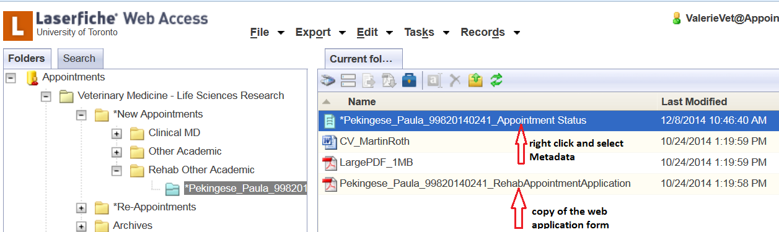
  - The entry with the blue icon beside it is the Appointment Status Template. This is where the Department Appointments Committee will record their recommendation and the Areas of Responsibility selected for this candidate.

- To record the Department Appointments Committee’s recommendation and the Areas of Responsibility selected for this candidate, right-click on the blue Appointment Status Template and select Metadata from the drop down list that appears.
- There are only two fields available to edit:
  - Under DAC Recommendation, select either Yes, No, or leave Blank.

YES = DAC supports the appointment and the application proceeds to HR/Dean for review and approval. No action occurs when ‘Yes’ is selected until the Department Administrator further processes the file.

NO = DAC defers the application and notifies the applicant appropriately. No appointment is granted.

BLANK = DAC is undecided and/or requires further information. Notes should be taken outside the system.

  - Any or all of the Areas of Responsibility may be selected as applicable. Select one and an additional empty line will immediately appear below the selection. In this empty line, another selection may be made.
  - To delete a selection, hover the mouse over the applicable line and a red ‘X’ will appear. Click on the ‘X’ and the selection will be deleted. 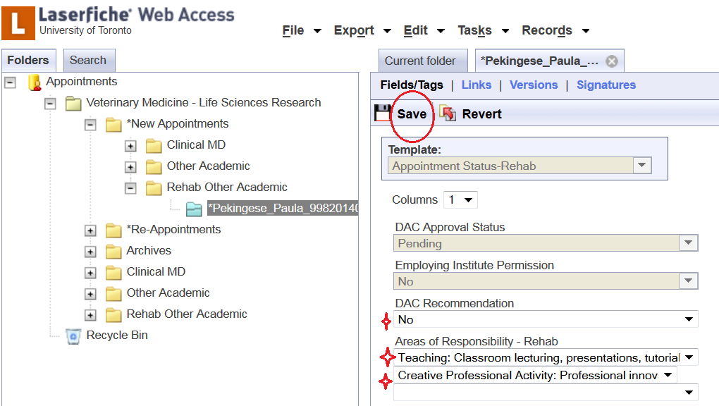
  - When all applicable selections are made, click Save at the top of the template.
- This Appointment Status template opened in a new tab. Close this tab after saving.
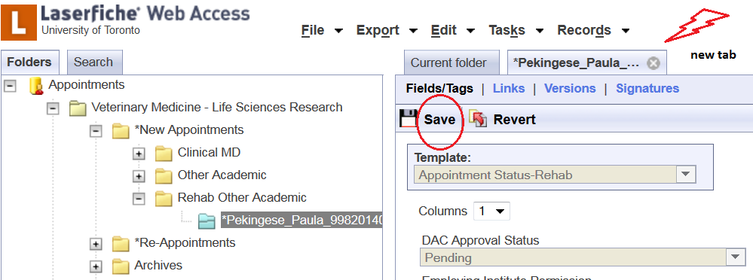
- Follow steps 5 - 9 for each blue folder on the left-side bar, or for those to which you have been assigned. The number of files a committee member is responsible for reviewing is determined by the Department Appointments Committee Chair.
- When the review is complete, log out by clicking the Log Out button in the top right-hand corner of the window.

