Rehabilitation Sciences
Appointment Application Review Instructions for the DAC

- In Firefox or Chrome, go to the LaserFiche Web Client
http://documents.med.utoronto.ca/laserfiche/
- Make sure to select the Appointments Repository
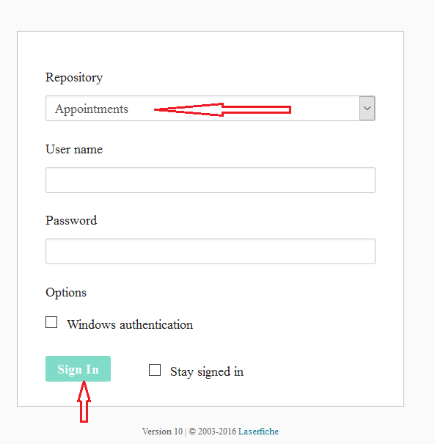
- Log in using the username you were given by your DAC Chair. If you have questions about usernames, contact Annmarie Riley at rehab.sector@utoronto.ca
- Navigate to the appointment candidate folders:
  - Expand your Department folder in the left-side panel by clicking on the plus sign beside it.
  - Expand the *New Appointments folder in the left-side panel by clicking on the plus sign beside it.
  - Expand the folder called Rehab Other Academic in the left-side panel by clicking on the plus sign beside it. You will see a list of blue folders pertaining to each of the candidates who have submitted an application form.
- Highlight one of the blue folders. In the middle panel, you will see the list of documents submitted by this candidate.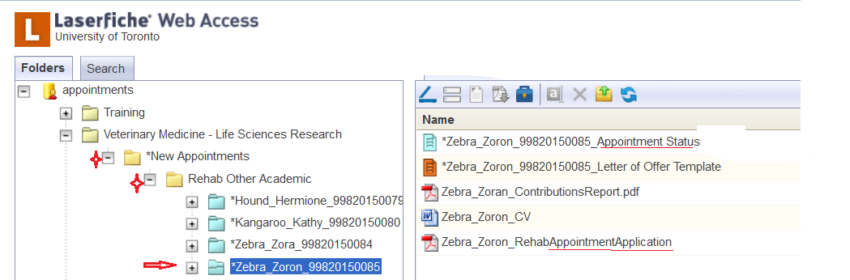
- Review the documents in the blue folder.
  - One of these entries (lastname_firstname_RehabAppointmentApplication) is a pdf copy of the web form that was submitted.
  - Another of these entries, the one with the blue icon beside it, is the Appointment Status template. This is where you will record your recommendation and the Areas of Responsibility you select for this candidate.
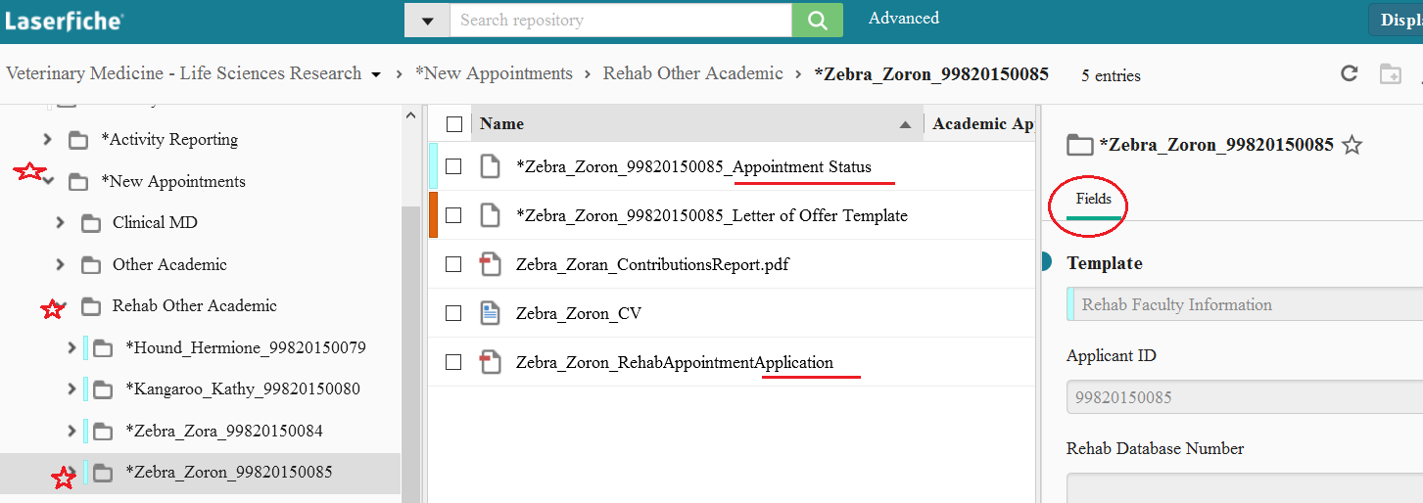
- To record your recommendation and the Areas of Responsibility you determine for this candidate, check the box beside the blue Appointment Status Template in the middle panel. A template called Appointment Status-Rehab will appear in the right-side panel. If you do not see the Appointment Status-Rehab template, select the Fields tab.
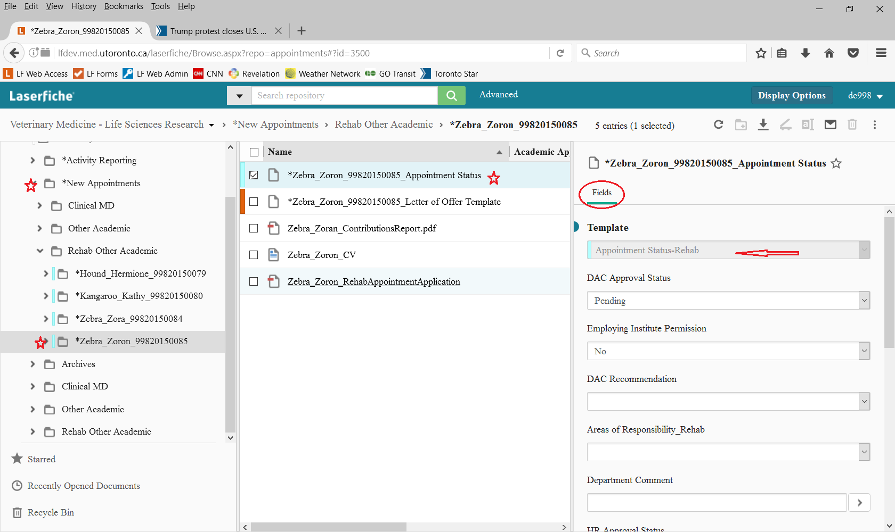
- There are only three fields in the Appointment Status-Rehab template available to you to modify.
  - Under DAC Recommendation, select either Yes or No.
  - Under Areas of Responsibility you may select as many as you believe are applicable. Select one and an empty line will immediately appear immediately blow the selection. In this empty line, make another selection.
  - If you would like to leave a comment, you may write it in the Department Comment box (max 600 characters).
  - When you have made your selections, click on Save at the bottom of the template.
- Follow steps 5 - 8 for each blue folder on the left-side bar, or for those Candidates to which you have been assigned.
- The Sign Out button is on the top right-hand corner of the window, below your user name.

__________________________

