Guide to Academic Appointments
Using Web Forms and LaserFiche
Clinical Department Coordinators Version

Discovery Commons
February 2015

Table of Contents
When to Use the LaserFiche Online Appointments System 3
Introduction to the Components of the Appointments System 4
Which Modules Do I Use 6
Logging in to the Modules of the Appointments Application 7
The Appointments Workflow 9
Step-by-Step: 9
Changing the Status of a Dossier 18
Uploading Documents Directly into LaserFiche 19
Editing the PDF Appointment Application Document 20
I. Using the Desktop Client of LaserFiche8 20
II. Editing the PDF Using the Web Client LaserFiche8 22
Column Headings – Refining your View, Sorting your Lists 24
Letters of Offer 28
Generate Letters of Offer (Using LaserFiche Web Access ): 28
Re-create the Letter of Offer Template 29
Make Changes to a Letter of Offer: 32
Department Address Data: 32
E-Mail Letters of Offer: 33
E-Mailing Other Documents Directly From LaserFiche 34
Appendix A - Quick Reference to Appointments System Websites 36
Appendix B – Clinical Appointments Workflow 38
Appendix C – Other Academic Appointments Workflow 39

When to Use the LaserFiche Online Appointments System

- All Clinical MD appointments including foreign-trained physician appointments, and clinical cross appointments
- Junior Promotions (this refers solely to clinical appointments where the applicant is moving from the rank of Lecturer to Assistant Professor )
- Status-Only Appointments
- Non-budgetary cross appointments
- Adjunct and Visiting Appointments
- Part-time appointments

Note: Tenure, Tenure-stream, Contractually-Limited Term Appointments (CLTAs), and Teaching-stream appointments are still processed through the university’s TALEO system.

Introduction to the Components of the Appointments System
The Appointments Workflow is carried out over 5 different, but inter-related modules. These will be described in more detail as we go through the Appointments workflow but the following is a brief description of the role each application plays in the system.

1. The Guide to Academic Appointments (http://aca.med.utoronto.ca/) will guide you, in a step-by-step process, to the correct appointment category for your candidate and will show a list of the list of documents required in each appointment category’s application package. The Guide also contains links to online application forms and to other helpful information.
2. Online Application Forms (2) and the Supplementary Document Submission form (1). By using these online forms an appointment candidate (or their agent) can apply for an academic appointment AND submit many of the required documents for the appointment. Links to these web forms are in the above-mentioned Guide to Academic Appointments but their URLs may be bookmarked or placed in other information pages for quick access. These online application forms supersede the paper application posted in the HR toolbox. Submission and subsequent acceptance of an online application form triggers a sequence of events in LaserFiche that result in a dossier (folder) being created for the applicant and the insertion of any documents attached to the application form into that dossier. There are 2 online applications form, one for clinical MD appointments and one for non-MD appointments.
The Supplementary Document Submission form is used to submit supplementary documents to a dossier that has already been created (i.e. through the acceptance of an application form).
Here are the URLs for the forms:
Application Form for Clinical MD Appointments:
http://documents.med.utoronto.ca/WebForms/clinical
Application Form for Other Academic (non-MD) Appointments: http://documents.med.utoronto.ca/WebForms/nonclinical
Form For Submitting Supplementary Documentation: http://documents.med.utoronto.ca/WebForms/appointmentdocs
3. WebForms Manager: Using the Online Forms Manager (http://documents.med.utoronto.ca/WebForms) the Departmental Coordinators (DCs) can review the submitted applications forms, correct them if necessary, add information to the form, reject or place a form on hold, or accept a form. When an application form is accepted several functions begin, not the least of which is the automatic creation of a dossier for the candidate in LaserFiche document system. All of the functions that take place when a form is accepted are described in detail in The Appointments Workflow section of this manual.
4. LaserFiche: LaserFiche is the central document management system for this project. LaserFiche is configured to allow key staff members (e.g. department coordinators, Human Resources staff and the Dean or the Dean’s representatives) to route application packages through an approval process. It will accept, store and display documents for an appointment candidate, create unique ID numbers, allow changes to the access rights on document sets, record workflow events, create personalized Letters of Offer (if desired), and send notification e-mails, with attachments, to various stakeholders throughout the approval process.
LaserFiche can be accessed through a desktop icon (preferable) that the Discovery Commons can load onto Department Coordinators computers or it can be accessed on the web. You may use both access routes interchangeably. The desktop client, which has a few features that make is slightly easier to use, is only available for PC computers. The desktop client is not available for Macs.
5. Read-Only Portal: The Read-only Portal (http://documents.med.utoronto.ca/appointments) allows persons who are not licensed to use the full version of LaserFiche to view the documents in a candidate’s dossier. It is used as part of the approval process mentioned above. The department coordinator can control when documents become visible on the Read-only Portal, and to whom. This portal will be used by members of Departmental Appointments Committees (DACs), Hospital Coordinators (HC), and by members of the FAAC to view the contents of a dossier.

Which Modules Do I Use

Logging in to the Modules of the Appointments Application

1. The Guide to Academic Appointments (http://aca.med.utoronto.ca/) requires no login; it is will be open to the public.
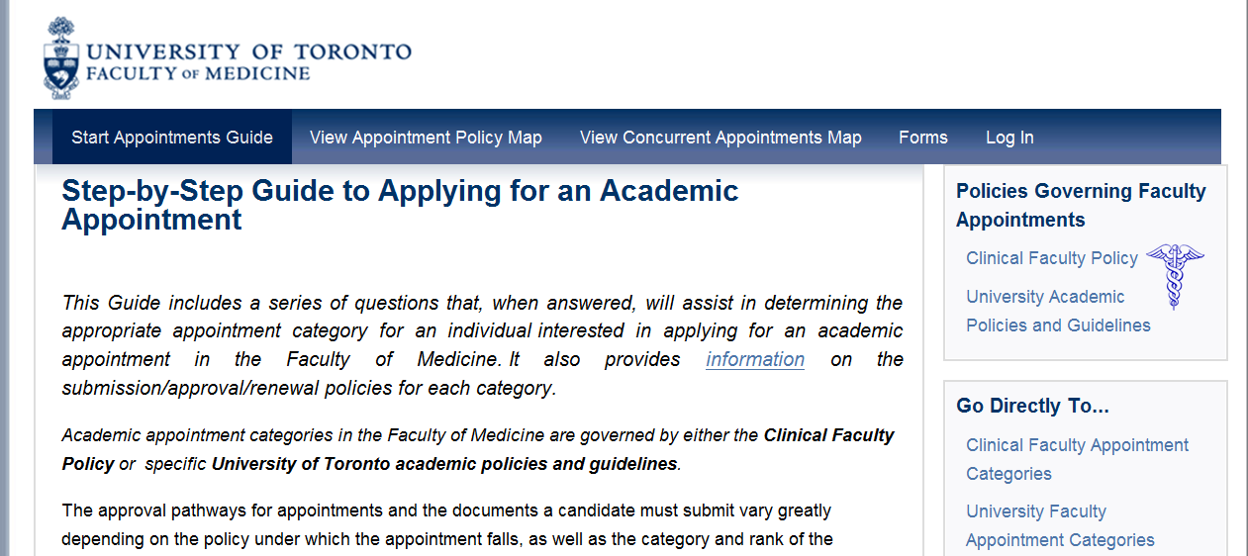
2. Web Submission Forms: The Applications Forms do not require a log in. The Supplementary Data forms do not require a log in, but they do have a required field for the unique ID number of the appointment candidate. This unique ID is generated when an application form is accepted by the department coordinator, causing a dossier to be created in LaserFiche.
3. WebForms Manager: (http://documents.med.utoronto.ca/WebForms). This is an online application; there is no desktop version of this application. Only the Departmental Coordinator (DC) has access to the WebForms Manager. You will be prompted to log-in. Your username is dcxxx where xxx is your departments Org unit. For example: dc999. Password (to begin) = password.
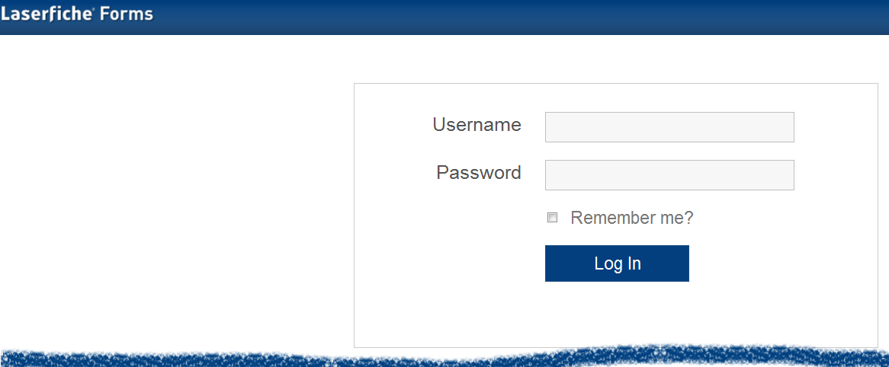
When the system becomes widely operational we will be changing the passwords to make the repositories more secure. If you have questions about your login and password, you may contact Libby Shirriff (Libby.Shirriff@utoronto.ca), Donna Deak (d.deak@utoronto.ca) or Christianne Green (christianne.green@utoronto.ca) in Human Resources.
4. LaserFiche: (http://documents.med.utoronto.ca/laserfiche8).
The Department Coordinators (DC), the Human Resources Coordinators (HR), the Dean, the Vice Dean of Clinical Affairs, and the Chair of the FAAC may use either the desktop application (desktop client) or a web-based application (web client) to administer the Academic Appointments process. The desktop client is accessible through an icon on your desktop.
For Department Coordinators, your username is dcxxx where xxx is your department’s Org unit. For example: dc999. Your password, initially, is password.
Human Resources staff, the Chair of the FAAC, the Vice dean of Clinical Affairs and the Dean of the Faculty of Medicine will be individually informed of their usernames and passwords.
You can access the LaserFiche web client by entering the URL above into a web browser from any computer that has access to the internet. For those of you familiar with our LaserFiche system for Promotions, this is an oft-used website. However, you will select a different repository (Appointments) and use a different login name and password. It may be a good idea to save this URL in your browser’s favorites to save you from entering it in every time you’d like to access the Academic Appointments system.
In either the web client or the desktop client, select the repository ‘Appointments’ and you will be prompted to log-in.
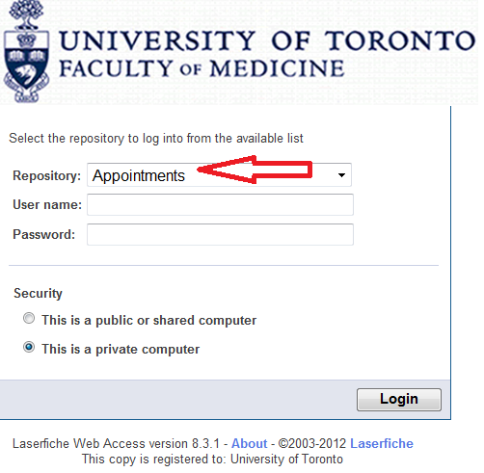
5. Read-Only Portal: (http://documents.med.utoronto.ca/appointments).
The Departmental Appointments Committee (DAC) will log in to the read-only portal using the username = dacxxx where the xxx is your department’s Org unit. For example: dac999. The password, initially, is password.
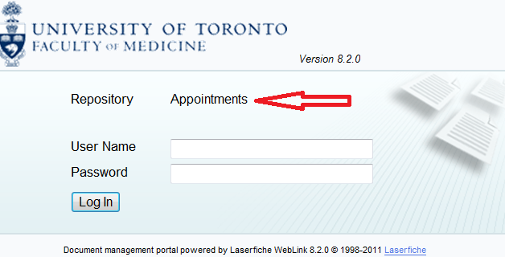
http://documents.med.utoronto.ca/appointments

The Appointments Workflow

Step-by-Step:
a. The Guide to Academic Appointments is open to the public; any qualified individual with an interest in an academic appointment can work through the Guide to find the appointment category appropriate for them and the documents required in an application package.
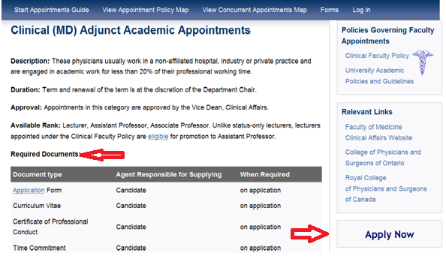

b. If the appointment candidate or their agent is using the Guide, they may access the correct online application forms by clicking on Apply Now in the right-hand side bar of the page describing the appointment category. Alternately they may access the desired form by selecting the Forms link on the menu bar. The applicant (or their agent) will fill in the form, attach any documents that they currently have ready, and click Submit.
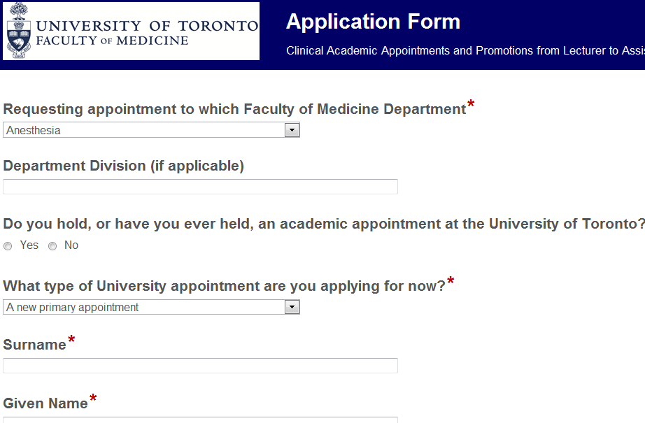

c. The Departmental Coordinator (DC) then receives an e-mail (sender=LaserFiche) informing them of the submitted application form. The DC logins to the WebForms Manager (http://documents.med.utoronto.ca/webforms) and reviews the form. The DC can edit the text boxes the candidate filled in, if they wish. The DC is required to fill in additional information at the bottom of the form in boxes that were invisible to the candidate when filling out the form. The form can be rejected, put on hold if a question requires further investigation, or it can be accepted.
d. When a form is accepted several things happen automatically.
- The web form sends LaserFiche the data from the form. LaserFiche takes the data and uses it to fill in two features:
  - It creates a dossier for the candidate in the department’s Appointments repository and fills out an information template with the data. That template is called the Candidate Information template and it can be accessed by right-clicking on the dossier and selecting metadata.
  - LaserFiche takes the data and fills in a pdf template of the application form and inserts this new pdf document into the newly created dossier.
- LaserFiche creates a unique ID for the dossier.
- Any documents that were attached to the application form are then automatically inserted into the dossier.
- LaserFiche creates a new template called Appointment Status. This template will allow various users to trigger events by changing the status of a dossier and it will show a record of all of the status changes that have taken place for a given dossier.
- If this is a clinical academic appointment where the applicant holds, or will hold, a hospital appointment at one of U of T’s fully-affiliated or community-affiliated sites, the Hospital Coordinator (HC) named in the application form receives an e-mail directing them to review the dossier on the Read-Only Portal. The e-mail contains the appointment candidate’s unique ID mentioned above, and the website for the Document Submission Form should any additional documentation be required.
e. If this is an application for a clinical appointment, the Hospital Coordinator (HC) gathers any further documents that may be required. (These may include a letter from the Physician-in-Chief and possibly a letter of reference.) The Hospital Coordinator may consult the Guide to Academic Appointments http://aca.med.utoronto.ca if they are unsure of what documents are needed to complete the dossier. When ready, the HC submits any additional required documents by filling out the Document Submission Form http://documents.med.utoronto.ca/appointmentdocs and attaching the documents to it.
f. LaserFiche inserts the documents into the candidate’s dossier and e-mails the DC to let them know that additional documents were submitted.
g. The DC reviews the dossier. If it is customary in the department, the DC advises the DAC Committee that there are applications pending.
h. Members of the DAC can log on to the public portal and view the dossier. The DAC informs the DC of their decision about the appointment.
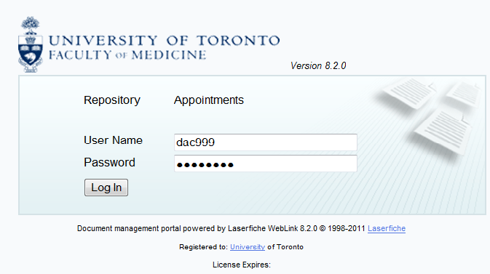
i. The DC uploads the Letter from the Department Chair, and a job description if one is required. See page 19 for instructions on how to upload documents directly into LaserFiche.
j. At this point, before changing the dossier status to ‘DAC Approved’ (see page 18), the DC can choose to have LaserFiche generate a Letter of Offer. Alternately, they may upload one to the dossier themselves. Please see the section below on generating Letters of Offer.
k. The DC changes the status of the dossier to Approved. (see the Changing the Status of a Dossier section below).
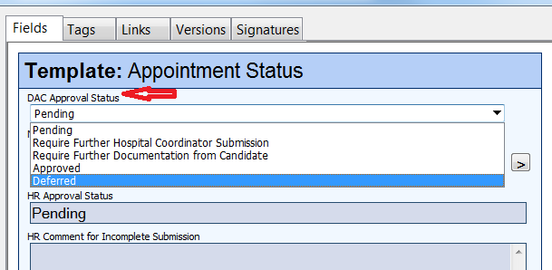
This removes the visibility of the dossier from the DAC. It also gives access to the dossier to the Human Resources staff (HR) and sends an e-mail to HR to inform them that your DAC has approved the applicant.
l. Human Resources reviews the dossier.
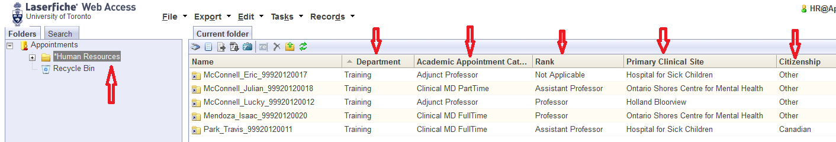
If the dossier is not complete, they may select the status ‘Incomplete: Return to Dept Coordinator’ in the Appointment Status template. Before clicking SAVE they can add a comment about what changes are necessary to the template. Clicking Save e-mails the DC who may then make the changes requested by HR.
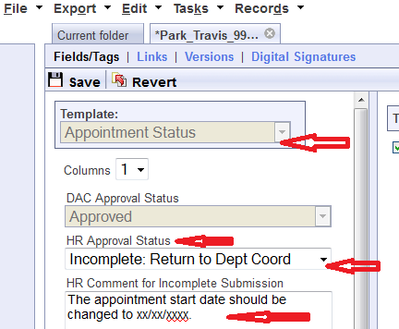

m. If the DC receives an e-mail like this, they will make the necessary changes and/or upload any further required documentation (see the sections below on ‘Editing the PDF Appointment Application Document’ and on ‘Uploading Documents Directly into LaserFiche’).
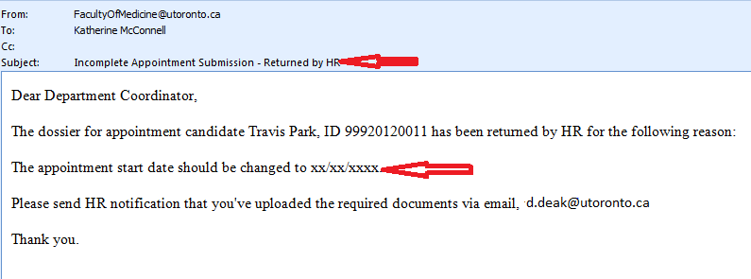
The DAC Approval Status on the Appointment Status template reverts back to PENDING. The DC has the option to
n. When HR is satisfied with the dossier, using the same Appointment Status template, they grant access to the dossier to either the Vice Dean, the FAAC, or the Dean.
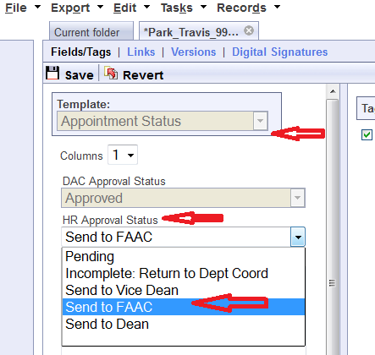

o. The Vice Dean, the FAAC, and the Dean ARE NOT notified that this access has now been granted. This is to limit the amount of e-mail they get. They do have full access to the LaserFiche system and, unlike the DAC and the Hospital Coordinators (HC), will log in to LaserFiche (http://documents.med.utoronto.ca/laserfiche8). When they log in they will see only the applicant dossiers that have been approved for their review.
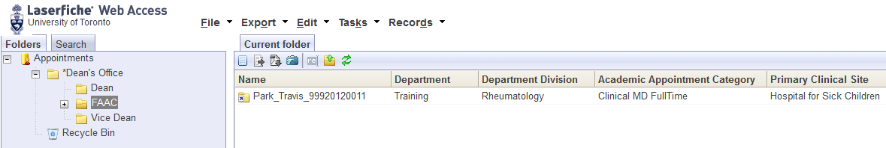
p. To approve or defer an appointment candidate the Vice Dean, the FAAC Chair or the Dean will open the Appointment Status document (purple icon), and make a selection from the dropdown list under the Dean/Vice Dean/FAAC Approval Status.
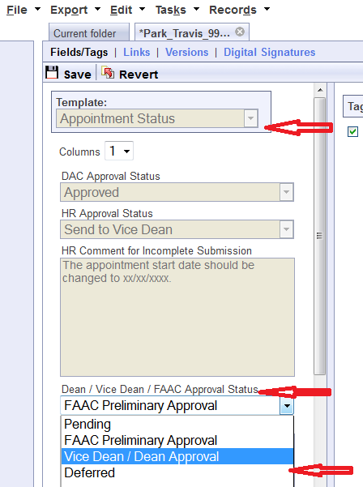
q. When the value ‘Vice Dean/Dean Approval’ is selected, the DC (Department Coordinator) is alerted via e-mail that the appointment for this candidate has been approved.
Note: The use of LaserFiche to manage the appointment may end here if the department prefers to handle the issues of notifying the candidate and extending Letters of Offer, in their own unique fashion. If the department decides to stop here in LaserFiche, please read paragraph z of this workflow summary to learn about updating the candidate’s metadata template with a Personnel Number when one is assigned.
r. If the department wishes, LaserFiche can send an e-mail, with an attached Letter of Offer and Job Description (if desired), to the candidate congratulating them on the appointment. In order for this to happen there must be in the dossier a letter of offer that has the file name
Surname_FirstName_Letter of Offer.
This file may have been created by the Letter of Offer Template (see paragraph j above, and the section below titled Letters of Offer) or it may have been uploaded by the DC. Regardless, to be recognized by LaserFiche it must have the file name detailed above.
Similarly, if a job description is to be attached to the e-mail, there must be a file in the dossier named
Job Description
s. To send an e-mail with attached Letter of Offer and, if necessary, a Job Description, the Department Coordinator will once again open the Appointment Status template (purple icon). Scrolling down to the bottom of the template shows a previously invisible field titled “Email Letter of Offer to Candidate.
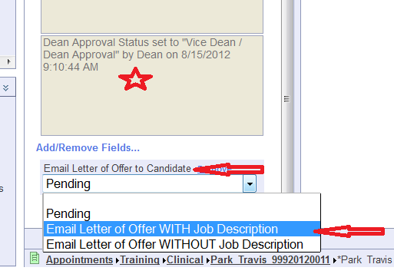
Note that the e-mail will be sent to the e-mail address the candidate or their agent supplied on the initial application form. This data filled in a template called Candidate Information. You can view this data by right-clicking on the candidate’s name in the left sidebar and selecting metadata.
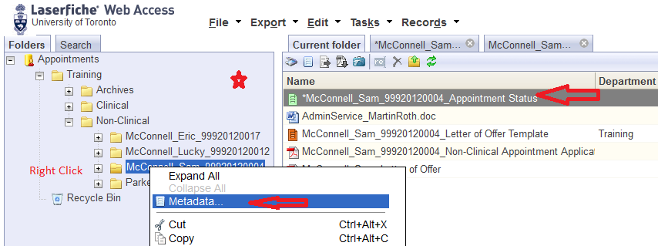

Back on the Appointment Status template make the Letter of Offer selection you prefer (assuming the necessary files exist in the dossier with the required filenames) and click SAVE. Scroll back up the template and click SAVE to send the e-mail. You, as the Department Coordinator, will receive a copy of the Letter of Offer e-mail that is sent to the Candidate.
t. The Letter of Offer e-mail gives the appointment candidate the e-mail address of the Department Coordinator (DC). It is up to the appointment candidate to sign the Letter and get it back to the department. There is no LaserFiche function for this.
u. Upon receiving the signed Letter of Offer, you may upload it directly into the candidate’s dossier.
Note: If you are a user of the desktop LaserFiche client and a user of Microsoft Outlook you may save e-mails and attachments directly from Outlook to LaserFiche. On your Outlook Inbox, with the e-mail selected, click on File >> Send to LaserFiche. You will be asked to select the correct repository (Appointments) and to provide your log in and password.
v. After you have received your signed Letter of Offer it is the department’s responsibility to add the new appointee to the HRIS database. When a Personnel Number is available it would be prudent to add the Personnel Number to the Candidate information template in LaserFiche.
You can open this by right-clicking on the candidate’s name in the left sidebar and selecting metadata.

**This Completes the Step-by-Step Outline of the Workflow**

Changing the Status of a Dossier
The status of a dossier is controlled and recorded on the candidate’s ‘Appointment Status’ sheet. This is the file with the purple icon in dossier. It is created when the dossier is created. Double click on this file to open it.
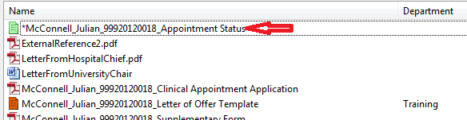
The status of a dossier defines for whom the contents of the dossier are visible. (i.e. Human Resources cannot see appointment dossiers from the departments until the DAC Approval Status is set to approved. Likewise, the FAAC, the Vice Dean or the Dean cannot see the dossiers until the HR Approval Status is set to ‘Send to …(someone in the Dean’s Office)’).
Permission to change a dossier status is limited to the user controlling that portion of the workflow (see Appendix A).
The Appointment Status sheet also records events as they occur in the workflow. In the illustrations below we can see the date the application form was submitted and the date the supplementary data form was submitted. As the workflow progresses, further events will be recorded.
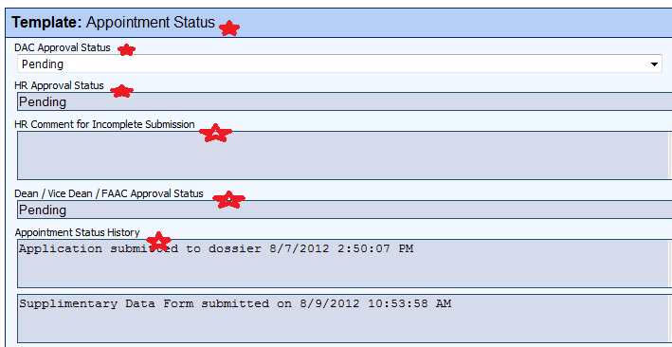

A. To change the status of a dossier using the desktop client
Double click on the Appointment Status file in the dossier (the one with the purple icon). You will see a new template open and a new tab on the top of the screen.
You will only be able to change the status of a workflow in areas where you have control. Change the status from the drop down box and click OK.
Open the Appointment Status file again (purple icon), and you will see that the status change event was recorded in the box at the lower end of the template called Appointment Status History.
B. To change the status of a dossier using the web
Double click on the Appointment Status file in the dossier (the one with the purple icon). You will see a new template open and a new tab on the top of the screen. (Click back and forth between the two tabs to see what they represent.)
You will only be able to change the status of a workflow in areas where you have control. Change the status from the drop down box and click okay.
Go back to the Current Folder tab to see the dossier contents again, double click on the Appointment Status file again, and you will see that the status change event was recorded in the box at the lower end of the template called Appointment Status History.

Uploading Documents Directly into LaserFiche
Uploading documents directly into the dossier is simple.
Using the desktop client:
Click File >> Import >> Select the document>> Click Okay on the Message Box that appears (ignore any information inside the message box) >> Check that you are in the Current Content tab and Refresh the screen.
Using the web client:
Click File >> Import >> Select the document>> Click Start Import >> Click Next on the Message Box that appears (ignore any information inside the box) >> Check that you are in the Current Content tab and Refresh the screen.
Using the Web Form:
Supplementary Document Submission Form: http://documents.med.utoronto.ca/WebForms/appointmentdocs

Editing the PDF Appointment Application Document

There are a few pieces of data required on the web application forms that the DC may not be certain of at the time the web application form is accepted and the Appointment Application PDF is automatically generated.
Editing pdfs is not an easy task – it is always easier to get it right the first time. To ensure that the changes you make to the pdf application form are visible to all future stakeholders, please follow the steps below exactly.

I. Using the Desktop Client of LaserFiche8
- In the desktop client of LaserFiche, open the Original Application folder for the applicant.
- Double click on the appointment application pdf to open the document in Adobe Reader
- In the top, left-hand side of the tool bar, click on the icon titled Sign, Add Text, or Send a Document. A new panel should open on the right.
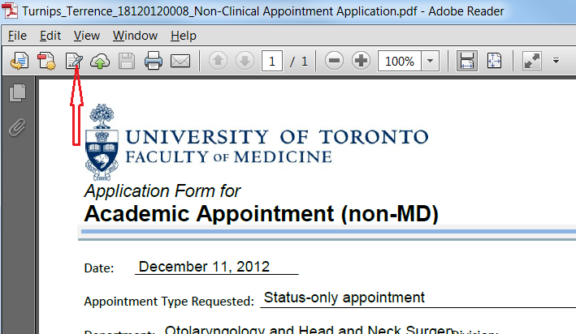
if you cannot see this toolbar
click View >> Show/Hide >> Tool Bar Items >> Show Toolbars
- In the panel that opened on the right, click once on the Add Text button.
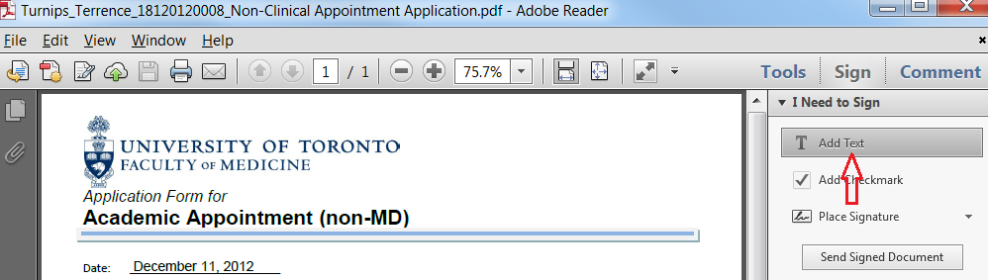
- Move your mouse pointer to the area on the pdf where you want to add text and click once. This will add a cursor at that spot and you may start to type what you want.
You cannot delete anything with this tool, but if you need to erase a previous entry, you may put the cursor at the start of the text you want to get rid of and type a row of X’s over the top of it.
It is very important to follow the next steps exactly!
- When you are done, click File on the menu bar and select Save.
- The Save As box will appear. Do not change anything. Simply click Save.
- When asked if you want to replace the file, click Yes.
- Close the pdf document by clicking on the X at the very top, right-hand corner of the window.
- After a few moments, LaserFiche will show a message box asking about the modified file. Select ‘Overwrite the existing document’ and click OK.
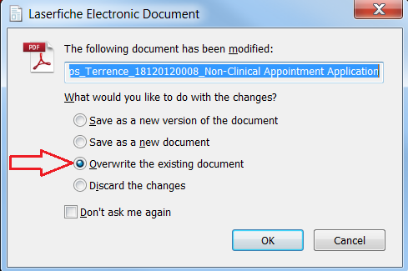
- Back in the Original Application folder, check that your changes were saved by opening the Appointment Application document. You may want to refresh your screen first.
- If the dossier status has not been approved by the DAC yet, test your changes again by logging in to the Read-Only Portal as if you were a member of your DAC. The changes you made to any pdfs should be visible to them as well. If not, you have not edited the actual pdf but merely an image view in LaserFiche. If the changes are visible to the DAC they will be visible to HR and to the Dean or Vice Dean as well.

II. Editing the PDF Using the Web Client LaserFiche8
You will find it easier if, before you do this for the first time, you create a folder for this function anywhere on your computer. The key issue is that you remember where this folder is - you will put temporary files in it as you follow the steps below. If you don’t create your own folder, your operating system (Windows or Mac) will put them in a temporary folder. That is not a problem but you will then have to find that temporary folder later in the process and that will slow you down. We called our folder AppointmentEdits.
- In the web client (http://documents.med.utoronto.ca/LaserFiche8), open the Original Application folder.
- Double click on the appointment application pdf to open the document in Adobe Reader.
- In the top, left-hand side of the tool bar, click on the icon titled Sign, Add Text, or Send a Document. A new panel should open on the right.
if you cannot see this toolbar
click View >> Show/Hide >> Tool Bar Items >> Show Toolbars
- In the panel that opened on the right, click once on the Add Text button.
- Move your mouse pointer to the area on the pdf where you want to add text and click once. This will add a cursor at that spot and you may start to type what you want.
You cannot delete anything with this tool, but if you need to erase a previous entry, you may put the cursor at the start of the text you want to get rid of and type a row of X’s over the top of it.
- When you are done, click File on the menu bar and select Save.
- The Save As box will appear. Select the folder into which you are going to save this newly edited document. If you have created an AppointmentEdits folder on your desktop, select this now. Do not change the name of the file. Click Save.
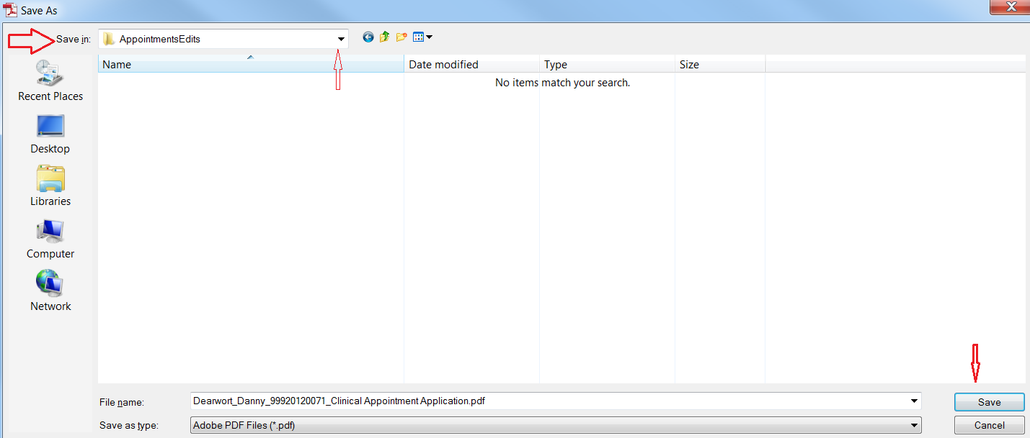
- Back in the web client; go back to your Original Application folder so that you can see the list of collected documents in the Current folder. Click on the word Tasks in the tool bar and select Add/Replace Electronic File.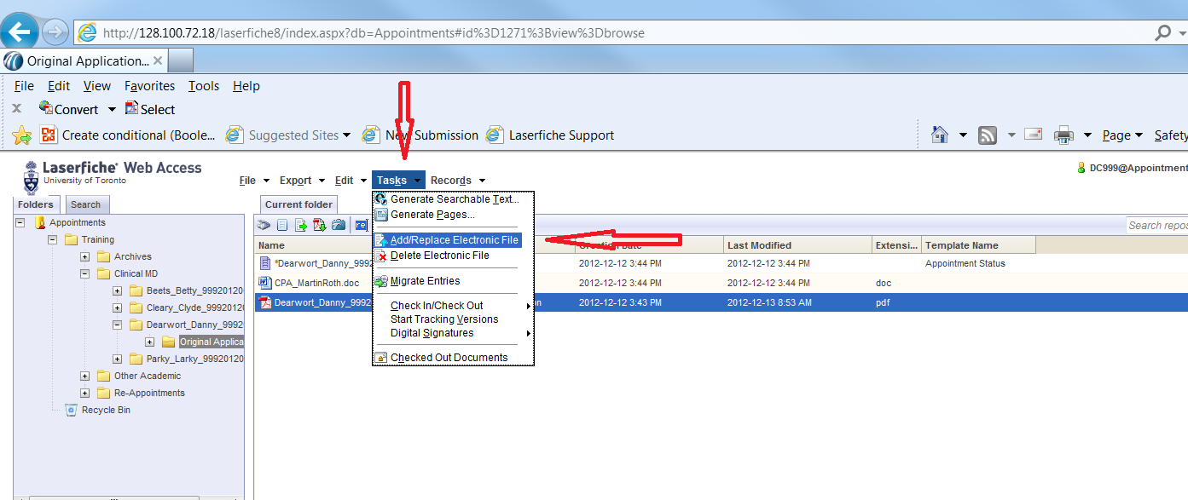
- The Add/Replace Electronic File box will appear. Browse to the AppointmentEdits folder where you stored your edited file.
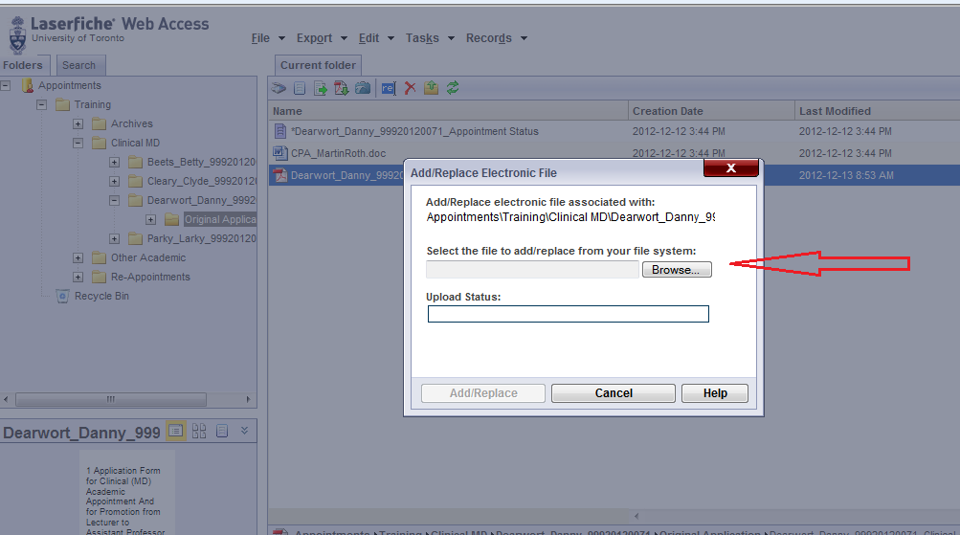
- Select the filename you just edited and click on Add/Replace.
- Refresh your screen and open the file you just edited. You should be able to see your changes.

Column Headings – Refining your View, Sorting your Lists

When viewing a list of pending or accepted appointees you may want to see some information about them displayed in the columns. The information people want displayed is quite variable, and can be individual to each department, hospital, or user. Not every piece of metadata is available, or desirable, as a column heading, but there are some that may be helpful. Other metadata may be used as a column header by default but may not be very useful.
The most useful metadata, we think, that can be used in columns comes from the Candidate Information template. This is the template that holds the data from the application form.
A. To change what column headings are displayed on the desktop client (for Department Coordinators, Human Resources Coordinators, the Vice Dean, the FAAC or the Dean):
Right click on any existing column header >> From the drop-down box select Template Fields >> Select Candidate Information >> Select the desired metadata for a column heading.
Below is an image of what departments may find useful. We could have selected, as a column header, Department as well as Department Division. Hospital Coordinators on the Public Portal and Human Resources staff may find that useful, but Department Coordinators only see their own department’s list of appointees anyway, so for them, that information would be redundant.
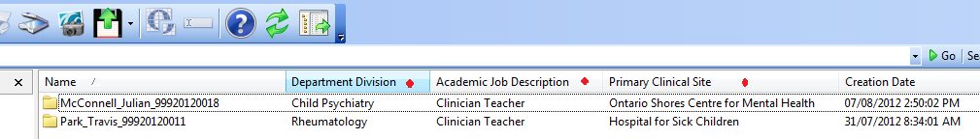

B. To change what columns are displayed on the web client (for Department Coordinators, Human Resources Coordinators, the Vice Dean, the FAAC or the Dean):
Right click on any existing column header >> Select configure columns >> In the leftmost box, make sure Browser Columns is highlighted >> In the middle box, under Available Columns, select Template >> Scroll down to Candidate Information >> Directly under Candidate Information, one by one, highlight the fields you would like to see used as columns and click the sideways arrow to add it to the rightmost box >> When you have all the desired fields, Click SAVE.
By highlighting fields in the rightmost box and clicking a sideways arrow you may remove from view any columns headings that are not useful (ie. Pages).
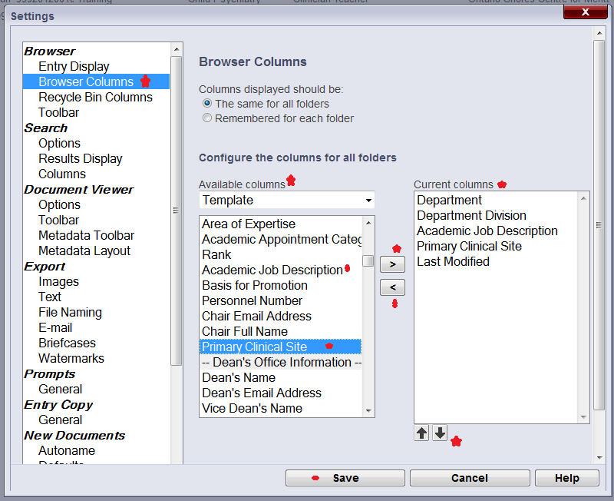

C. To change what columns are displayed on the Public Portal (for Hospital Coordinators and DAC members):
After logging in, click on My WebLink in the top-right area of the screen >> In the leftmost box, make sure Browse Options is highlighted >> In the middle box, under Choose Displayed Fields, select Template >> Scroll down to Candidate Information >> Directly under Candidate Information, one by one, highlight the fields you would like to see as columns and click the sideways arrow to add it to the rightmost box >> When you have all the desired fields, Click SAVE.
By highlighting fields in the rightmost box and clicking a sideways arrow you may remove from view any columns headings that are not useful (ie. Pages).
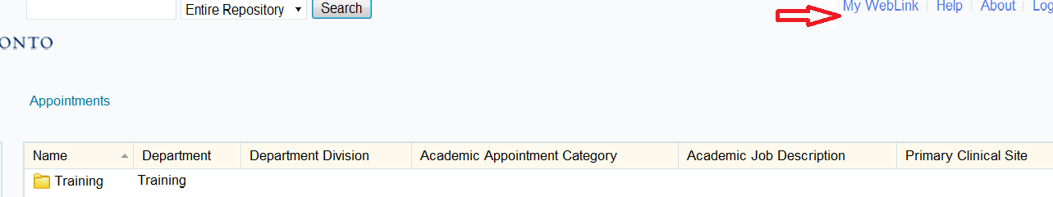
------------------------------------------------
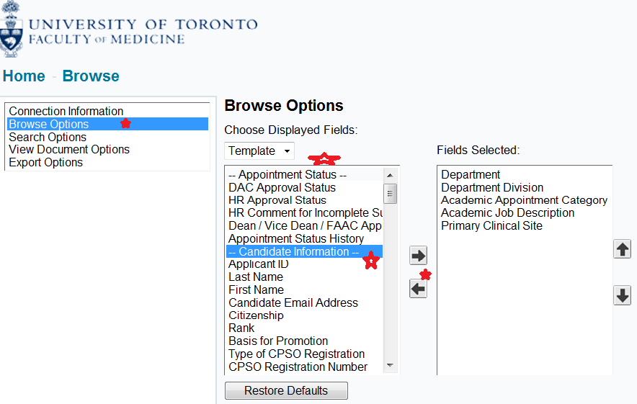

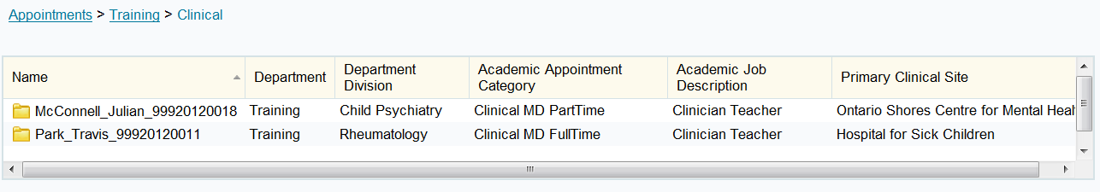

And remember that you can sort your list by columns: Simply left-click on the column header to sort the list of appointees alphabetically, by the metadata in that column.

Letters of Offer

Letters of Offer are standard for most clinical appointments. Unless there are exceptional circumstances, departments are required to use LaserFiche to generate clinical offer letters. For those individual exceptions where a unique letter is necessary, Departments still have the option to create their own letter and upload it into LaserFiche.
Departments also have the option of having LaserFiche send the Letter of Offer to the applicant attached to an email, or of sending it to the applicant themselves. Again, unless there are special circumstances, using LaserFiche to send the letter is the preferred method.
Creating letters and sending letters are two different functions in LaserFiche and the choice of which way to go in each case is independent of the other choice.
Letters of Offer generated by LaserFiche are personalized to the applicant with field values from both the Candidate Information template and the Letter of Offer template. The Letter of Offer templates are unique to each appointment category. When the Letter of Offer Status field in the Letter of Offer template says Create Letter of Offer, the template runs a workflow which inserts the personalized data into the appropriate letter template. The completed letter will appear in the Current Folder.
Letters of Offer are reviewed in Human Resources before the appointment is approved so it is necessary to have an initial version of the letter in the dossier before the dossier status is changed to ‘DAC Approved’. It will very likely be necessary to make some minor changes in the letter after the application receives approval from the Dean’s office and before it is sent to the candidate. This is a very simple procedure, requiring only that the relevant fields in the templates be updated, the Letter of Offer field be reset to Create Letter of Offer, and the letter of offer template be saved again. This regenerates the letter and overwrites the earlier one.
If Letters of Offer are going to be sent automatically by LaserFiche, the file name for the letter must be in this format: ‘Lastname_Firstname_ApplicantID_Letter 0f Offer’.

Generate Letters of Offer (Using LaserFiche Web Access ):
As of Feb 2015, as soon as a clinical applicant dossier is created in the *New Appointments/Clinical MD area, a Letter of Offer template is automatically inserted into the current folder for the dossier.
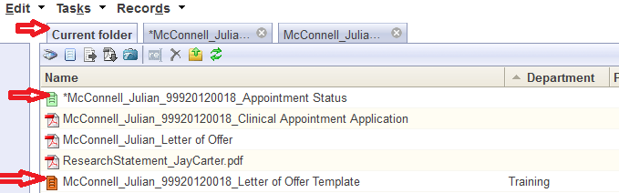

Re-create the Letter of Offer Template
If the Letter of Offer template is not there or if you deleted it, you may recreate the Letter of Offer Template by right-clicking on the Appointment Status template in the current folder and selecting Metadata from the drop down list.
In the right-most frame, put a check mark in the box beside the words ‘Generate Letter of Offer Template’. Click SAVE. The Letter of Offer template will appear in the Current Folder as a file with an orange icon and has a file name with the format ‘Lastname_Firstname_ApplicantID_Letter 0f Offer Template’. You may have to refresh the screen to see it.
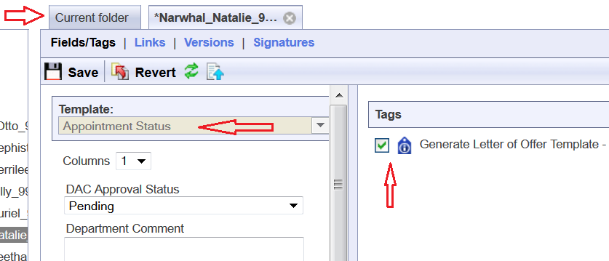
Once you can see the Letter of Offer template
- Open the Letter of Offer template in the Current Folder by right-clicking on it and selecting Metadata from the drop down list. Check that the Template title is for the correct appointment category.
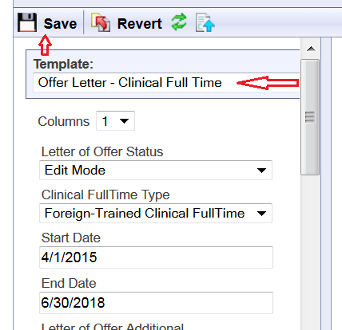
  - If it is not for the correct appointment type, first go back to the Candidate Information template by right-clicking on the dossier (yellow folder in the left-sidebar) and selecting Metadata from the drop down list. Change the Academic Appointment Category field to the correct category and Save. Only then, go back to the Letter of Offer template and using the drop down arrow beside the Template name select the correct Letter of Offer template and click Save.
- Fill in the fields in the Letter of Offer template. The fields vary per Academic Appointment Category.
  - Clinical Full Time Type is a field only in the Clinical Full Time Template. It allows you to indicate whether this letter will be for a regular full-time applicant, a foreign-trained full-time applicant, or a clinical full-time equivalent.
  - Start and End Dates: To ensure that appointment dossiers never get saved in LaserFiche without an End Date, an End Date has been automatically calculated from the current system date. This may be changed but all dates must adhere to accepted policy. If you are unsure of the date, select an estimated Start Date. This will likely need to be changed before the final version of the letter of offer is generated.
The same Start and End Date fields can be seen on the Candidate Information template. If you create a letter of offer with the Letter of Offer template, those date values will overwrite the date values in the Candidate Information template. The reverse process is not true.
  - Letter of Offer Additional allows for a department-specific paragraph of text in the letter. The text generally appears in the last paragraph of the first page of the letters. It has a maximum character count of 310 characters.
  - Offer Retraction Date: This is the date after which the offer of appointment to the applicant becomes invalid. If necessary, update this for the final version of the letter.
  - Chair Full Name: This is the same field that appears on the Candidate Information Template but here, it is allowed to add credentials after the name or to add a stand-in. The letter will show the value from this field. It will not overwrite the value in the Candidate Information Template
eg: Dr. Leonard Nimoy, MD, PhD
Dr. Leonard Hofstadter for Dr. Leonard Nimoy
  - Letter of Offer CC: Up to 4 names may be added to this field, each on separate lines. They will appear in the CC area of the letter.
  - Letter of Offer CC Email Addresses: If there are names in the Letter of Offer CC field above, it is necessary to add the associated email addresses in this field. This is a multi-value field, meaning that when one email address is typed in the box, a second box will appear to house the next one – do not type the email addresses all into one box as was done in the Letter of Offer CC field above.
If there is a Hospital Administrative Email address in the Candidate Information template, it is automatically added – there is no need to add it here.
  - Letter of Offer Enclosures: If you plan on sending additional material to the applicant along with the actual letter of offer, the titles of those documents can be mentioned here. Type them on separate lines in the one box.
Very Important Note: Typing text into this Letter of Offer Enclosures field simply adds the text to the letter of offer in the Enclosures area. It does not control whether those documents actually exist in the dossier nor does it tell LaserFiche to attach them to the Letter of Offer email.
Any documents mentioned in this field need to be uploaded to the dossier before the final version of the letter is sent AND, if LaserFiche is being used to send the Letter of Offer, the file names of these additional documents need to begin with the word Enclosure.
examples: Enclosure_DepartmentProfile
EnclosureAcademicPositionDescription
- Once the fields have been filled in, change the Letter of Offer Status field at the top of the template to Create Letter of Offer and click Save.
- Go back to the Current folder and refresh the screen. You will see a new pdf document has appeared in the dossier having a file name format of ‘Lastname_Firstname_ApplicantID_Letter of Offer’.
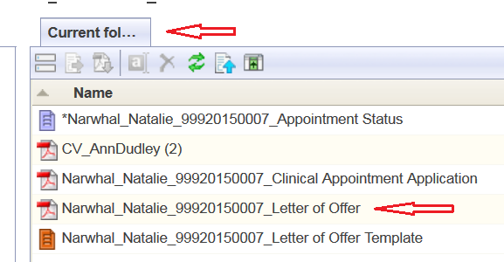
- Double click this pdf file to open it and review the letter.
Make Changes to a Letter of Offer:
If you need to make changes to the editable field values in a Letter of Offer (i.e. you want to change the appointment start date or change the mailing address) you need to change the field values in the templates in which the data is housed. The letter of offer workflow pulls field values from either the Candidate Information template or the Letter of Offer template. Look there to make your desired changes.
Once the changes have been made, and if it isn’t already opened, right-click on the Letter of Offer template and select Metadata to open it. Change the Letter of Offer status back to Create Letter of Offer and click Save. Go back to the Current Folder and refresh the screen. The revised Letter of Offer will have immediately overwritten the previous one.

Department Address Data:
The department address that appears in the footer of the first page of each letter of offer can be found in a field in the Department Information template. To edit the Department Address field follow the steps below. Note that the address MUST only be 3 lines.
- In the left-hand side bar right click on the department name and select metadata. The Department Information template will appear in the inner frame.
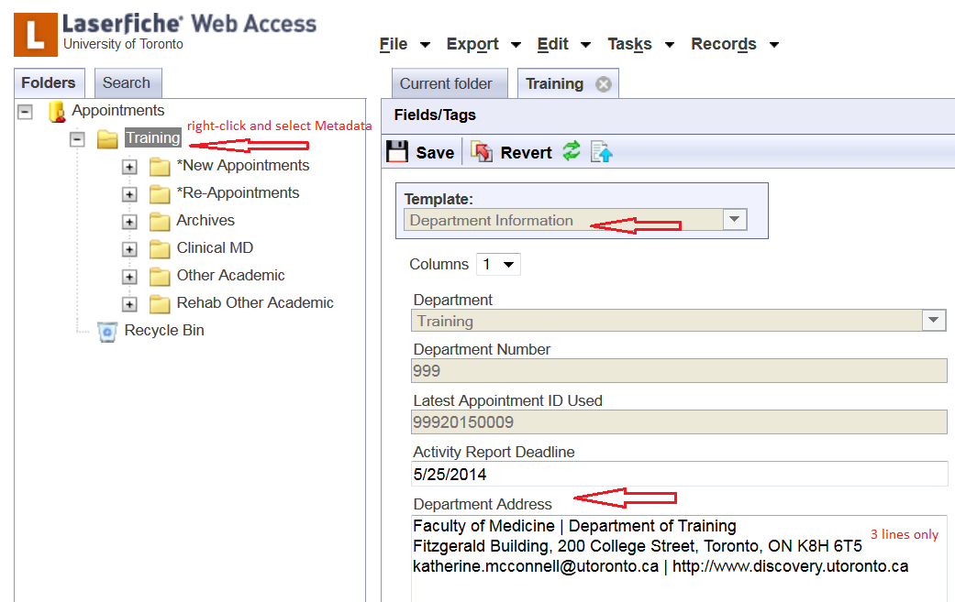
- Widen this frame so that the existing value in the Department Address field reveals that it is indeed 3 lines long.
- Edit the address, making sure it does not exceed 3 lines.
- Click Save.
- If necessary, go back to the Letter of Offer template, change the value of the Letter of Offer Status field to Create Letter of Offer, and click Save. This will re-create the letter of offer with the new address.

E-Mail Letters of Offer:
To send an e-mail with an attached Letter of Offer and, if desired, some additional attachments (enclosures) follow these steps below:
- Make sure that a Letter of Offer is in the dossier and that it is named in the format Lastname_Firstname_ApplicantID_Letter of Offer
- Make sure that any Enclosures you wish to send with the Letter of Offer and/or are mentioned in the Letter of Offer Enclosures field, exist within the dossier AND that their file names begin with the word Enclosure.
examples: Enclosure_DepartmentProfile, EnclosureAcademicPositionDescription, etc.
Important Notes on Enclosures:
  - The letter of offer itself does not need to have word Enclosure at the beginning of the file name.
  - Any file beginning with the word Enclosure will be picked up and attached to the Letter of Offer email regardless of whether or not it is mentioned in the Enclosures field in the Letter of Offer template.
- Make sure that the e-mail address for the candidate is correct in the Candidate Email Address field in the Candidate Information template. You can view and edit this Candidate Information template by right-clicking on the candidate’s name (yellow folder) in the left sidebar and selecting metadata.
- Once again, open the Appointment Status template (purple icon) by right-clicking and selecting Metadata. Scrolling down to the bottom of the template shows a previously invisible field titled “Email Letter of Offer to Candidate. This field only becomes visible when the application receives final approval.
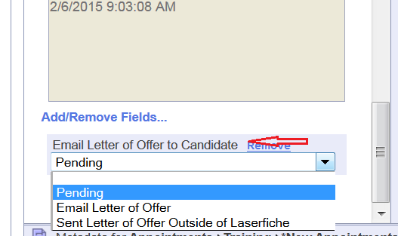
- Select Email Letter of Offer, and up at the top of the template, click Save. An email will be sent to the candidate with the letter of offer and any files beginning with the word Enclosure attached.
The email will be automatically copied to the department coordinator, to any email addresses in the Letter of Offer CC Email Addresses field, and, if there is an email address in the Hospital Administrative Email field in the Candidate Information template, to the hospital coordinator.

E-Mailing Other Documents Directly From LaserFiche

In the preceding section, we talked about how the Appointments approval workflow is set up to send automated notification e-mails to the Vice Dean, the Dean, the FAAC, and/or back to the Department Coordinator. The Provost, however, is not included in this list of automated e-mails.
It is easy to send copies of documents directly from LaserFiche to anyone using your Outlook e-mail application.
- Open the Original Application folder for the candidate so that you can see the list of the documents. (steps 1 – 4 of the last section)
- Select the documents you want to send by highlighting the file names. You may select more than one. The ‘templates’ not attach to your e-mail even if they are selected.
- Hover your mouse pointer over the selected documents, right click, and select ‘Send Document in E-Mail’.
if you are using the desktop client the box below will appear with your selected documents listed.
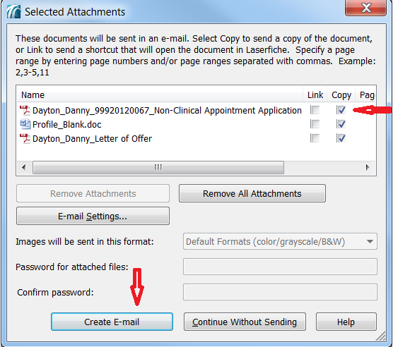
Make sure that the Copy check box is selected and click on ‘Create E-Mail. If you have Microsoft Outlook on your desktop you should not have to change any other settings.
If you are using the web version of the LaserFiche client you will this box instead.
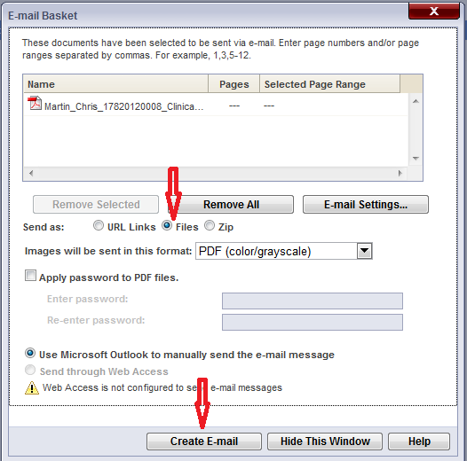
Make sure that the Files radio button is selected and click on ‘Create E-Mail’. If you have Microsoft Outlook on your desktop you should not have to change any other settings.
- Clicking ‘Create e-Mail’ should open up your own e-mail client with copies of these files attached. Send the e-mail to whoever has a need to see them.

Appendix A - Quick Reference to Appointments System Websites

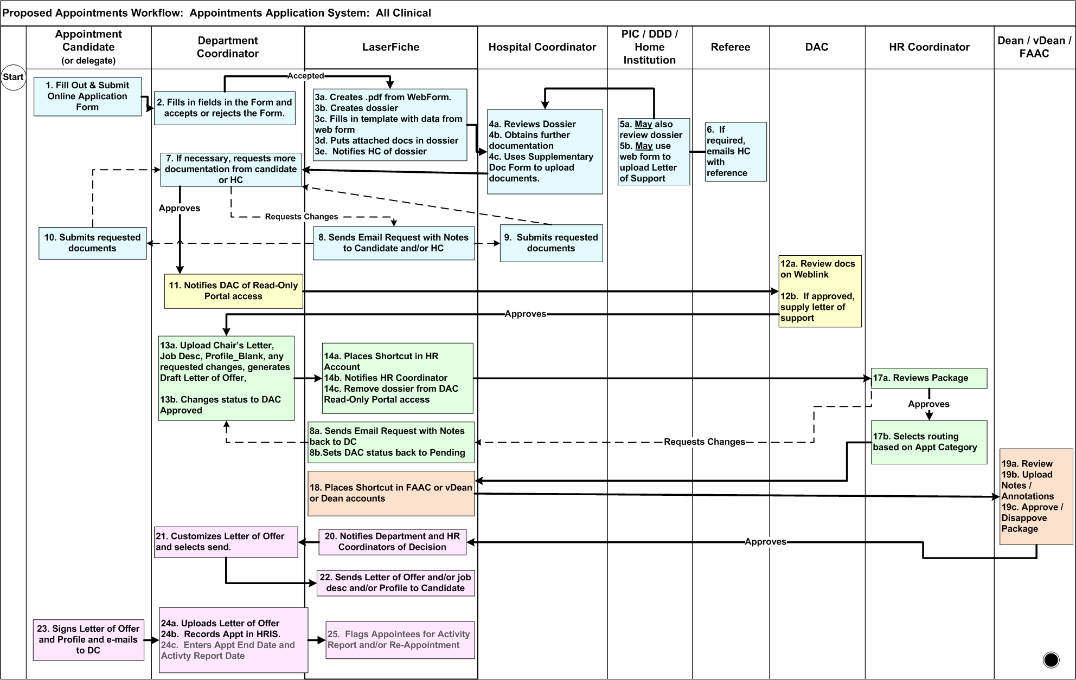
Appendix B – Clinical Appointments Workflow

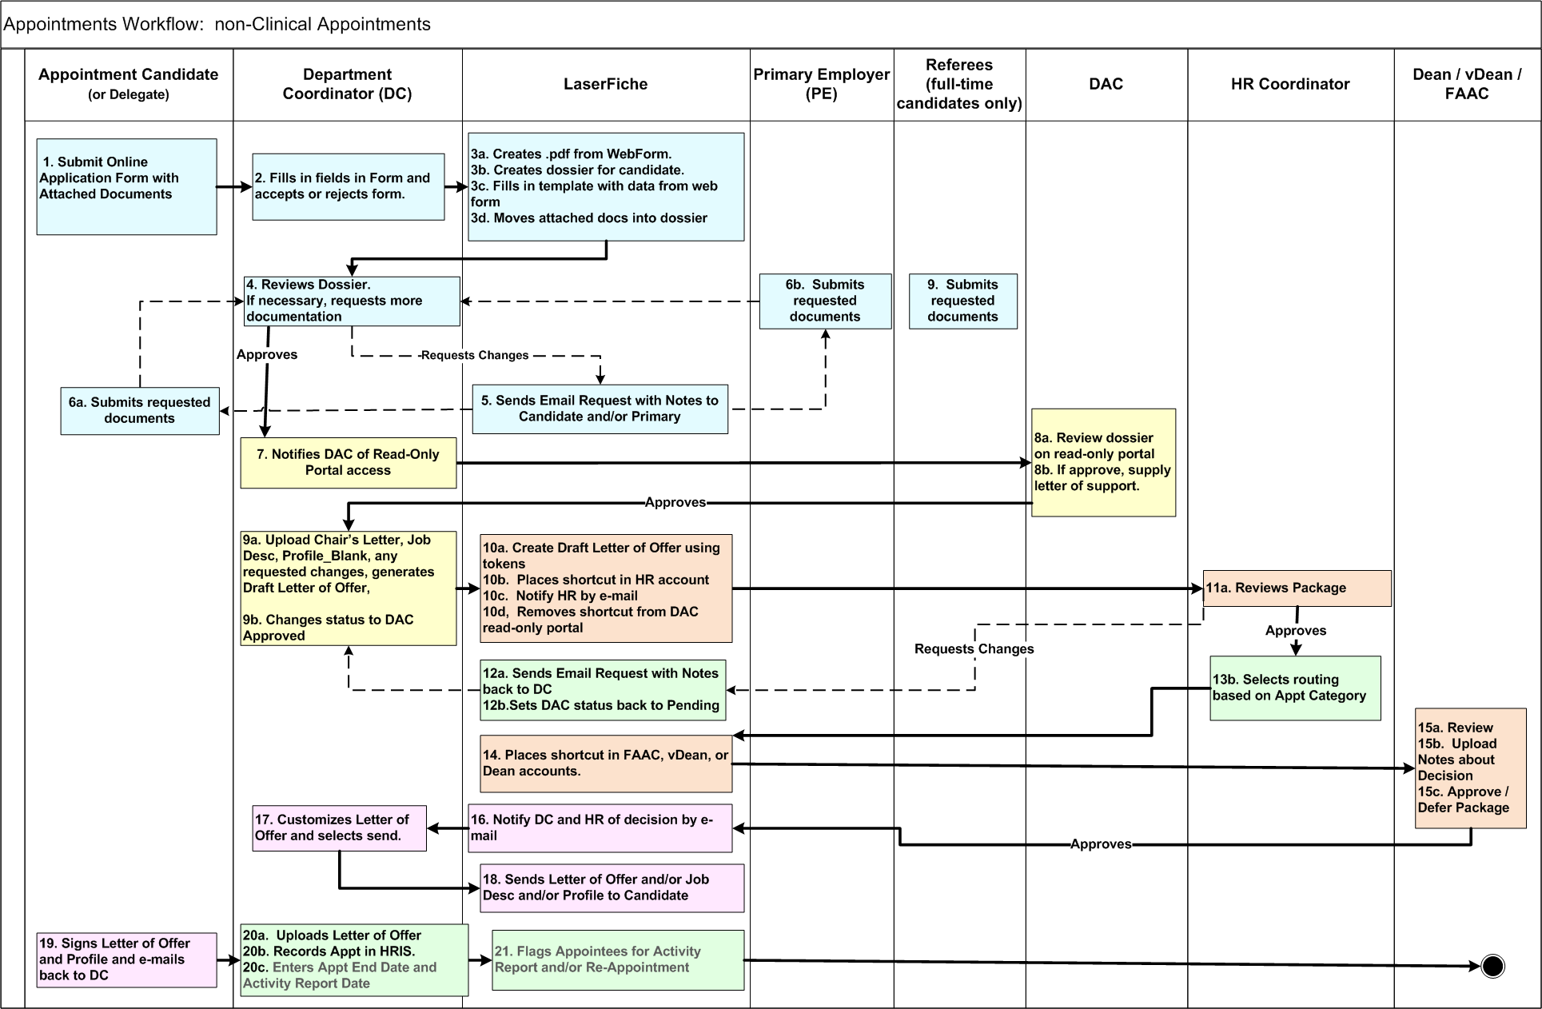
Appendix C – Other Academic Appointments Workflow

