LaserFiche Instructions – Clinical Offer Letters

Letters of Offer

Letters of Offer are standard for most clinical appointments. Unless there are exceptional circumstances, departments are required to use LaserFiche to generate clinical offer letters. For those individual exceptions where a unique letter is necessary, Departments still have the option to create their own letter and upload it into LaserFiche.
Departments also have the option of having LaserFiche send the Letter of Offer to the applicant attached to an email, or of sending it to the applicant themselves. Again, unless there are special circumstances, using LaserFiche to send the letter is the preferred method.
Creating letters and sending letters are two different functions in LaserFiche and the choice of which way to go in each case is independent of the other choice.
Letters of Offer generated by LaserFiche are personalized to the applicant with field values from both the Candidate Information template and the Letter of Offer template. The Letter of Offer templates are unique to each appointment category. When the Letter of Offer Status field in the Letter of Offer template says Create Letter of Offer, the template runs a workflow which inserts the personalized data into the appropriate letter template. The completed letter will appear in the Current Folder.
Letters of Offer are reviewed in Human Resources before the appointment is approved so it is necessary to have an initial version of the letter in the dossier before the dossier status is changed to ‘DAC Approved’. It will very likely be necessary to make some minor changes in the letter after the application receives approval from the Dean’s office and before it is sent to the candidate. This is a very simple procedure, requiring only that the relevant fields in the templates be updated, the Letter of Offer field be reset to Create Letter of Offer, and the letter of offer template be saved again. This regenerates the letter and overwrites the earlier one.
If Letters of Offer are going to be sent automatically by LaserFiche, the file name for the letter must be in this format: ‘Lastname_Firstname_ApplicantID_Letter 0f Offer’.

Generate Letters of Offer (Using LaserFiche Web Access ):
As of Feb 2015, as soon as a clinical applicant dossier is created in the *New Appointments/Clinical MD area, a Letter of Offer template is automatically inserted into the current folder for the dossier.
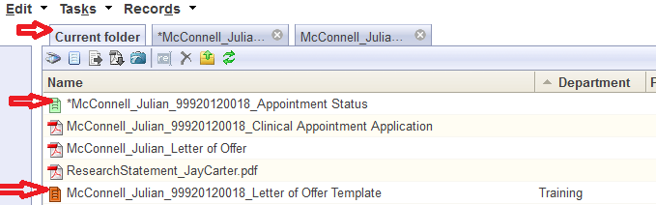

Re-create the Letter of Offer Template
If the Letter of Offer template is not there or if you deleted it, you may recreate the Letter of Offer Template by right-clicking on the Appointment Status template in the current folder and selecting Metadata from the drop down list.
In the right-most frame, put a check mark in the box beside the words ‘Generate Letter of Offer Template’. Click SAVE. The Letter of Offer template will appear in the Current Folder as a file with an orange icon and has a file name with the format ‘Lastname_Firstname_ApplicantID_Letter 0f Offer Template’. You may have to refresh the screen to see it.
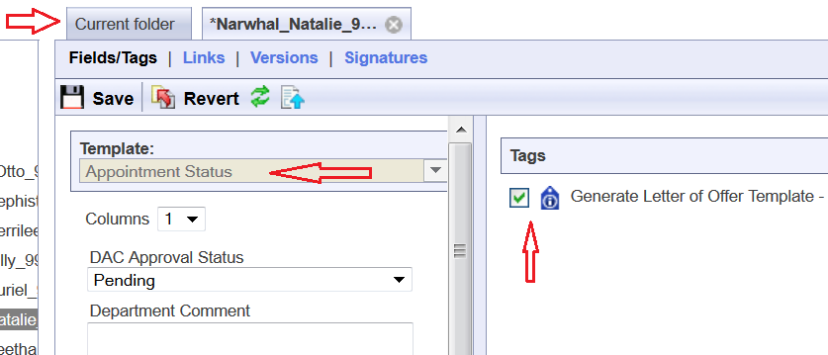
Once you can see the Letter of Offer template
- Open the Letter of Offer template in the Current Folder by right-clicking on it and selecting Metadata from the drop down list. Check that the Template title is for the correct appointment category.
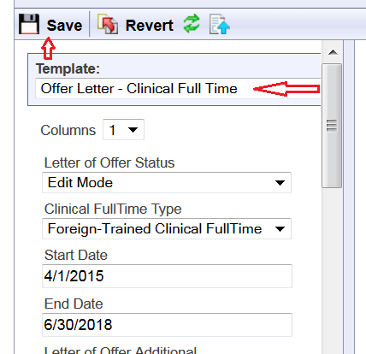
  - If it is not for the correct appointment type, first go back to the Candidate Information template by right-clicking on the dossier (yellow folder in the left-sidebar) and selecting Metadata from the drop down list. Change the Academic Appointment Category field to the correct category and Save. Only then, go back to the Letter of Offer template and using the drop down arrow beside the Template name select the correct Letter of Offer template and click Save.
- Fill in the fields in the Letter of Offer template. The fields vary per Academic Appointment Category.
  - Clinical Full Time Type is a field only in the Clinical Full Time Template. It allows you to indicate whether this letter will be for a regular full-time applicant, a foreign-trained full-time applicant, or a clinical full-time equivalent.
  - Start and End Dates: To ensure that appointment dossiers never get saved in LaserFiche without an End Date, an End Date has been automatically calculated from the current system date. This may be changed but all dates must adhere to accepted policy. If you are unsure of the date, select an estimated Start Date. This will likely need to be changed before the final version of the letter of offer is generated.
The same Start and End Date fields can be seen on the Candidate Information template. If you create a letter of offer with the Letter of Offer template, those date values will overwrite the date values in the Candidate Information template. The reverse process is not true.
  - Letter of Offer Additional allows for a department-specific paragraph of text in the letter. The text generally appears in the last paragraph of the first page of the letters. It has a maximum character count of 310 characters.
  - Offer Retraction Date: This is the date after which the offer of appointment to the applicant becomes invalid. If necessary, update this for the final version of the letter.
  - Chair Full Name: This is the same field that appears on the Candidate Information Template but here, it is allowed to add credentials after the name or to add a stand-in. The letter will show the value from this field. It will not overwrite the value in the Candidate Information Template
eg: Dr. Leonard Nimoy, MD, PhD
Dr. Leonard Hofstadter for Dr. Leonard Nimoy
  - Letter of Offer CC: Up to 4 names may be added to this field, each on separate lines. They will appear in the CC area of the letter.
  - Letter of Offer CC Email Addresses: If there are names in the Letter of Offer CC field above, it is necessary to add the associated email addresses in this field. This is a multi-value field, meaning that when one email address is typed in the box, a second box will appear to house the next one – do not type the email addresses all into one box as was done in the Letter of Offer CC field above.
If there is a Hospital Administrative Email address in the Candidate Information template, it is automatically added – there is no need to add it here.
  - Letter of Offer Enclosures: If you plan on sending additional material to the applicant along with the actual letter of offer, the titles of those documents can be mentioned here. Type them on separate lines in the one box.
Very Important Note: Typing text into this Letter of Offer Enclosures field simply adds the text to the letter of offer in the Enclosures area. It does not control whether those documents actually exist in the dossier nor does it tell LaserFiche to attach them to the Letter of Offer email.
Any documents mentioned in this field need to be uploaded to the dossier before the final version of the letter is sent AND, if LaserFiche is being used to send the Letter of Offer, the file names of these additional documents need to begin with the word Enclosure.
examples: Enclosure_DepartmentProfile
EnclosureAcademicPositionDescription
- Once the fields have been filled in, change the Letter of Offer Status field at the top of the template to Create Letter of Offer and click Save.
- Go back to the Current folder and refresh the screen. You will see a new pdf document has appeared in the dossier having a file name format of ‘Lastname_Firstname_ApplicantID_Letter of Offer’.
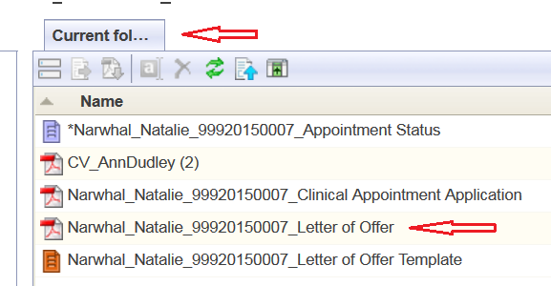
- Double click this pdf file to open it and review the letter.
Make Changes to a Letter of Offer:
If you need to make changes to the editable field values in a Letter of Offer (i.e. you want to change the appointment start date or change the mailing address) you need to change the field values in the templates in which the data is housed. The letter of offer workflow pulls field values from either the Candidate Information template or the Letter of Offer template. Look there to make your desired changes.
Once the changes have been made, and if it isn’t already opened, right-click on the Letter of Offer template and select Metadata to open it. Change the Letter of Offer status back to Create Letter of Offer and click Save. Go back to the Current Folder and refresh the screen. The revised Letter of Offer will have immediately overwritten the previous one.

Department Address Data:
The department address that appears in the footer of the first page of each letter of offer can be found in a field in the Department Information template. To edit the Department Address field follow the steps below. Note that the address MUST only be 3 lines.
- In the left-hand side bar right click on the department name and select metadata. The Department Information template will appear in the inner frame.
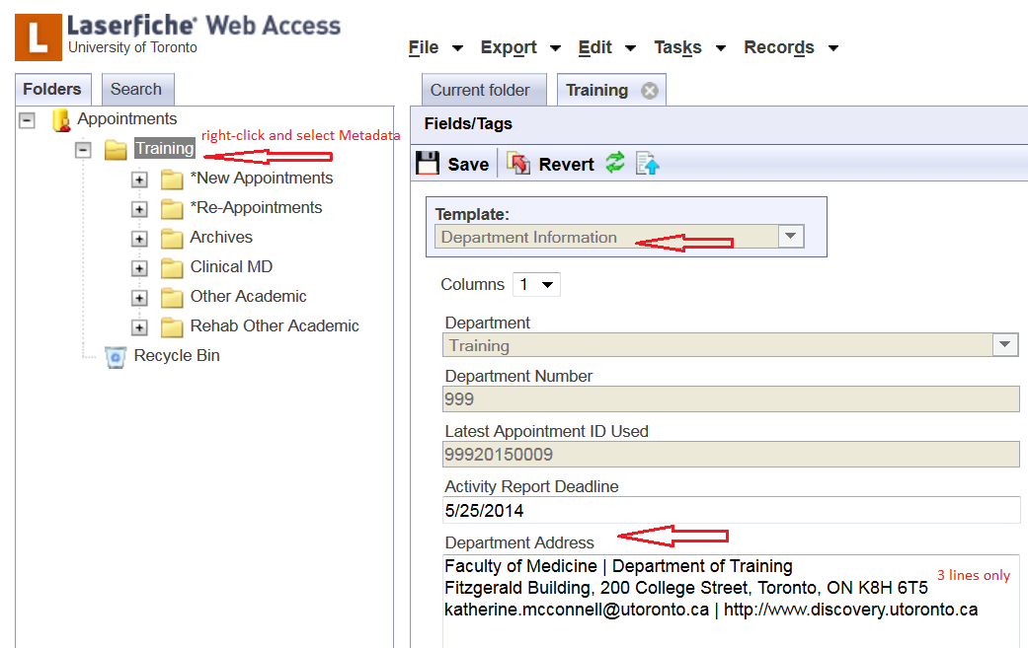
- Widen this frame so that the existing value in the Department Address field reveals that it is indeed 3 lines long.
- Edit the address, making sure it does not exceed 3 lines.
- Click Save.
- If necessary, go back to the Letter of Offer template, change the value of the Letter of Offer Status field to Create Letter of Offer, and click Save. This will re-create the letter of offer with the new address.

E-Mail Letters of Offer:
To send an e-mail with an attached Letter of Offer and, if desired, some additional attachments (enclosures) follow these steps below:
- Make sure that a Letter of Offer is in the dossier and that it is named in the format Lastname_Firstname_ApplicantID_Letter of Offer
- Make sure that any Enclosures you wish to send with the Letter of Offer and/or are mentioned in the Letter of Offer Enclosures field, exist within the dossier AND that their file names begin with the word Enclosure.
examples: Enclosure_DepartmentProfile, EnclosureAcademicPositionDescription, etc.
Important Notes on Enclosures:
  - The letter of offer itself does not need to have word Enclosure at the beginning of the file name.
  - Any file beginning with the word Enclosure will be picked up and attached to the Letter of Offer email regardless of whether or not it is mentioned in the Enclosures field in the Letter of Offer template.
- Make sure that the e-mail address for the candidate is correct in the Candidate Email Address field in the Candidate Information template. You can view and edit this Candidate Information template by right-clicking on the candidate’s name (yellow folder) in the left sidebar and selecting metadata.
- Once again, open the Appointment Status template (purple icon) by right-clicking and selecting Metadata. Scrolling down to the bottom of the template shows a previously invisible field titled “Email Letter of Offer to Candidate. This field only becomes visible when the application receives final approval.
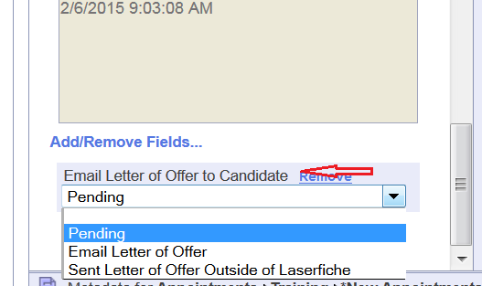
- Select Email Letter of Offer, and up at the top of the template, click Save. An email will be sent to the candidate with the letter of offer and any files beginning with the word Enclosure attached.
The email will be automatically copied to the department coordinator, to any email addresses in the Letter of Offer CC Email Addresses field, and, if there is an email address in the Hospital Administrative Email field in the Candidate Information template, to the hospital coordinator.

