LaserFiche Instructions:

Rehab Post-DAC Review and Submission to HR for Status-Only and Adjunct Lecturer Appointments

Following the Department Appointments Committee (DAC) review each dossier’s Appointment Status template should show a DAC Recommendation of either “Yes” or “No”.

DAC Recommendation = No

The DAC Chair should discuss the outcome with the Department Chair to receive support in the decision and notification should be provided to the candidate.

DAC Recommendation = YES

The DAC Chair should discuss all outcomes with the Department Chair and receive support in the decisions.

Status-Only applicants require confirmation and approval of the appointment from their primary employer, indicating that the employer agrees to the Status-Only appointment and that the applicant is employed with that institution.

Upon receipt of written confirmation from the employer, the Department Coordinator may proceed in submitting the application for HR review and Dean approval.

Submission of Application to HR

Chair’s Letters

Chair’s Letters are standard for all Status-Only or Adjunct Lecturer appointments and will automatically be generated at the same time an offer letter is created (using the instructions below). The type of Chair’s letter generated will correspond with the appointment type available in the Candidate Information Template. The content of the letter is based on the Department Appointments Committee (DAC) criteria selection for appointment.

Letters of Offer

Letters of Offer are standard for most Status-Only or Adjunct Lecturer appointments. Unless there are exceptional circumstances, it is required to generate offer letters using LaserFiche. Where exceptions are required and a unique letter is necessary, Departments still have the option to create their own letter and upload it into LaserFiche.
Departments also have the option of having LaserFiche send the Letter of Offer to the applicant attached to an email, or of sending it to the applicant themselves. Again, unless there are special circumstances, using LaserFiche to send the letter is the preferred method.
Creating letters and sending letters are two different functions in LaserFiche and the choice of which way to go in each case is independent of the other choice.
Letters of Offer generated by LaserFiche are personalized to the applicant with field values from both the Candidate Information template and the Letter of Offer template. The Letter of Offer templates are unique to each appointment category. When the Letter of Offer Status field in the Letter of Offer template is changed to Create Letter of Offer and is saved, the template runs a workflow which inserts the personalized data into the appropriate letter template. The completed letter will appear in the Current Folder. You may need to refresh the screen to see it. A portion of the content in the letter is based on the Department Appointments Committee (DAC) criteria selection for appointment.
Letters of Offer are reviewed in Human Resources before the appointment is approved so it is necessary to have an initial version of the letter in the dossier before the dossier status is changed to ‘DAC Approved’. It will very likely be necessary to make some minor changes in the letter after the application receives approval from the Dean’s office and before it is sent to the candidate. This is a very simple procedure, requiring only that the relevant fields in the templates be updated, the Letter of Offer field be reset to Create Letter of Offer, and the letter of offer template be saved again. This regenerates the letter and overwrites the earlier one.
If Letters of Offer are going to be sent automatically by LaserFiche, the file name for the letter must be in this format: ‘Lastname_Firstname_ApplicantID_Letter 0f Offer’.

Generate Letters of Offer (Using LaserFiche Web Access):

A Letter of Offer template is automatically created in the current folder of the dossier.

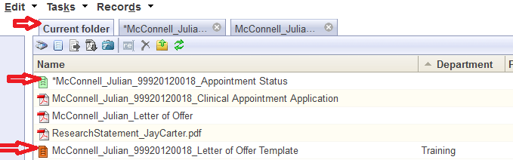

Re-create the Letter of Offer Template
If the Letter of Offer template is not there or if you deleted it, you may recreate the Letter of Offer Template by right-clicking on the Appointment Status template in the current folder and selecting Metadata from the drop down list.
In the right-most frame, put a check mark in the box beside the words ‘Generate Letter of Offer Template’. Click SAVE. The Letter of Offer template will appear in the Current Folder as a file with an orange icon and has a file name with the format ‘Lastname_Firstname_ApplicantID_Letter 0f Offer Template’. You may have to refresh the screen to see it.
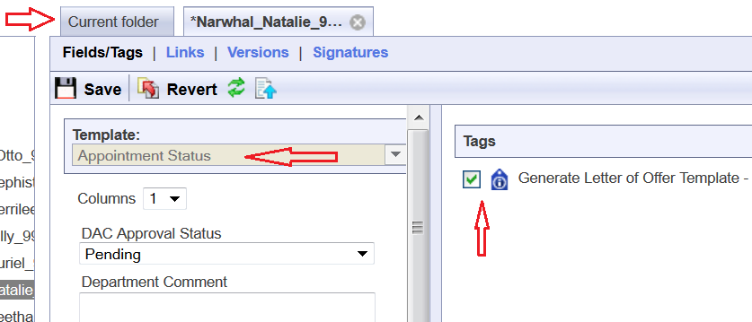
Once you can see the Letter of Offer template:
- Open the Letter of Offer template in the Current Folder by right-clicking on it and selecting Metadata from the drop down list. Check that the Template title is for the correct appointment category.
  - If it is not for the correct appointment type, first go back to the Candidate Information template by right-clicking on the dossier (yellow folder in the left-sidebar) and selecting Metadata from the drop down list. Change the Academic Appointment Category field to the correct category and Save. Only then, go back to the Letter of Offer template and using the drop down arrow beside the Template name select the correct Letter of Offer template and click Save.
- Fill in the fields in the Letter of Offer template. The fields vary per Academic Appointment Category.
  - Name Prefix: Ensure the prefix is accurate for the candidate.
  - Start and End Dates: To ensure that appointment dossiers never get saved in LaserFiche without an End Date, an End Date has been automatically calculated from the current system date. This may be changed but all dates must adhere to accepted policy.
The same Start and End Date fields can be seen on the Candidate Information template. If you create a letter of offer with the Letter of Offer template, those date values will overwrite the date values in the Candidate Information template. The reverse process is not true.
  - Chair Full Name: This is the same field that appears on the Candidate Information Template but here, it is allowed to add credentials after the name or to add a stand-in. The letter will show the value from this field. It will not overwrite the value in the Candidate Information Template
eg: Dr. Leonard Nimoy, MD, PhD
Dr. Leonard Hofstadter for Dr. Leonard Nimoy
- Once the fields have been filled in, change the Letter of Offer Status field at the top of the template to Create Letter of Offer and click Save.
- Go back to the Current folder and refresh the screen. You will see a new pdf document has appeared in the dossier having a file name format of ‘Lastname_Firstname_ApplicantID_Letter of Offer’.
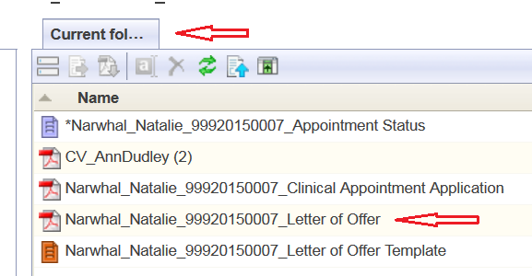
- Double click this pdf file to open it and review the letter.
Make Changes to a Letter of Offer:
If you need to make changes to the editable field values in a Letter of Offer (i.e. you want to change the appointment start date or change the mailing address) you need to change the field values in the templates in which the data is housed. The letter of offer workflow pulls field values from either the Candidate Information template or the Letter of Offer template. Look there to make your desired changes.
Once the changes have been made, and if it isn’t already opened, right-click on the Letter of Offer template and select Metadata to open it. Change the Letter of Offer status back to Create Letter of Offer and click Save. Go back to the Current Folder and refresh the screen. The revised Letter of Offer will have immediately overwritten the previous one.

Department Address Data:
The department address that appears in the footer of the first page of each letter of offer can be found in a field in the Department Information template. To edit the Department Address field follow the steps below. Note that the address MUST only be 3 lines.
- In the left-hand side bar right click on the department name and select metadata. The Department Information template will appear in the inner frame.
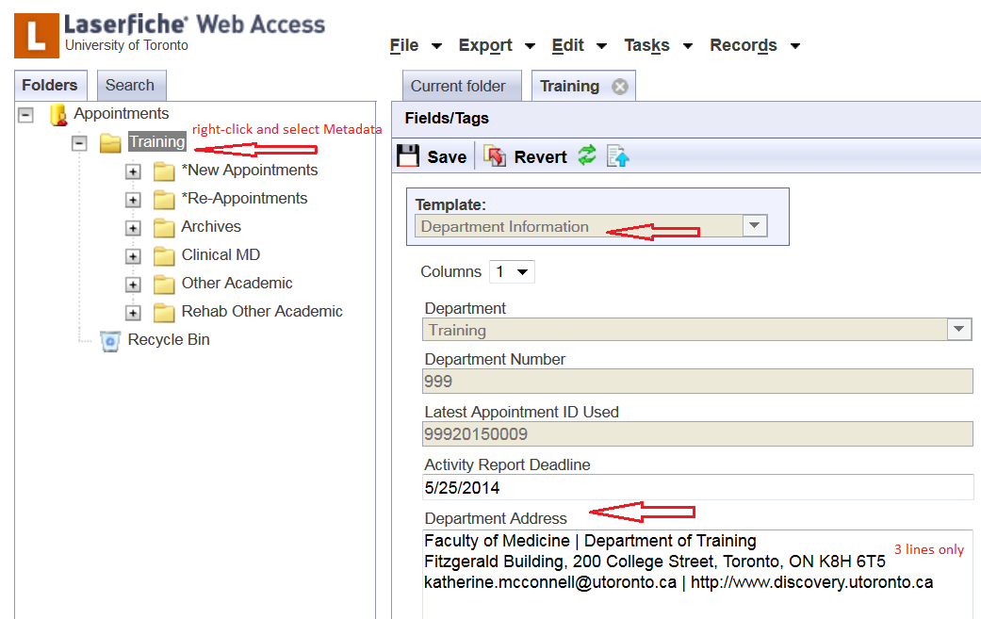
- Widen this frame so that the existing value in the Department Address field reveals that it is indeed 3 lines long.
- Edit the address, making sure it does not exceed 3 lines.
- Click Save.
- If necessary, go back to the Letter of Offer template, change the value of the Letter of Offer Status field to Create Letter of Offer, and click Save. This will re-create the letter of offer with the new address.

Submission to HR

Confirm first whether you are submitting a Status-Only or Adjunct Lecturer appointment.

Appointment Status Template:

- Open the Appointment Status template in the Current Folder by right-clicking on it and selecting Metadata from the drop down list. This is the same template that the DAC recording their recommendation and list of Areas of Responsibility applicable to the candidate.

- If the application is for a Status-Only candidate, indicate whether the Employing Institute has provided written confirmation that they permit the appointment using the dropdown options (Yes/No).

By selecting “yes” the Department confirms that they have received a document from the primary employer of the Status-Only applicant indicating that the employer agrees to the Status-Only appointment and that the applicant is employed with that institution.

- When the application is considered complete and ready for review by HR and the Dean, set the DAC Approval Status to “Approved”.
- Click “Save”. HR will now be notified that there is an application for review.

E-Mail Letters of Offer:

Letters of offer can only be sent in LaserFiche once the dossier has been approved by HR and/or the Dean’s Office. The Department Coordinator will receive an email confirmation of approval for each dossier approved by HR and/or the Dean.

To send an e-mail with an attached Letter of Offer and, if desired, some additional attachments (enclosures) follow these steps below:
- Make sure that a Letter of Offer is in the dossier and that it is named in the format Lastname_Firstname_ApplicantID_Letter of Offer
- Make sure that any Enclosures you wish to send with the Letter of Offer and/or are mentioned in the Letter of Offer Enclosures field, exist within the dossier AND that their file names begin with the word Enclosure.
examples: Enclosure_DepartmentProfile, EnclosureAcademicPositionDescription, etc.
Important Notes on Enclosures:
  - The letter of offer itself does not need to have the word Enclosure at the beginning of the file name.
  - Any file beginning with the word Enclosure will be picked up and attached to the Letter of Offer email regardless of whether or not it is mentioned in the Enclosures field in the Letter of Offer template.
- Make sure that the e-mail address for the candidate is correct in the Candidate Email Address field in the Candidate Information template. You can view and edit this Candidate Information template by right-clicking on the candidate’s name (yellow folder) in the left sidebar and selecting metadata.
- Once again, open the Appointment Status template (purple icon) by right-clicking and selecting Metadata. Scrolling down to the bottom of the template shows a previously invisible field titled “Email Letter of Offer to Candidate. This field only becomes visible when the application receives final approval.
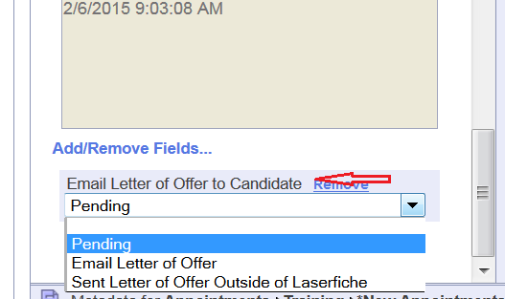
- Select Email Letter of Offer, and up at the top of the template, click Save. An email will be sent to the candidate with the letter of offer and any files beginning with the word Enclosure attached.
The email will be automatically copied to the department coordinator.

Under unusual circumstances it may be necessary to send a Letter of Offer outside of LaserFiche. If this occurs, it is suggested that it is recorded in LaserFiche by selecting Send Letter of Offer Outside of LaserFiche and clicking Save. This will make a note of the date the letter was sent in the History field.

