

**FACULTY PROMOTIONS**

**The Senior Academic Promotions Process in LaserFiche**

DPC Administrator’s Guide

Discovery Commons

Last updated June 20, 2025

Contents

Quick Reference to Promotions Websites 3

Changes and/or Important Information for the Senior Promotions process for June 2025 – IMPORTANT PLEASE READ 4

Logging in to the Academic Promotions System (LaserFiche Web Access) 5

Adding your Department’s Promotion Details to LaserFiche 5

Creating a Candidate’s Dossier 8

Outcomes of submitting the Promotion Candidate Dossier creation form 9

Sample email sent to candidate when Promotion Candidate dossier creation form is submitted 10

Submitting Documents to Dossier 11

Outcomes of Document Submission 13

Dossier Subfolders 14

Progressing Through the Promotions Approval Process 15

To view or update the approval status of a candidate’s dossier: 16

Approval Status Descriptions 17

1. Potential Candidate 17

2. DPC Preliminary Candidate 18

3. DPC Additional Info Required 19

*4. Referee Review* 20

*NEW! Sharing Files with Referees Using Direct Share 21

Collecting and Reviewing Reference and Student Letters 24

6. DPC Review (Departmental Promotions Committee Review) 25

7. DPC Recommended (Irreversible) 27

8. DPC Withdraw (Irreversible) 28

Deferral Documents 29

Obtaining Reference Letters during Decanal Review 29

Appendix A: Summary of Dossier Status Permissions 31

Appendix B: Summary of Metadata Templates 32

Appendix C: Block Laserfiche from Asking for Template Data when Uploading Documents 33

Appendix D: Turn Off Zipping of Direct Share Documents 35

Appendix E: Re-create the Candidate Information Document 36

Appendix F: Email Documents Directly from LaserFiche 36

Appendix G: Glossary of Terms 38

Appendix H: Troubleshooting and FAQs 41

# Quick Reference to Promotions Websites

* **Promotion Candidate Dossier creation form:**  
  [https://documents.medicine.utoronto.ca/Forms/PromoCandidate#](https://documents.medicine.utoronto.ca/Forms/PromoCandidate)
* **LaserFiche Web Access**  
   [https://documents.medicine.utoronto.ca](https://documents.medicine.utoronto.ca/)   
  (The main site where you will manage the Promotions process and store documents.)
* *Be sure to select* ***FacMedPromotions*** *under Repository*
* Department Coordinators will sign in with their UTORid preceded with ad\  
  ex. Ad\smithp44 password = *UTORid password*
* **Read-Only Portal**  
  <https://documents.medicine.utoronto.ca/weblink>   
  (The website where read-only committee members (department promotions committee members and decanal committee members) can view the contents of the dossiers. Their UTORids must have been provided to MedIT first for inclusion in the Grouper groups.
* **Candidate Document Submission form**   
  <https://documents.medicine.utoronto.ca/forms/candidatesubmission>#  
  (This can be used by the DPCAdmin and by the Candidates to submit documents. Submissions are saved into the appropriate dossier category subfolders.)
* **Letter of Reference – External Referees form**  
   <https://documents.medicine.utoronto.ca/forms/externalreferee>  
  (This can be used by DPCAdmins and External Referees to submit reference letters)
* **Letter of Reference – Internal Referees form**  
   <https://documents.medicine.utoronto.ca/forms/internalreferee>  
  (This can be used by DPCAdmins and Internal Referees to submit reference letters)
* **Student Letters form**  
   [https://documents.medicine.utoronto.ca/forms/StudentLetters#](https://documents.medicine.utoronto.ca/forms/StudentLetters)  
  (This can be used by DPCAdmins and Students to submit student letters)

# Changes and/or Important Information for the Senior Promotions process for June 2025 – IMPORTANT PLEASE READ

1. You will continue to use the Promotion Candidate Dossier creation web form to create dossiers. You **do not** need to send a list of these candidates to MedIT so Referee groups can be created for them in Grouper.
2. Departmental Promotions Committee members will continue to log in to the **Read-only Portal** using UTORids preceded by ad\ (ex: ad\smithp44).  
     
   Read-only Portal: <https://documents.medicine.utoronto.ca/weblink>   
     
   **Task Reminder!** The UTORids of departmental promotions committee members must still be given to MedIT at least 3 - 4 days prior to any work needing to be done by these faculty so they can be added to your departmental group in Grouper.
3. **Referees will not log in to the Read-only Portal at all**. Instead, you may use a new LaserFiche function called Direct Share to share documents with Referees. It functions similar to ShareFile. See section below on Referees.
4. To accommodate Direct Sharing without risking a privacy breach during sharing with referees, ‘Read’ access to External and Internal Referee Letters and Student Letters has been removed for department coordinators. Instead, you will receive copies of all reference letters submitted by the reference letter web forms.
5. There is a new field on the Promotion Candidate Information template that is similar to, but not the same as the Basis for Promotion field that appears on the initial web form and whose values are captured on the Promotion Candidate Information template.  
     
   This field is called **Department-approved Promotion Pathway**. This field must be completed after the DPC (department promotions committee) has approved the promotion and approved the pathway for promotion. It must have a value before the DPC Current Status can be rolled over to 7. DPC Recommended (Irreversible). If you attempt to change the DPC Current Status to 7 without filling in this field, the process won’t occur and you will receive an email informing you of the error and how to fix it.

# Logging in to the Academic Promotions System (LaserFiche Web Access)

LaserFiche Web Access is your main administrative site for FacMedPromotions. Supported web browsers are Firefox, Chrome, and Edge. Please note that the Safari browser is not supported – opening LaserFiche Web Access on a full version of Safari on an Apple desktop often works well but functionality may be compromised on Apple tablets.

<https://documents.medicine.utoronto.ca>

It is a good idea to add this URL in your browser’s favorites to save you from entering it in every time you would like to access the Academic Promotions system.

* At the log in page select the repository ‘FacMedPromotions’.
* Sign in with your UTORid preceded with ad\  
  ex. ad\smithp44 password = *UTORid password*

# Adding your Department’s Promotion Details to LaserFiche

**Note:** This section (2 pages) can be skipped altogether or filled in after you have created dossiers for your promotion candidates in the next section.

Every department within the Temerty Faculty of Medicine has their own folder in the FacMedPromotions repository. When you log in you will only see your own department folder. This folder will hold the dossiers for your department’s promotion candidates. Information specific to the department (not to the candidate), such as the Department Promotion Committee (DPC) member’s email addresses and various submission deadlines, can be entered into the metadata for the department folder.

To enter your departmental metadata, in left-hand panel of the LaserFiche window expand the “Active Promotions” folder by clicking the **>** sign beside it. Click on your department’s folder to highlight it (in the illustration below, the department name is Training). The right-hand panel will default to the Fields tab and will show the template called ‘Department Information’. It is not mandatory that you fill in the fields in the Department Information template. You may fill them in or revise them at a later date.

LaserFiche Web Access

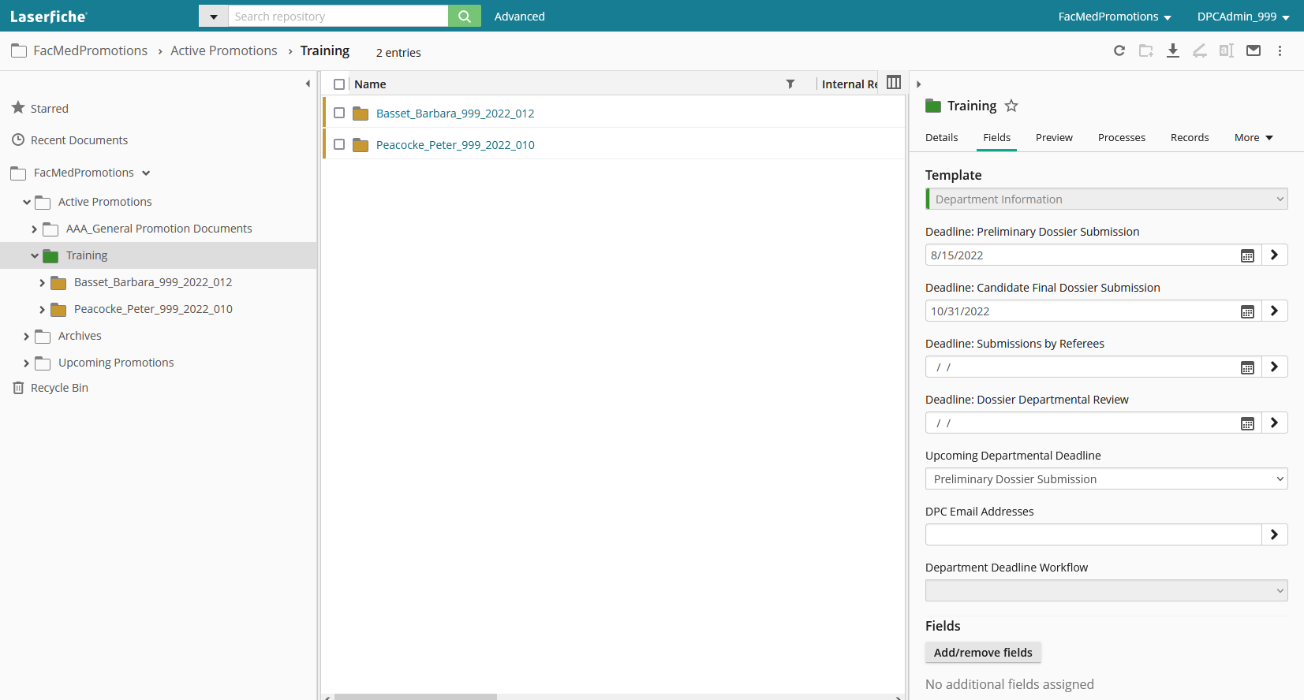

Department Highlighted

|  |  |
| --- | --- |
|  | For each of the deadline fields, click the calendar icon beside each field. Choose a date relevant to the deadline indicated. If the particular deadline is not yet determined, you may leave the field(s) blank. If filled in, these deadline dates are referenced and inserted into email messages that are sent out, but they do not control any functions or permissions associated with a change in the dossier status.  Further down you will see a field for DPC Email Addresses. This is a multi-valued field, meaning that when you enter data into the first blank text box, an additional blank text box will appear. This allows a user to enter as many DPC email addresses as there are members of your Departmental Promotions Committee. LaserFiche will use these addresses when sending email alerts when each candidate’s dossier is ready for review by the committee.  If you are using this feature, these email addresses must be filled in before changing a dossier’s status to 6. DPC Review. |

When you are satisfied with the information you entered, click on “Save” near the bottom of the template. If you do not see the Save button at the bottom of the template it is because you have not made any changes to the template that require saving.

# **Creating a Candidate’s Dossier**

Create a Promotion Candidate Dossier by completing the web form found here:

* [https://documents.medicine.utoronto.ca/Forms/PromoCandidate#](https://documents.medicine.utoronto.ca/Forms/PromoCandidate)

**The web form contains the following fields:**

|  |  |
| --- | --- |
| **Field names:**  *Required fields | **Field values and notes:** |
| **Department\*** | Primary department in the Temerty Faculty of Medicine  Only primary departments will manage the Promotion processes.   * Select department from drop down list |
| **Candidate Lastname\*** | Surname or Family Name as it appears in FOCUS or HRIS |
| **Candidate Firstname\*** | Please do NOT include nicknames or brackets |
| **Personnel Number\*** | Cannot contain leading zeros or letters |
| **Candidate Email Address\*** | Use a departmental email address if you do not want the candidate to be notified immediately of the promotion candidate dossier creation. This email address can be changed later. |
| **Candidate Gender** | * Female | Male | Other |
| **Appointment Type\*** | * Select from drop down list   *(Note: If Appointment Type value selection is Teaching Stream, Tenure, Contractually Limited Term, or Non-clinical Part-time; then the Primary Employment Arrangement field is not required and will not be displayed.)* |
| **Appointment Date\*** | The date the candidate began an academic appointment at the University of Toronto. This may be found in FOCUS or HRIS |
| **Cross Appointment(s)** | (if applicable) |
| ***Primary Employment Arrangement\**** | * Select from drop down list (This field and those below are not visible if your candidate is Tenured, Teaching Stream or CLTA as those individuals work for U of Tm by default. |
| ***Affiliated Hospital\**** | * Select from drop down list |
| ***Research Institute\**** | * Select from drop down list |
| ***Other Employment Arrangement\**** | Text field |
| **Current Rank\*** | * Select either Assistant Professor or Associate Professor from drop down list |
| **Start Date of Current Rank\*** | This may be found in FOCUS or HRIS |
| **Proposed Rank\*** | * Select either Associate Professor or Professor from drop down list |
| **Basis for Promotion Checkboxes** | (check all that apply)   * Competence in CPA * Competence in Research * Competence in Teaching Education * Excellence in CPA * Excellence in Research * Excellence in Teaching Education * Administrative Service |
| **Review Submission\*** | Please review submission for completeness and accuracy then check the box below.   * Submission Reviewed   When checked, the Personnel Number field will disappear from this form but it will be saved in the database. |

## 

## Outcomes of submitting the Promotion Candidate Dossier creation form

1. A new promotion candidate folder (dossier) will be automatically created for this candidate in LaserFiche Web Access. The dossier can be found by expanding the folder titled Active Promotions (by clicking the **>** sign next to it) and then expanding the department folder (by clicking the **>** sign next to it).

This folder name has the following format: Lastname_Firstname_PromotionID

The candidate folder will have an associated ‘Promotion Candidate Information’ template which can be found by highlighting the dossier on the left and viewing the template on the right. The values submitted on the web form are saved to the fields on the template.

1. A snapshot of the submitted form and is created and saved in the candidate folder as a PDF file. The file is named CandidateInformation_Lastname_Firstname_PromotionID. See Appendix G for instructions on how to re-create this form if data in the Candidate Information template is changed or updated.
2. A folder called ‘Dossier’ will be created inside the candidate’s folder and within it, all possible subfolders for each document category. These subfolders will be visible to promotions committee members even if they are empty. They can be deleted by department coordinators if you do not want them. If deleted, they can be re-created by submitting a document using the candidate submission form <[*https://documents.medicine.utoronto.ca/forms/candidatesubmission#*](https://documents.medicine.utoronto.ca/forms/candidatesubmission%23)> and selecting the correct document category on the form.  
     
   The purpose of pre-creating these subfolders is to allow you to bulk upload documents directly into the subfolders without having to submit the document submission form, while at the same time strictly maintaining the various permissions assigned to each subfolder (see **Appendix C** for instructions on how to bulk upload).
3. A **Promotion ID** has been created for this candidate.  
   The Promotion ID is a unique number created for each candidate. It will be used to enter all subsequent documents into the candidate’s dossier. It has the format below:

<Department Number>_<Year>_<Incremental Number>

(For example, for promotion year 20xx, the Promotion ID for the department of Training could be: 999_20xx_004.  
  
The Promotion ID is always the number you see after the Lastname_Firstname portion of the candidate’s dossier name. It can also be found at the bottom of the ‘Promotion Candidate Information’ template (see previous note 1).

1. Once a candidate dossier has been created, the DPC Administrator, the candidate and selected referees can submit documents to the dossier, depending on the status (DPC Current Status) of the dossier within the workflow. Dossier Status is explained later in this manual.
2. Immediately after the DPC Administrator creates the dossier (by submitting the Promotion Candidate dossier creation form), the candidate will receive an automated email message indicating that the academic promotion dossier has been created. The email provides instructions on how to submit documents to the dossier. The candidates and, later, the referees, cannot see or manage the submitted documents, but they will receive email confirmation when they submit a document.

### Sample email sent to candidate when Promotion Candidate dossier creation form is submitted

|  |
| --- |
| **Subject:** *Promotion Candidate Dossier Created for <Firstname Lastname>*  Dear <Firstname Lastname>  I am pleased to inform you that a Promotion Dossier has been established for you in our records management system and is ready to accept your promotion documents. Please note that documents must be in PDF file formats.  You may upload your documents by accessing the online candidate submission form:  https://documents.medicine.utoronto.ca/forms/candidatesubmission  You will be asked to enter your Promotion ID, select a document category, and browse to upload your documents.  Your Promotion ID is: ###_####_###  Please contact your Department Promotion Committee administrator if you have any questions or concerns, at <**Department Coordinators Email**>.  Thank You.  **Academic Promotions | Temerty Faculty of Medicine University of Toronto** |

**Important Tip:** If the department coordinator does not want the candidate to receive this email then, when first submitting the Promotion Candidate Dossier creation form, use a departmental email address in the candidate’s email address field.

# Submitting Documents to Dossier

Once a dossier has been created, both DPC Administrators and candidates can use the same web form to submit documents into the dossier. Alternately, DPC Administrators can upload documents directly into LaserFiche Web Access.

[https://documents.medicine.utoronto.ca/forms/candidatesubmission#](https://documents.medicine.utoronto.ca/forms/candidatesubmission%23)

Users will likely submit this form several times. Using the web form to submit documents allows LaserFiche to collate documents into several different category subfolders in a candidate’s dossier.

Document category subfolders include:

* Administrative Service
* Creative Professional Activity
* Curriculum Vitae
* External Assessments
* Internal Assessments
* Reporting Letters
* Research
* Student Letters
* Teaching and Education

The user may submit documents one-by-one or attach multiple documents to the form. All documents attached to one submission of the form must belong to the same category as they will be loaded into the same subfolder.

1. Go to [https://documents.medicine.utoronto.ca/forms/candidatesubmission#](https://documents.medicine.utoronto.ca/forms/candidatesubmission%23)
2. Fill in the fields and upload (attach) documents from one category. Click Submit
3. If the documents are successfully uploaded, the submitter will receive an email confirming the upload. And the department coordinator should see them in the candidate’s dossier.

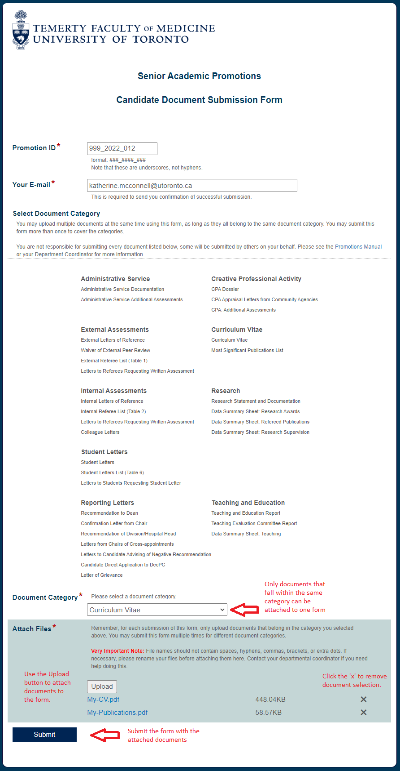

## Outcomes of Document Submission

* Whether or not FacMedPromotions will accept the documents coming in from a web form is entirely dependent on the current status of the dossier. See *Progressing through the Promotions Approval Process* on page 15.
* If the document submission was successful, an email notification is sent out to the person submitting a web form (*Your Email* field on the web form) confirming this. The message is as follows:

|  |
| --- |
| **Subject:** *Promotion Document Successfully Uploaded*  Dear Promotion Candidate,  I am pleased to inform you that the upload of your document(s) to your Promotion Dossier 999_xxxx_xxx was successful.  Document Type: <*Document Category*>  NOTE: Candidates cannot see the list of documents in their Promotion Dossiers. You will receive emails, such as this one, notifying you about the success or otherwise of your document uploads.  Please consult your Department Promotion Administrator if you have any questions or concerns. You may reach them via email at the address <Department Coordinators Email>.  Thank You.  **Academic Promotions | Temerty Faculty of Medicine**  **University of Toronto** |

If the document submission is not successful, the submitter will receive the following email.

|  |
| --- |
| **Subject:** *Promotion Document Submission Unsuccessful*  Dear Promotion Candidate,  You have recently attempted to submit documents to your Promotion Dossier, and although we did receive the web form, there has been an error uploading the document(s). Document Category = <Document Category>  At your earliest convenience, please resubmit your document(s) by accessing a new web submission form located at:  https://documents.medicine.utoronto.ca/forms/candidatesubmission#  There are several reasons why this upload may have failed.  a. The most likely reason is that you were working with a cached instance of the webform. This means your browser was holding values from an earlier submitted instance of the web form. You may clear a browser cache for a site by entering Ctrl and F5 on your keyboard at the same time or by closing all browsers windows before returning to the site.  b. The name of your file may contain spaces, commas, extra periods, brackets or other unprocessible characters. You can try renaming the file at its source and upload it again. If you need help renaming a file, please contact the department coordinator.  c. You may have opened the file after having attached it to the submission form. This sometimes disrupts the attachment of the file to the form. Please fill out the form again and re-select your file.  d. Your computer, or your network may not allow you, for security purposes, to upload documents to internet sites. This is true of some hospital supplied computers or computers in hospitals. Please discuss this with your hospital or institution's own IT personnel.  If this issue continues, we suggest that you try using a different computer at a different site. Alternately you may email your documents to your Department Promotions Administrator at <Department Coordinators Email>.  Thank You.  **Academic Promotions | Temerty Faculty of Medicine**  **University of Toronto** |

# Dossier Subfolders

Every promotion candidate dossier created by submitting the Promotion Dossier Creation web form contain several subfolders, primarily a ‘Dossier’ subfolder, and a ‘Summary of Submissions’ subfolder.

The **Dossier** subfolders will house all documents subsequently uploaded using the document submission web form in the appropriate document category subfolder. If a subfolder for that category is not present, one will be created upon submission of the document submission web form with that category chosen. These subfolders have different permissions associated with them.

The **Summary of Submissions** subfolder contains shortcuts to all the documents in the dossier subfolders. It is used by some read-only portal users as a more convenient way of viewing documents without having to open all the subfolders. If a document is submitted, either via a web form, or by direct upload, a shortcut to it will be created immediately. If the actual file in the Dossier subfolder is deleted then the shortcut to that file in the Summary subfolder will be automatically deleted.

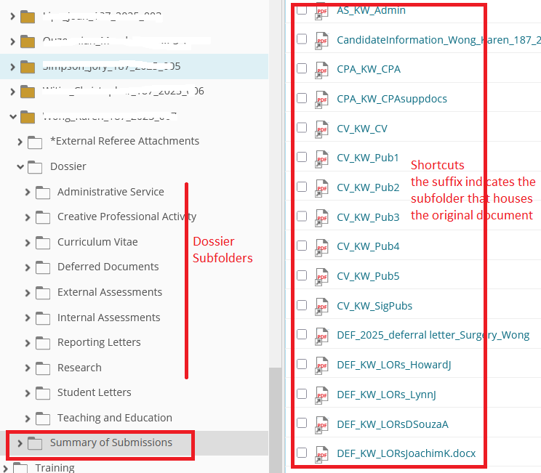

# Progressing Through the Promotions Approval Process

A dossier can be in any one of several phases (DPC Current Status) in the promotion process. The change to a given status can assign or remove user permissions or initiate a task. Examples include sending notifications to DPC (departmental promotions committee) members to review a dossier, approving a candidate to move forward to the decanal committee, or withdrawing a candidate completely from the promotion process while retaining a history of their application.

## To view or update the approval status of a candidate’s dossier:

* Highlight the candidate’s folder in the left-hand panel and put a check mark beside the Dossier Status and Comments page in the center panel. The Promotion Status template will open in the right-hand panel (see illustration below). Be sure the Fields tab is selected in the right-hand panel.

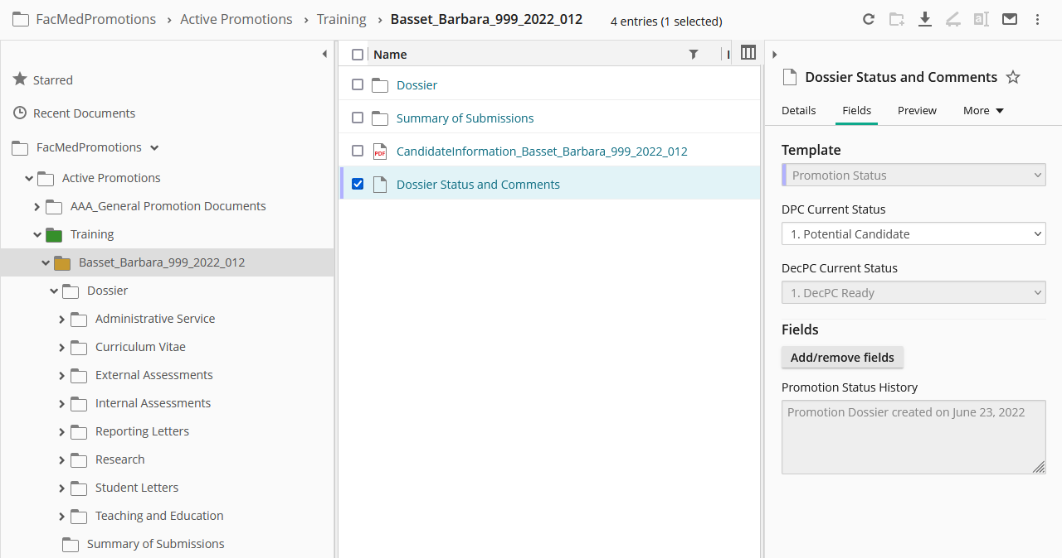

2

3

1

* Under DPC Current Status, select the desired Status and click Save. Note the Save button only becomes visible if you have made a change to the selection in this drop-down list.

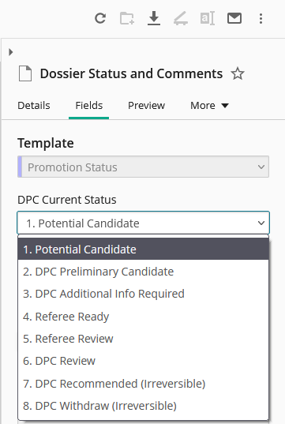Although there are 16 possible phases (dossier statuses) in the promotion process, DPC Administrators only have to concern themselves with seven. They are as follows:

1. Potential Candidate
2. DPC Preliminary Candidate
3. DPC Additional Info Required
4. Referee Review
5. Referee Review
6. DPC Review
7. DPC Recommended (Irreversible)
8. DPC Withdraw

See below for a description of, and the requirements of each status.

## Approval Status Descriptions

**Important:** Read the descriptions of each status **BEFORE** saving a change. The workflow that triggers the change to the new status may require certain data that may or may not be present in the templates.

**It is the change from one status to another that triggers the desired activity, not the status itself.**

### 1. Potential Candidate

This status is the default that is set when a candidate dossier is first created in the Academic Promotions system. When a dossier is created, the candidate is automatically notified by email of the creation of the dossier, and is given instructions how to submit documents to the dossier folder (see sample email on page 10).  
  
The permission on the dossier is configured to accept submissions from the web form. You may revert to this status at any time prior to the selection of status 7. DPC Recommended (Irreversible) or 8. DPCWithdraw (Irreversible).

Committee members are able to see documents in the read-only portal at this status.

### 2. DPC Preliminary Candidate

If your department does not do formal preliminary reviews of the candidates, where only selected members of the DPC review a dossier specifically assigned to them, this step can, and should, be skipped.

Changing the status to 2 DPC Preliminary Candidate will trigger the application to send an email notification to the one or two DPC members *specifically assigned* to do a preliminary review of this specific candidate. The email addresses of these assigned DPC members would need to have been added to the candidate’s ‘Promotion Candidate Information’ template **PRIOR** to selecting this status.  
  
To add these email addresses and proceed with this status:

* Highlight the main dossier for a candidate in the left panel.
* In the right panel, ensure the Fields tab is selected to display the ‘Promotion Candidate Information’ template. Scroll down the list of fields and fill in the assigned DPC Members emails in the field titled ‘DPC Assigned Email Addresses’. Click Save.
* In the centre panel, checkmark the box beside the **Dossier Status and Comments**.
* In the Promotion Status template on the right panel, change the status from ‘1. Potential Candidate’ to ‘2. DPC Preliminary Candidate’ and click Save.  
    
  The email message sent to the ‘assigned’ DPC members looks like this:

|  |
| --- |
| **Subject:** *Candidate Dossier Ready for Your Review*  **Message:**  Dear Departmental Review Committee Member,  You have been selected to perform a preliminary review of the Promotion Dossier of a potential senior promotion candidate from your department.  Candidate’s Name: <Candidate First and Last Name>  Current Rank: <Current rank>  Proposed Rank: <Proposed rank>  To access the Candidate’s promotion dossier, please follow this link:  https://documents.medicine.utoronto.ca/weblink  username = ad\utorid (ex: ad\smithp44)  password = utorid password  Please contact your Department Promotions Administrator at <Department Coordinators Email> for further information and support.  Thank You.  **Academic Promotions | Temerty Faculty of Medicine**  **University of Toronto** |

### **3. DPC Additional Info Require**d

Selecting this status indicates either that a candidate has been preliminarily approved and you are now requesting more documentation **OR that** this candidatedid not require preliminary approval but you want to remind them to complete the submission of their documents.

Changing to this status and clicking Save will send an email notification to the candidate requesting that they submit any documents they have not yet supplied. So the status change to this step may be used as a reminder to candidates to send in the rest of their documents.

You will notice in the email message below it indicates a deadline date for the submissions. This deadline date must be input into the Department Information template BEFORE a change to the promotion status 3. DPC Additional Info Required is saved.

To add this date and proceed with this status change

* Double check that the ‘Candidate Email Address’ in the Promotion Candidate Information template is correct.
  + Highlight the candidate’s folder in the left panel.
  + In the Promotion Candidate Information template in the right panel, scroll down and check that the ‘Candidate Email Address’ field value is correct. If it is not, fix the address and click Save.
* Double check that the Candidate Final Submission Deadline in the Department Information template is correct.
  + Hightligh the Department folder (the name of your department) in the left panel.
  + In the Department Information template that appears in the right panel scroll down to the **Deadline: Candidate Final Dossier Submission** field and select a date. Click Save.
* Highlight the candidate’s folder in the left panel.
  + In the centre panel, checkmark the box beside the ‘Dossier Status and Comments’.
  + In the Promotion Status template on the right panel, change the status to ‘3 Additional Info Required’ and click Save.

The email message sent to the candidate looks like this:

|  |
| --- |
| **Subject:** *Additional Info Required: Firstname Lastname*  **Message:**  *Dear Firstname Lastname*  *Please note that your Promotion Dossier has been reviewed by the Departmental Promotions Committee and we would now like to see the complete set of your documents.*  *The deadline date for document submission is <Deadline: Candidate Final Dossier Submission>.*  *You may upload further documents to your promotion dossier by accessing the following URL:*  [*https://documents.medicine.utoronto.ca/forms/candidatesubmission*](https://documents.medicine.utoronto.ca/forms/candidatesubmission)  Your Promotion ID is: ###_####_###  Please contact your Department Promotion Committee administrator if you have any questions or concerns, at *<Department Coordinators Email>.*  Thank You.  **Academic Promotions | Temerty Faculty of Medicine University of Toronto** |

### ***4.*** ***Referee Review***

**\*New in 2025:** **Direct Share**

**Note**: All the referees for one candidate should be reviewing the same set of documents before writing their letters. Therefore, it is policy to collect all the documents necessary for review by referees before making those documents available to individual referees. Hence the step Referee Review. This means all the required documents have been obtained and the solicitation of reference letters can begin.

The Direct Share function in LaserFiche allows you to share files from a candidate’s dossier with persons inside or outside the University of Toronto, similar to one would using MS Sharefile.

But not all documents are to be shared. Documents residing in the External Assessments subfolder, the Internal Assessments subfolder and the Student Letters subfolder are restricted.

It is general practice that you contact potential referees first to gauge their interest in providing a letter of reference before making documents available to them.

### *NEW! Sharing Files with Referees Using Direct Share

1. Select the documents you would like to share.
   1. Select them individually from within each dossier subfolder or
   2. Go the Summary of Submissions folder and first select all the shortcuts, then deselect the files from the External Assessments, Internal Assessments and Student Letters subfolders. These can be easily identified by the prefixes EA, IA and SL  
        
      A screenshot of a computer

      AI-generated content may be incorrect.
2. When you have selected the desired documents or shortcuts, right-click and select **Share** from the dropdown list.
3. A box called an Email basket will appear. From this box you can email documents or share them using Direct Share. It is likely that the amount of documents will exceed what most institutional email serves will accept, so it is advised to use Direct Share. **Select Direct Share.**
4. Add the Referees email address(s) and a descriptive subject line.   
   It is possible to add all the external or the internal referee email addresses to the To line as long as the addresses are separated by a semi colon and a space.  
   *ex. To jane.doe@harvard.edu; mohammad.albakr@ujohannesbuerg.sa; ray.lima@uvenito.it*   
     
   The addresses go through as bcc so are not visible to all the recipients.  
   Do Not Share Documents with Students – their review is not required for a student letter.
5. Add a short message that contains the Promotion ID for the Candidate and the URL for the correct web form. (either the URL for the External Referee submission form, the URL for the Internal Referee submission form or the Student Letters submission form. See page 3 of this document for these URLs)  
     
   A screenshot of a computer

   AI-generated content may be incorrect.
6. Set the desired number of days that the documents will remain available to the recipients.   
   Setting a password is optional. If this box is checked, you will need to send the password in a separate email as the message box will delete it put in there.
7. Click Send.
   1. Each recipient will receive a link to a place where they can download the documents.  
        
      The department coordinator’s email is visible under the Subject line and in the message.  
        
      A screenshot of a computer

      AI-generated content may be incorrect.
   2. The department coordinator
      1. Will receive a copy of the email sent to the referees
      2. Will receive notification when the documents are downloaded
      3. Is **able to track** which files were shared, to whom and whether they have been downloaded or not. See the Shared button near the top left of your screen.

**Notes About Direct Share**

* The email messages go out with a header saying Do Not Reply. This cannot be changed but the department coordinators email address is immediately below it along with the Subject line. It is advised to put an easily recognizable phrase in the Subject Line. For example, University of Toronto and the candidate’s name.
* The message in the message box cannot be formatted. Keep it short and be sure to include the Promotion ID and the correct URL for submitting the reference letter.  
    
  You may consider sending a standardized email for each candidate containing more detailed instructions for writing and submitting reference letters. Again, be sure to include the Promotion ID and the correct URL for submitting the reference letter. If all recipients are bcc’d, recipients will not know who else has received the email
* If you have a lot of files, Direct Share can share them individually or as a Zip file. The default is to zip them. If you prefer the files be shared in an unzipped format see **Appendix D** at the end of this document to configure an unzipped format. You will only have to do it once.

Collecting and Reviewing Reference and Student LettersReference and Student Letters can be submitted using the webforms listed on page 3 of this document or they can be uploaded from your desktop (see appendix to block the request for template data you upload). You will need to send your referees or students the URL. Be sure to include the Promotion Candidate ID.

The department coordinator and the submitter will receive confirmation via email whenever a reference letter has been submitted using one of the three web forms.

The letters of reference submitted via web form will be loaded automatically into Dossier subfolders titled ‘External Assessments’, ‘Internal Assessments’ or ‘Student Letters’ respectively. Both methods of submission will generate shortcuts in the Summary of Submissions folder (refresh your screen if you do not see the shortcuts).

Aligning with the Promotions policies, DPCAdministrators do not have access to delete letters from these referee subfolders.

*To ensure these letters are not shared with other referees, ‘Read’ access has been removed from the department coordinators. Instead of Read Access

* Copies of the letter will be attached to the confirmation emails sent when a letter is submitted through the Referee Submission webforms. Letters can be read and reviewed outside of LaserFiche.
* The letter will be renamed as they are submitted and the fiel names will contain the last name of the referee.
* Read access for the DPC committee members has not changed (see Status 6 below).

### 6. DPC Review (Departmental Promotions Committee Review)

Departmental Promotions Committee members review the finalized contents (including all reference letters) of the Promotions dossiers in the Read-Only Portal. (Note: they retain ‘read’ access to the reference letters as they do not have the ability to accidentally share them with others.) DPC committee members are all internal to the University of Toronto community and thus should have their own UTORids.   
  
A list of their names and UTORids should have been provided to MedIT before this point. If you haven’t done so, please do so now.

Read-Only Portal: <https://documents.medicine.utoronto.ca/weblink>

**Login: ad\UTORid Password: UTORid password**

To change the status to 6. DPC Review, highlight the candidate’s dossier on the left and put a checkmark beside the ‘Dossier Status and Comments’ document in the centre panel. The Promotion Status template will appear in the Fields tab in the right panel. Change the ‘DPC Current Status’ field value to status 6-DPC Review. Click Save at the bottom of the template.

If you have input DPC member email addresses into the Department metadata template (see page 6) then, moving to this step and clicking Save triggers LaserFiche to send an email notification to all DPC members whose addresses it finds in the Department metadata. The email indicates that this particular candidate’s dossier is complete and ready for review and provides a link directly to the candidate’s dossier. This will happen once for every candidate whose status is changed to 6.

**The Deadline Date for DPC Review used in the email** will be the date in the field called Deadline: Dossier Departmental Review in the Department Information template.

|  |
| --- |
| **Subject:** *Promotion Dossier for <Candidate First and Last Name> Ready for DPC Review*  Dear Departmental Review Committee Member,  The full Promotion Dossier for <Candidate First and Last Name> is ready for review.  Candidate’s Name: <Candidate First and Last Name>  Promotion ID: <Promotion_ID>  Current Rank: <Current rank>  Proposed Rank: <Proposed rank>  To access the Candidate’s Promotion Dossier, please follow this link:  <https://documents.medicine.utoronto.ca/weblink>  username = ad\UTORid (ex: ad\smithp44)  password = UTORid password  deadline for review: <Dept_Deadline>  You will receive an email notification when each additional candidate’s Promotion Dossier is ready for review. Please consult your Department Promotion Committee administrator at [email address] if you have any questions or concerns.  Thank You  **Academic Promotions | Temerty Faculty of Medicine University of Toronto** |
|  |

**Note:** If you have multiple candidates and you don’t want to inform your DPC members every time you change a candidate’s dossier status to ‘6-DPC Review’ then simply leave the DPC email address fields blank in the Department metadata template.

**On or Shortly Before the Deadline for Submission to HR**

**VERY IMPORTANT!**

Prior to proceeding to Status 7 or Status 8, upload any Reporting Letters proceeding from the Departmental Review Committee meetings, including the Confirmation Letter from the Department Chair and/or Letters Advising of Negative Recommendations.

Moving forward from status 6 by changing the status of a dossier to Status 7 or Status 8 removes all ability to upload any further documents into the dossier, unless, at a later date, you are specifically asked to supply deferral documents by the decanal review committee. Move on to these irreversible status selections only when the dossier is complete and ready to be passed to HR for decanal review (status 7) OR when a dossier is not approved by the DPC and that decision will not be challenged (status 8).

### 7. DPC Recommended (Irreversible)

This status should be selected if, after the departmental review committee members have made their decision

* The candidate has received departmental approval and the candidate dossier will be offered for review by the Decanal Promotions Committee   
  **OR**
* The candidate has not received departmental approval but has decided to petition the decanal committee on their own.

If there are any documents proceeding from the committee meeting (e.g. confirmation letter from the Chair, deferral letter from the Chair), upload them BEFORE selecting this status. Changing the dossier status to ‘7- DPC Recommended’ gives the Decanal Administrator (DecPC Administrator) in Human Resources, permission to see and control the dossier. The DecPCAdmin will promote it to the decanal committee. You (the DPC Administrator) will still be able to view the dossier but cannot act on it unless given permission, at a later date, by the decanal committee.

You will receive an email confirming the recommendation to the Decanal Committee.

Dear DPC Coordinator  
  
This message is confirmation that Promotion Candidate <Firstname Lastname>, ID <xxx_xxxx_xxx> has been recommended to the Decanal Promotions Committee to continue the promotion approval process.  
  
Permission to add documents to this dossier has now been removed. If you attempt to add any documents to this dossier at this time, they will be diverted to a 'Rejected Documents Folder' which is not visible to you.   
  
The Decanal Administrator will inform you via email if further documentation is requested by the Decanal Committee. At that time, the Decanal Administrator may re-instate your permission to add documents to this candidate's dossier.  
  
If you have any questions, please contact HR at patricia.cayetano@utoronto.ca  
  
Thank you.  
 **Academic Promotions | Temerty Faculty of Medicine  
University of Toronto**

### 8. DPC Withdraw (Irreversible)

This status should be selected if, after the departmental review committee meetings have taken place, the DPC members recommend that the candidate dossier NOT be offered for review by the Decanal Promotions Committee AND the candidate has accepted this decision. **If there are any documents proceeding from the committee meeting (e.g. Letter to Candidate Advising Negative Recommendation), upload them prior to selecting this status.**

The role of the DPCAdmin, for a candidate whose dossier has been withdrawn, will be over once this status has been entered. LaserFiche will no longer accept documents to this dossier. The Dossier folder will disappear from your list of dossiers in Active Promotions and re-appear in Archives. When archived, the dossier and its contents will never be visible to the Decanal Committee. The files will be kept in Archives for 7 years, during which time the DPCAdmin has access to view the contents of the dossier but cannot alter the contents. This archived dossier cannot be re-instated for another promotion application in later years. A new dossier needs to be created for each promotion cycle.

Therefore, it is advisable to wait to see if the committee’s decision not to recommend the candidate will be challenged because changing the status to ‘8. DPC Withdraw’ will automatically archive the dossier. It cannot be re-instated as an ‘active’ promotion.

***

# Deferral Documents

If your candidate has been recommended to the Decanal Committee, the Decanal Committee may, at a later date, request that further documentation be supplied. You will be advised by the Decanal PC Administrator if this is the case. These extra documents are referred to as Deferral Documents.

If the Decanal Committee requests deferral documents, the Decanal PC Administrator will set the status of the dossier to ‘6. **Dec**PC Additional Info Required’. (Note that this is a decanal status 6, not the status 6 we covered previously, and not a status available for you to select). When that happens, you will receive an email like the one below.

**Subject:** *Promotions - Additional Info Required - <First Name Last Name>*

Dear DPC Administrator,  
  
The Decanal Committee has reviewed the promotion dossier of %(RetrieveCandidateInformation_Candidate First Name) %(RetrieveCandidateInformation_Candidate Last Name), ID %(RetrieveCandidateInformation_Promotion ID) and has expressed the desire to see further documentation from your department. Human Resources will contact you with more information.

Access has been granted temporarily to submit additional documents to this Candidate's dossier **using the Candidate Document Submission web form** at https://documents.medicine.utoronto.ca/forms/candidatesubmission.

Any documents submitted at this point, using the Candidate Submission web form, including reference letters, will be placed in a new subfolder called Deferral Documents.

If you have any questions, please contact Patricia Cayetano at patricia.cayetano@utoronto.ca.

Thank you.  
**Academic Promotions | Temerty Faculty of Medicine  
University of Toronto**

When the dossier status is thus set, you will temporarily be able to submit documents **using the Candidate Submission Form (**https://documents.medicine.utoronto.ca/forms/candidatesubmission**)**. These documents will be routed to a newly created subfolder in the dossier called ‘Deferral Documents’.

## Obtaining Reference Letters during Decanal Review

If the deferral document requested is a new reference letter, the Decanal PC Administrator will set the status of the dossier to ‘7. **Dec**PC Additional Referee Assignment. (Note again that this is a decanal status 7, not the status 7 we covered previously, and not a status available for you to select). When that happens, you will receive an email requesting another reference letter and any specifics the Decanal Committee would like covered.

The department coordinator has retained the ability to use Direct Share to share the necessary documents with new referees for review. Please see the section above on Direct Share to allow new referees to review documentation.

At this point, permissions have been temporarily opened to allow referees to submit letters using either the Internal or External Reference Letter submission forms. Any submitted forms will be placed in the folder called Deferral Documents.

# Appendix A: Summary of Dossier Status Permissions

|  |  |  |  |
| --- | --- | --- | --- |
|  | **Dossier Status** | **Permissions** | |
|  |  | **Web Document Submission Forms** | **Read-Only Portal https://documents.medicine.utoronto.ca/weblink** |
| 1 | Potential Candidate | DPCAdmin can submit Candidate can submit | DPCAdmin DPC |
| 2 | DPC Preliminary Candidate | DPCAdmin can submit Candidate can submit | DPCAdmin DPC |
| 3 | DPC Additional info Required | DPCAdmin can submit Candidate can submit | DPCAdmin DPC |
| 4 | Referee Review | DPCAdmin can submit Candidate can submit | DPCAdmin DPC |
| 6 | DPC Review | DPCAdmin can submit  Candidate can submit  Referees can submit | DPCAdmin DPC |
| 7 | DPC Recommended | No one can submit | The DPCAdmin and the DPC can see what has been uploaded this far, but nothing can be submitted or deleted after this point, unless access is granted by the Decanal Administrator (DecPCAdmin). |
| 8 | DPC Withdraw | No one can submit | The DPC can no longer read the documents. The Promotions Dossier is moved automatically to Archives and can be viewed there by the Department Administrator and the Decanal Administrator. |

# Appendix B: Summary of Metadata Templates

There are three places where departmental administrators may input metadata into the LaserFiche Promotions application.

* **Department Information** template (e.g. departmental deadlines, dpc member email addresses).  Data here applies to every candidate
  + In the left panel, after expanding the Active Promotions folder, highlight your department folder (the one named after your department).  The Department Information template will appear under the Fields tab in the right panel.
* The **Promotion Candidate Information** template is whereindividual candidate information is stored. This template is created when you first submitted the webform to create the dossier for the candidate.  This template holds information specific to the candidate and allows you to assign referee user names that have permission to view only this candidate’s dossier.
  + In the left panel, after expanding your department folder, highlight the candidate’s main folder. The template called Promotion Candidate Information will appear under the Fields tab in the right panel.
* The **Promotion Status** template is where the dpc administrator will control the status of a candidate’s dossier.
* In the left panel, select the candidate’s main folder. In the centre panel, checkmark the ‘Dossier Status and Comments’ document. The template called Promotion Status will appear under the Fields tab in the right panel.

More information about the templates listed above can be found in the main section of this document (see table of Contents).

# **Appendix C:** Block Laserfiche from Asking for Template Data when Uploading Documents

**Very Important** - BEFORE you upload any documents into a folder in the LaserFiche repository using the Upload feature (Up Arrow in the top right hand side of the menu bar) or by dragging and dropping, please be sure to configure your personal account properly. Failure to do so will cause you to be prompted for template data when uploading. This is undesirable from a technical standpoint and confusing for you.

To configure your account, when logged in to the repository, click your log in name found in the top right-hand of the green menu bar and select Options.

In the Options page, click New Document on the left and configure the selections exactly as shown below. Scroll down at click Save.

To upload documents, go back to the folders window and highlight the subfolder into which you would like to upload the documents. When this is highlighted, an Up arrow will appear in the tool bar on the right, below the green menu bar. Click the Up arrow and follow the prompts.

If you don’t see the up arrow, either you do not have a folder selected or you do not have permission to upload into that folder.

**Note: Shortcuts to bulk uploaded documents will be not be created to the ‘Summary of Submissions’ folder immediately, it may take several minutes.**

# Appendix D: Turn Off Zipping of Direct Share Documents

Your account may default to zipping up documents for Direct Sharing if multiple documents have been selected To turn this off

1. Near the top righthand corner of the repository window, click the small down arrow beside your username.

2. Select Options and in the window that opens, select the **Download** menu item on the left.

3. Under Send Email >> Attachments, remove the check in the box ‘*Combine documents into one zip file’*.

4. Also, under ‘By default, send attached documents as’, make sure that Files is selected and not Links.5. Scroll down to Save

6. To return to the Promotion Dossiers, click ‘Go to documents’ in the top right.

# Appendix E: Re-create the Candidate Information Document

The original Candidate Information document is a snapshot of the web form submitted when the Candidate dossier was first created. It is automatically put into the Candidate’s folder. At times, information on this document needs to be updated. It is a PDF so the document needs to be re-generated.

1. Enter the correct data into the Promotion Candidate Information template seen on the right when the Candidate’s main folder is selected. Save
2. Right-click on the Candidate’s main folder and select Start Business Process. If you do not see this option, make sure the main brown folder for the candidate is highlighted
3. Click the green Start button beside ‘Promotions - Re-create Candidate Information Form’.
4. Wait several seconds and then refresh your screen. A document with the new information will have been created.

# Appendix F: Email Documents Directly from LaserFiche

If you are an Outlook user, you may attach files in LaserFiche directly to emails.

* Select the documents desired by putting a check mark beside them in the centre panel and click the Share icon in the menu bar in the upper right-hand corner of the screen.  
    
  A screenshot of a search box

  AI-generated content may be incorrect.
* You will see the documents listed in the Email basket that appears. Ignore the settings about Pages of Page Range.
* Share Via **Email** and Send as **Files**.
* Put a check mark beside ‘Use Email client to manually send the message’.
* Click Send.  
    
  LaserFiche will open an email window in your own Outlook client and attach the files to it. Add an email address and a subject line and proceed to send the email as you would normally.   
    
  A screenshot of a computer

  AI-generated content may be incorrect.

Appendix G: Glossary of Terms

|  |  |
| --- | --- |
| **Active Promotions:** | A primary folder in the repository FacMedPromotions that contains the departmental folder. Only folders under Active Promotions can receive submitted documents, move through status changes and be visible to DPC and DecPC members on the Read-Only Portal. |
| **Archive:** | Another primary folder in the repository FacMedPromotions. It contains the completed, previous years’ promotion documents. |
| **Assigned Email Address:** | A field in the **Promotion Candidate Information** template to be used only if individual DAC members will be doing a preliminary review, in depth, of a candidate’s dossier. If you do not use LaserFiche for this activity then leave this field blank. |
| **Candidate:** | A faculty member who is being considered for senior promotion. |
| **Dossier:** | A subfolder within a candidate’s main folder that contains most of the submitted promotion documents. It may itself contain several subfolders. The documents involved may be authored by the candidates themselves, referees, students, review committees, or the Dean. |
| **DPC:** | Departmental Review Committee – usually used to describe the members collectively. |
| **DPCAdmin:** | Departmental Review Committee Administrator – the person in a department responsible for using the Academic Promotions System to manage the promotion candidate’s dossier. |
| **DecPC:** | Decanal Promotions Committee– usually used to describe the members collectively. |
| **DecPCAdmin:** | Decanal Review Committee Administrator – the person working for the Dean who is responsible for using the Academic Promotions System to manage the promotion candidate’s dossier after it has been approved by the Department (currently Libby Shirriff). |
| **FacMedPromotions:** | The overall Laserfiche repository for Promotions documents that is accessed using Web Access. All Temerty Faculty of Medicine departments have a folder in FacMedPromotions. FacMedPromotions repository is separate from other departmental repositories that may be used for, for example, financial documents or faculty appointments and activity reporting. |
| **LaserFiche:** | The name of the Content Management System that is used for this Academic Promotions workflow. It is also the name of the company that created the content management system. |
| **Metadata:** | Data entries that are collected about a certain candidate, department, or user group. Metadata is often requested in a template that appears in association with a folder, subfolder, user or user group. (For example, metadata about a candidate includes name, Promotion ID, Personnel Number, and assigned referees and reviewers. Metadata about a department includes document submission deadlines, DPC member email addresses, etc.) |
| **Permissions:** | Access rights that specify which users of a system can view or make changes to field values and add or delete the contents of folders or documents. Permissions on a candidate’s folder change as the promotion status is moved through the several stages of the approvals process. |
| **Promotion Candidate Information template:** | This template holds data specific to one promotion candidate. This template is created when the Promotion Candidate Dossier webform is submitted. Required fields in this template must be filled in when submitting the webform, but some of the fields can be edited at a later date.  To view the Promotion Candidate Information template after the candidate folder has been created, highlight the folder in the left panel of the screen. The template will appear under the fields tab in the right panel. |
| **Promotion ID:** | The unique identifier given to a candidate’s promotion folder. It has a standardized format made up of the departmental Org Unit number, the promotion year, and an incremental identifier  example 1: 555_xxxx_001  example 2: 555_xxxx_002  This unique identifier will be used by DPCAdmins, candidates, referees, and DecPCAdmins to allow them to submit documents in to the correct promotion dossier. |
| **Promotion Status:** | As a candidate’s folder is moved through the stages of the Promotions process, the permissions on the dossier change and email alerts may be sent to various users informing them of the change. The Promotion Status field tells you what stage the workflow is in and allows you to change the status. |
| **Public Portal:** | (also known as the **Read-Only Portal**) A web site that referees and departmental and decanal review committee members use to view the documents in a candidate’s folder. The Public Portal is **read-only**. No one can submit documents using this website. Viewing permissions are strictly controlled throughout the promotions process. The URL is: https://documents.medicine.utoronto.ca/weblink/ |
| **Referees:** | Those individuals who will be asked to supply Letters of Reference for the candidate. They may be Internal Referees or External Referees depending on their relationship with the University of Toronto. |
| **Repository:** | The area of a LaserFiche database apportioned off to contain specific sets of documents. The Senior Promotions documents are housed in the repository FacMedPromotions. There is a workflow configured to control permissions on the folders and subfolders this repository. |
| **Template:** | A pre-defined form containing information (metadata) about a certain candidate or document. |
| **Web Access:** | Department Administrators (DPCAdmins) create and manage Promotions folders using this web site.  The URL is: https://documents.medicine.utoronto.ca |
| **Web Forms** | Web forms are web pages that are used to submit documents into existing candidate dossiers. Documents can be attached to these web forms and submitted.  A quick reference to the addresses for the various web forms can be found on page 3 of this manual. |
| **Workflow:** | A sequence of operations that control the creation, upload, routing, and approval of data and documents in a content management system. Primarily, the workflow controls and changes Permissions on folders and subfolders and sends out email alerts when appropriate. |

# Appendix H: Troubleshooting and FAQs

**My committee members can’t log in!**

Are they using the correct username? Their username is ad**\***utorid*  NOT ad**/**utorid

Have they tried an Incognito or a private window? Chrome holds onto old user sessions from previous logins. Using an incognito or private window forces a new session.   
  
Have you supplied MedIT with the committee member’s or the internal referee’s UTORid so they could be entered into the Grouper Referee group? If not, contact [discovery.commons@utoronto.ca](mailto:discovery.commons@utoronto.ca) immediately.

Do they remember their UTORid password? See next issue.

**My committee member cannot remember their UTORid password.**

The University is getting VERY strict on making people use their UTORids when dealing with University managed data and documents.  If they have forgotten their UTORid or their password they can send an email to [discovery.commons@utoronto.ca](mailto:discovery.commons@utoronto.ca) and MedIT will arrange for them to be able to use a password reset site.  You need to vouch for their identity. The email should just ask for a UTORid password reset, it has nothing to do with LaserFiche except indirectly.

**What is the difference between LaserFiche Web Access and the Read-Only website?**

Web Access is the site where departmental promotions administrators can administer their promotions folders and documents. The URL is: <https://documents.medicine.utoronto.ca>. Select the FacMedPromotions repository.  
This is the application where promotions documents are stored and approval processes are changed. It is a licensed site and U of T staff will log in with their UTORid (preceded by ad\).  
  
The Read-Only website is just that, read-only. A user on this site is not able to upload or delete documents. It does not require a license to access but access is still controlled by UTORid. It is used by referees and review committee members to view the promotions documents.

The URL is: https://documents.medicine.utoronto.ca/weblink. If, after viewing the documents here, a referee wants to submit a letter of reference, he or she will use the internal or external web submission web forms.

**My candidate was trying to upload their own documents but received an email telling them they have the wrong PromotionID.**

Promotion IDs must be in this format. ###_#####_###  
The candidate may be inserting hyphens or spaces in between the numbers instead of underscores.

**Where do I add my departmental deadlines and the email addresses for the departmental review committee members (dpc)?**

Data specific to a department is located in the Department Information template. Under Active Promotions in the left-hand panel, highlight the department folder. The Department Information template will appear in the right-hand panel under the Fields tab.

**Oops! I changed to status on a candidate’s dossier before I added the necessary email addresses or usernames. What should I do?**

Any approval status prior to status to 7 or 8 may be set back to a previous stage if desired. Status 7 and 8 are irreversible.

If the status is not at 7 or 8, simply re-set the dossier status back to the prior stage and click Save. Go to the template with the appropriate fields and fill in the desired data. Now advance the dossier status again to the next stage. Click save and the activity will be triggered. Note that it is necessary click Save after every status change.

**My candidate has decided to go against the DAC’s decision not to approve his/her application and to apply directly to the Decanal Committee. Which dossier status do I select?**

This is not a common situation. If it does happen, select Status # 7-DPC Recommended. This is the only way to maintain the ‘active’ status of the dossier and to get it in front of the Decanal Committee.   
  
Inform HR of the candidate’s request. If they ask that a letter from the Chair and/or the candidate be submitted, send them the documents and they will upload them into the dossier. You will have lost access at this point.