USER MANUAL 2.0

Table of Contents
Introduction 3
What is Focus? 3
Setting Up Departments on Focus 3
Types of User Access 3
Accessing Focus 4
Common Buttons & Terminology 4
Navigating the Home Page 5
Navigating an Individual Record 6
Groups & Lists 9
Groups 10
Shared Groups 10
Importing and Editing Shared Groups 11
Open an Existing Group or List 15
Sharing Groups 16
Lists 21
Create a List 21
Manage Lists 23
Edit Lists (Rename, Delete Records, etc.) 24
Reporting 26
Create a Report 26
Run an Existing Report 29
Manage Reports 30
Copy and Edit Reports 31
Email 34
Understanding Email Templates in Focus 35
Create Email Templates 37
Choosing the Email Source (Types of Email Addresses Stored on Focus) 38
Use and Send Email Templates 41
Manage Administrative Users 45
User Access 45
Add Users 45
Edit / Delete Users 47
Search For and Report On Users 48
FOCUS – User Groups and Permissions Matrix 49
Glossary 49
User Types 49
Access and Feature Rights default settings 51
Faculty Wide Units (FWU) 52

Introduction

What is Focus?
Focus is a web-based application containing records of individuals in the Temerty Faculty of Medicine (TFoM). Focus is used to look up and manage data, run reports, and send emails to targeted audiences.
Departments have access to records for staff and faculty affiliated with their own unit, as recorded in HRIS within the last 7 years. Excluded individuals include: students, fellows, guest lecturers, contractors or consultants.
Focus data is updated from multiple sources with most of it entered and maintained in HRIS. When a change is made in HRIS, it is reflected in Focus two days later. Departments can add and maintain additional data (customized fields) for their own use.
This document is intended to provide a summary of the most commonly used basic functions in Focus. It is best viewed and/or printed in colour.
Discovery Commons provides further information on Training, Advanced Features and other Focus resources through their website at: http://dc.med.utoronto.ca/content/hr-reporting-system-focus

Setting Up Departments on Focus
The Temerty Faculty of Medicine HR office provides departments with initial access to Focus. They set up the Department Administrator (usually the Department Manager / Business Officer). The Department Manager / Business Officer is responsible for managing the users within the department (see Section “Manage Administrative Users”).

Types of User Access
Department Administrator: full departmental access, including the ability to set up and manage user access.

Basic User (default): access to faculty records. Additional access is managed by the Department Administrator and may include the ability to:
- Use Email: send email using Focus.
- See Staff: access staff records (USW / PM / Confidential / Research Associates) in addition to Faculty Records.
- Manage Data: customize the layout for individual records; create and manage custom fields; and manage “departmental” email settings, groups, lists, reports, and email templates.
- Edit Custom Data: edit custom fields created by the department.
- See Dept Sensitive Data: see custom fields which have been marked as 'sensitive'.

Restricted Access: access to confidential HRIS data. Access is managed by the Temerty Faculty of Medicine HR Office based on requests made by the Department Manager / Business Officer.
- HRIS: ability to see Restricted Fields (e.g. birth date, retirement date, home address and phone number, personnel number, UTORid, etc.)
- Pnum: ability to see Personnel Number only.
- UTORid: ability to see UTORid only.
FoM Contact List User: access to limited faculty and staff information across all departments in the Temerty Faculty of Medicine. Please refer to the “FOCUS – User Groups and Permissions Matrix” section on pages 49-52 for more information.

Accessing Focus
- Focus Logon Screen: http://focus.med.utoronto.ca
- Logon Using: UTORid and password
- Recommended Browsers: Chrome or Firefox. NOTE: Microsoift Edge is officially NOT supported
Note: A FOCUS user’s IP address must be within the registered IP address range that are managed by the Discovery Commons. If you have correctly registered the user and they cannot login, please contact the Discovery Commons with the user’s IP address. FOCUS can be accessed off-site, by running CISCO AnyConnect (Remote Desktop connection is not required during the COVID pandemic). CISCO AnyConnect can be downloaded at: https://uoft.me/anyconnect-download (login with your UTORid and password).

Common Buttons & Terminology
The following symbols are used throughout Focus along with the action they perform when clicked on:
Close the current window
View
Copy
Edit
Delete
Share
Dropdown arrow, click on it to produce a dropdown list
checkbox

Navigating the Home Page
From the Focus Home Page, you can view information and perform a variety of actions, including select the group or list of records you want to view and work with; search for an individual, change settings, etc. Your access level determines the actions you can perform.
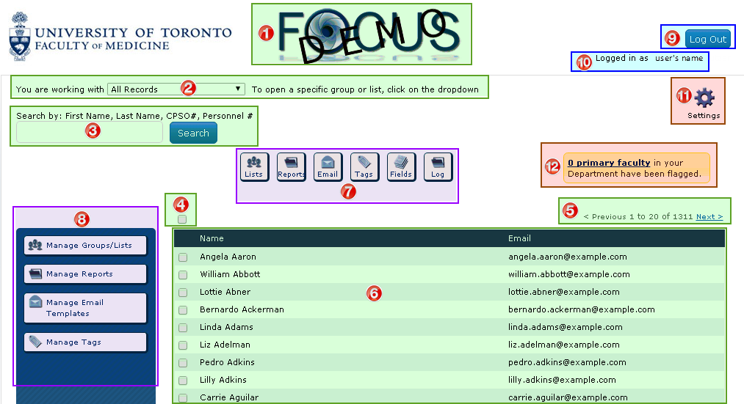
- Focus Icon: Click here to refresh the home page (e.g. reset search criteria and open the default Group/List).
- Opened Group/List: indicates the Group/List of records currently opened and available to view and work with. The Focus default is “All Records” associated with your department. (Click on the dropdown to select from existing Groups/Lists currently available to your department.)
Advanced Feature: Departments can set their own Group/List as the department default that opens when their users log into Focus (e.g. “All Active Faculty”).
- Search: Search for an individual by entering either the First Name, Last Name, CPSO Number (clinicians only), Personnel Number, or any series of letters that appear within a name to produce a list of individuals that meet that criteria.
- Checkbox: Select specific records to perform actions with (e.g. to email, add to a list, etc.). Click the “main” checkbox to select/deselect all records that appear on the screen (eg. 20 records) and a message will appear allowing you to select all remaining records within the Group/List. Or, select a record at a time by clicking on the checkbox beside that record.
Tip: Hold down Ctrl or Shift button at the same time to select multiple records.
Note: ALL records in the opened Group/List are selected by default when no records are checked off.
- Record Counter: Indicates the number of individuals associated with the opened Group/List and the number of records displayed on the screen. (In this example record 1 to 20 is displayed on the screen and there are 1311 records belonging to the opened Group “All Records”.) Click on <Previous/Next> to move through the record list, 20 records at a time.
- Record List: The names and emails for the records associated with the opened Group/List, arranged in alphabetical order by last name. Click on a name to open the Record Display for that individual.
- Action Buttons: View, open, and work with “Lists”, “Reports”, “Email”, “Tags”, “Fields”, and “Log”.
- Manage/Edit Functions: Manage and Edit “Groups/Lists”, “Reports”, “Email Templates”, “Tags”.
- Log Out: Click here to close Focus and Close your browers to fully log.
- Logged In As: Indicates the user logged into the system.
- Settings: Manage administrative and management settings in Focus. (The ability to use the different settings is based on the user’s level of access.)
- Flagged Records: Indicates the number of faculty records in Focus with errors in HRIS. (This field is restricted to specific users.)

Navigating an Individual Record
Focus contains a record for each individual. The individual record is made up of Fields of data, arranged within Tabs , that are kept in Containers.
Note: Within this manual, examples and screen prints are based on the Focus layout. If your view appears differently than the examples in this guide, then your department has customized the layout for their users.
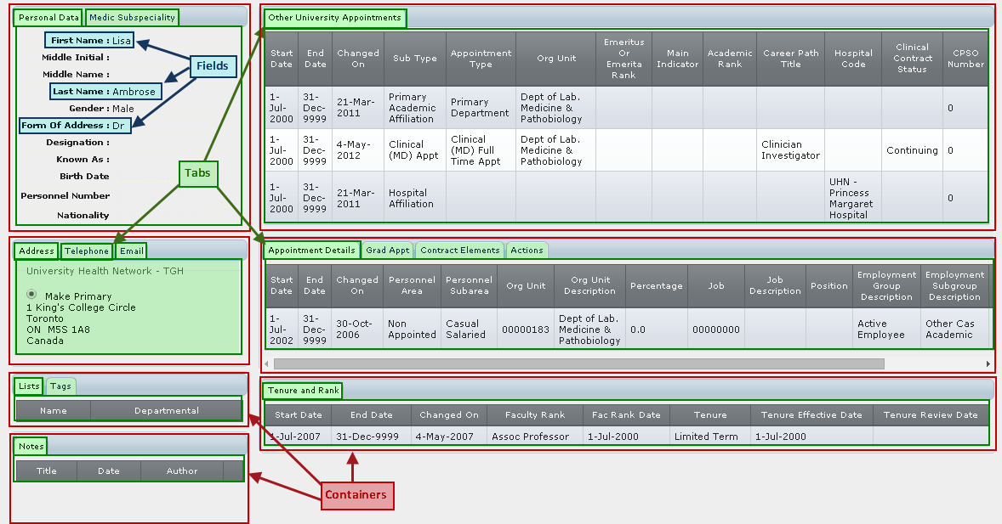
Records and data are downloaded from a primary source (usually HRIS). If data is incorrect or missing, including entire records, then it is incorrect or missing at the source. The data must be corrected and/or entered at the source in order for your Focus records to be accurate.
Advanced Feature: Departments can create custom fields and change the way individual records are displayed by moving, displaying and hiding fields.
Note: Custom fields are manually entered and maintained and are the only fields that can be edited within Focus.

(The following screen print has been cropped slightly on the right side)
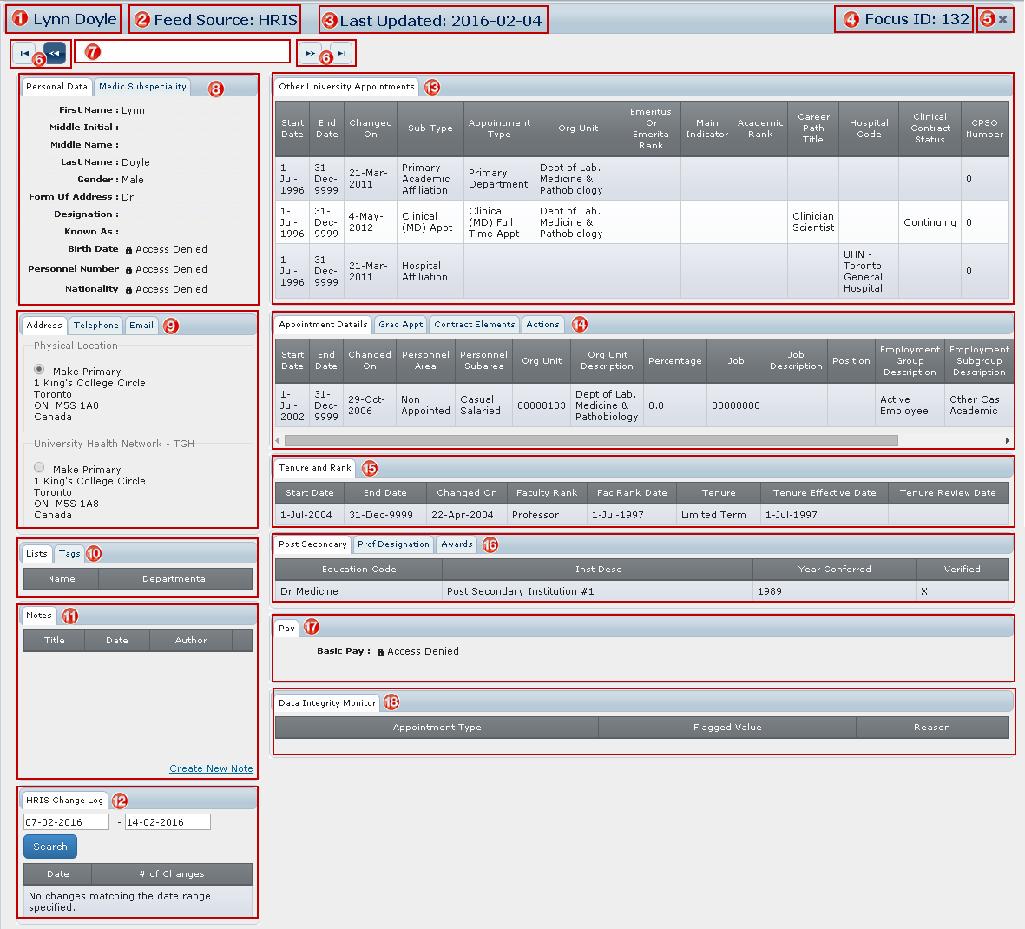
- Name: Of the individual whose record is displayed.
- Feed Source: Indicates the primary source from where the information is being downloaded.
- Last Updated: Date when information for that record was last updated through the HRIS feed. If the date is coloured red, the record is no longer considered active, and is no longer being updated by the feed.
- Focus ID: Unique number assigned by Focus to this record (focus identifier).
- X: Click here to close the window and return to the Home Page.
- Arrows: Navigate between records, e.g. move to the first record, between records (one by one), and to the last record.
- Search Bar: Type the first letter(s) or the entire last name to produce a list of matching records; click on the name of the record you want to open.
Note: You are only able to move within, or search among, records contained in the Group/List currently opened on the Home Page.
- Personal Data and Medical Subspecialty: General information and Medical Subspeciality information for clinical faculty.
Note: Confidential data, e.g. birth date, personnel number, etc. is restricted to specific users.)
- Contact: Address, Phone, Email. Where more than one entry exists in an area (e.g. 3 emails), the primary entry should be identified by selecting “Make Primary”.
- Lists and Tags: Identifies any lists and/or tags the individual has been added to.
- Notes: Manually entered and maintained within your own department. Only specific users can view, edit and delete notes. Notes marked as “sensitive” are restricted even further.
- HRIS Change Log: Provides details of changes that occurred on the record for a specified period
- Other University Appointments: indicates the primary department; hospital affiliation; whether the faculty member has emeritus status; and includes any non-budgetary cross, status only, adjunct, and/or clinical academic appointments.
- Appointment Details / Graduate Appointments / Contract Elements / Actions: Includes current and previous position(s)/appointment(s) held and their details (e.g. start and end dates, percentage FTE, continuing or term, etc.). Actions such as new and re- hire, termination, appointment change, etc. are also included.
- Tenure and Rank: Includes current and historical information about rank and status (e.g. tenure, probationary, limited term, etc.).
- Post-Secondary/ Professional Designation / Awards: Includes post-secondary education, professional designations and awards.
- Pay: Pay information (e.g. paybands) for non-faculty and restricted to specific users.
- Data Integrity Monitor: Displays errors that exist in the HRIS record that need to be corrected.

Groups & Lists
When you log into Focus, a default Group or List of individuals is open. These are the records you are viewing and working with until you open a different Group/List.
The Focus default is “All Records” meaning all Focus records associated with your department, both active and historical.
Departments create Groups and Lists to help organize and manage the records they are working with at any one time. Examples could include: All Faculty; Primary Faculty; Clinical Faculty; Graduate Faculty; Faculty located at Mt. Sinai Hospital; All Staff; etc.
Advanced Feature: Departments can change the default Group/List from “All Records” to one they create (e.g. “All Active Faculty”).
Groups are dynamic and contain a set of records that change based on whether or not they meet pre-set criteria for that group. Records are automatically added when they meet the criteria and removed when they no longer meet the criteria.
For example, the Group “Primary Faculty – Assistant Professor” contains all records of faculty primary to your department at the rank of Assistant Professor.
- When a primary faculty member is hired at, or promoted to, the rank of Assistant Professor, they are automatically added to the group.
- When a primary faculty member at the rank of Assistant Professor leaves their primary appointment in your department, or is promoted to a higher rank, they are automatically removed from the group.
Lists are static and contain a set of records that remain unchanged unless you manually add or delete a record. These are useful when you need a fixed list or when there is no common criteria that can be used to create a Group (e.g. members of a working group or committee).

Groups
Whether you are sending emails, running reports, or just viewing records, you will likely want to open a Group so that you are working with only the records you need at that time. For example, you may want to:
- view all Active Faculty;
- produce mailing labels for Faculty located at Mt. Sinai Hospital;
- run a report of Primary Faculty at the Rank of Professor;
- send an email to All Graduate Faculty.

Shared Groups
Shared Groups are Groups that have already been created and are available for importing into Focus, from the Discovery Commons Website. Shared Groups contain only records with an active status (e.g. an active faculty appointment or employment relationship) and have been created for the following scenarios.
Tip: It is suggested departments import all of the Shared Groups relevant to their unit as these will cover the majority of your needs.
- Primary Faculty: All (including Emeritus/Emerita)
- All Faculty: Active Faculty - Includes Clinical, Adjunct, Clinical Cross-Appointment, Non Budgetary Cross-Appointment, Status Only and Visiting Professor (does not include Emeritus/Emerita)
- Primary Faculty: Emeritus/Emerita
- Primary Faculty: Tenure and Tenure-Stream
- Primary Faculty: Status Only
- Primary Faculty: Status Only; rank of Lecturer
- Primary Faculty: Adjunct Lecturer and Adjunct Professor
- Primary Faculty: Clinical; Full-Time
These Groups are relevant to clinical departments only
- Primary Faculty: Clinical; Part-Time
- Primary Faculty: Clinical; Adjunct
- Primary Faculty: Clinical; Part-Time and Adjunct
- Primary Faculty: Clinical; rank of Lecturer
- Primary Faculty: rank of Assistant Professor
- Primary Faculty: rank of Associate Professor
- Primary Faculty: rank of Professor
- Cross Appointed Faculty
- Cross Appointed Faculty: Non-Budgetary Cross Appointment
- All Faculty (Primary and Cross Appointed)
- All Faculty: Clinical
- All Faculty: Status Only
- All Faculty: hospital affiliation: Hospital for Sick Children
- All Faculty: hospital affiliation: Mt. Sinai Hospital
- All Faculty: hospital affiliation: St. Michael's Hospital
- All Faculty: hospital affiliation: Sunnybrook Health Sciences Centre
- All Faculty: hospital affiliation: University Health Network
- All Faculty: Active Graduate Faculty
- All Faculty: Graduate
- All Faculty: Graduate; Primary Graduate Appointment
- Staff: Research Associates
- Staff: Active Staff - PM, USW, Research Associates (this includes Appointed and Non-Appointed Staff
- Staff: Active Appointed Staff - PM, USW, and Research Associates

Importing and Editing Shared Groups
The following example imports the Group “Appointed Staff – PM and USW All” and links it to your department.

On the Discovery Commons Website there is a list of available Shared Groups: http://dc.med.utoronto.ca/content/focus-shared-groups
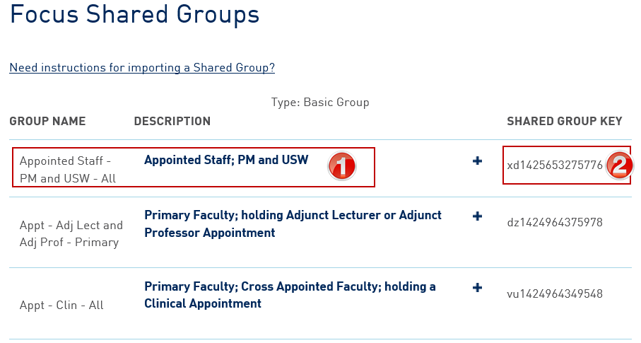
- Identify the Group you want to import (in the above example “Appointed Staff – PM and USW – All”).
- Write down the Shared Group Key (or select and copy it for pasting into Focus – ensure you have only selected the key itself and no additional spaces).

Open Focus and on the Home Page:
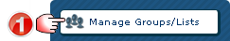
Manage Groups/Lists window opens:
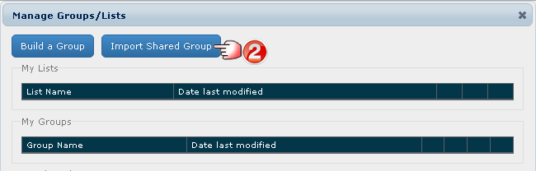

Import Shared Group window opens:
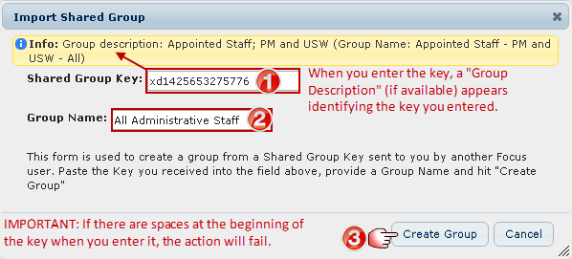
- Enter the Shared Group Key.
(Tip: Copy the Shared Group Key from the Discovery Commons website and paste it directly into Focus.)
- Enter a Group Name (you can enter the original name or choose a new one – in this example we chose “All Administrative Staff”).
- Click Create Group (you return to the Manage Groups/Lists window), or Cancel if you want to stop the process.

Manage Groups/Lists window opens:
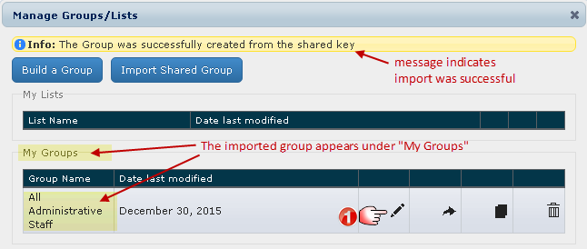
When a Shared Group is created, it is not linked to any department. You must edit the criteria for each imported Group to create the link to your department.
- Click the Edit Icon so that you can create the link to your department.

Group Builder window opens:

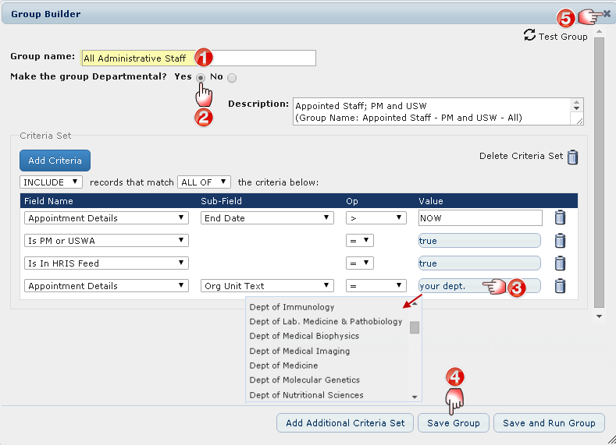

- The Group Name you entered appears. (If you enter a new name, it will overwrite the existing name when you save the group.)
- Click Yes to make this group Departmental and available to all your users.
Tip: It is suggested you do this with all Shared Groups.
- Link the Group to your department: Click “your dept.”and a drop down list appears. Locate your department name and click on it to select it.
Tip: You may have to enlarge the Group Builder window to allow for additional space to move through the drop down list.
- Click Save Group.
- Click here to close the window(s) to return to the Home Page;
or Click Save and Run Group (this will return you to the Home Page with the Group opened).

Examples of Linking shared Groups to your Department:
IMPORTANT REMINDER:
When a Shared Group is created, it is not linked to any department.
You must edit the criteria for each imported Group to create the link to your department.
See samples below.

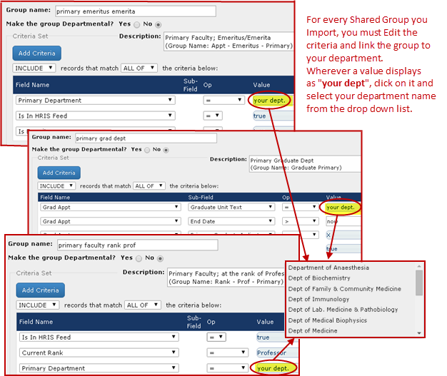

Open an Existing Group or List
The following example opens an existing Group called “Appt Staff – PM and USW” containing appointed staff who are either Professional/Managers or USW Appointed Staff. There are 15 individuals meeting this criteria in this department.
On the Home Page:
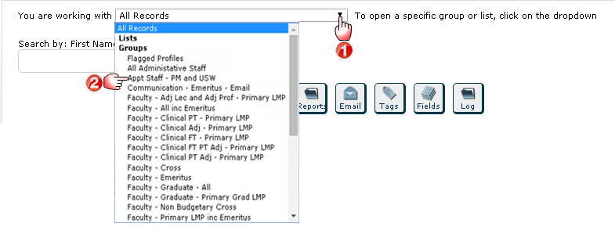
- Click the dropdown arrow to display the Groups/Lists that are currently available in your department.
- Select the Group/List you want to open.

Example: Home Page with “Appt Staff – PM and USW” Group Opened
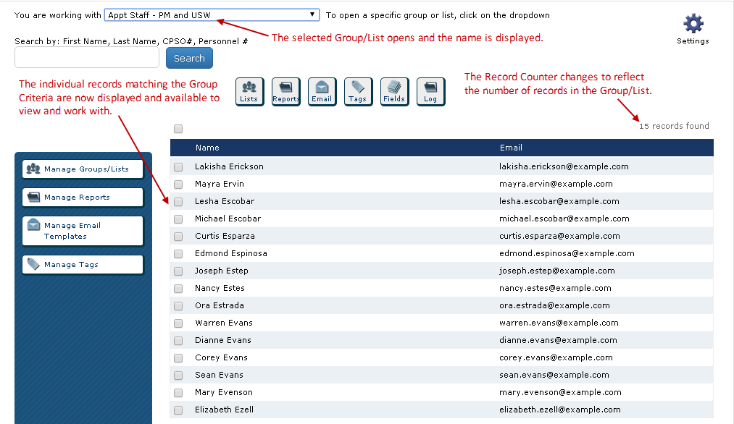

Sharing Groups

Groups can be shared with other FOCUS users within the same department or in other departments. To share a Group it must be under My Groups to access the Share button to create a Shared Group key. To share a Departmental Group (ie. these are not under My Groups), set it temporarily to non-departmental. This will move it to “My Groups”, and after the Shared Group key is generated, it can be changed back to a Departmental Group.
A Shared Group Key can be generated for any of these in My Groups since the Share button is available.
Edit button, no SHARE button
Share button
A Shared Group key cannot be generated for any of these Departmental Groups since the Share button is not available.

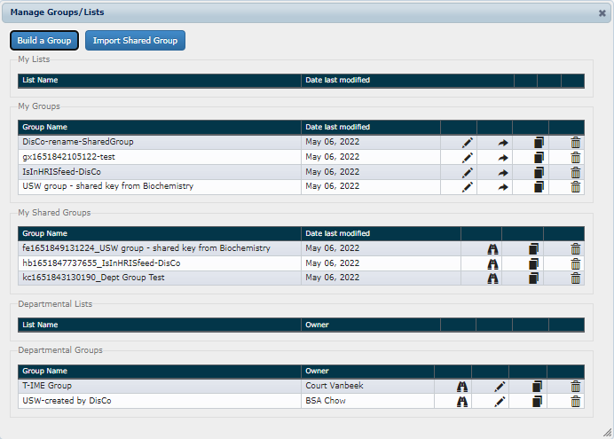
In the pages that follow, the steps to set the Departmental Group "USW-created by DisCo" to My Groups and generate a Shared Group key will be explained.

To change a Departmental Group to My Groups:

Note: If the Group is already under My Groups, then skip to the next section “To share a Group that is in My Groups”.

- Click on Manage Groups/Lists.
- Under Departmental Groups, select the "USW-created by DisCo" group by clicking the Edit button to the right.
- The Group Builder window will open. Set the “Make the group Departmental?” to No.
- Click Save Group.

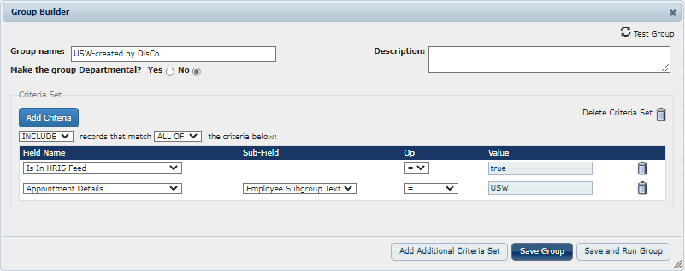

- A yellow band will display Info at the top of the window.
(ie. Info: The group: USW-created by DisCo" was successfully updated.)
- Close the Group Builder window by clicking the X in the upper right corner of the blue band.

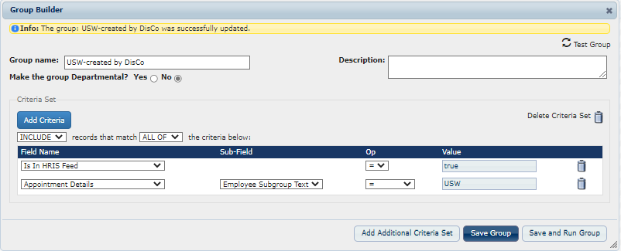

To share a Group that is in My Groups:

- Click on Manage Groups/Lists.
- Under My Groups, select the "USW-created by DisCo" group by clicking the Share button to the right of it.

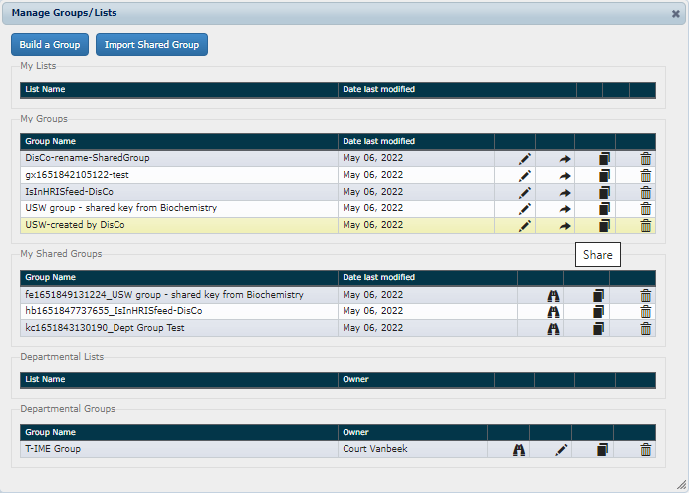

- A yellow band will display Info at the top of the window and a Shared Group key will be generated:
(ie. Info: A copy of this search named: on1651869070001_USW-created by DisCo was shared.)

Note: A Shared Group key consists of 2 alphabetical text characters and 13 numerical characters (ie. xxNNNNNNNNNNNNN), so the actual Shared Group key is "on1651869070001". The text after it beginning with an underscore "_" (ie. “_USW-created by DisCo”) is not entered when Importing a Shared Group. It is included for the user that created it so they can identify their Shared Group keys.

- The Group “on1651869070001_USW-created by DisCo” will be displayed under My Shared Groups.

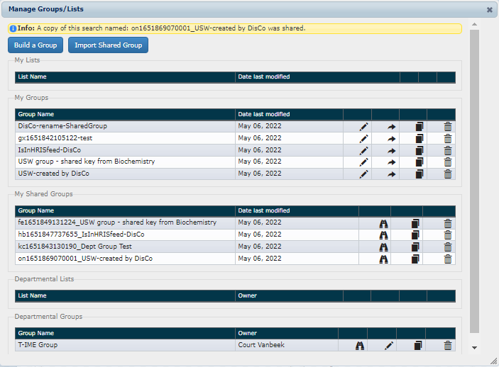
- Share the Group by sending the first part of the Shared Group key "xxNNNNNNNNNNNNN" (ie. on1651869070001) to other FOCUS users.

To change a group back to Departmental Group:

- Click on Manage Groups/Lists.
- Under My Groups, select the "USW-created by DisCo" group by clicking the Edit button to the right.
- The Group Builder window will open. Set the “Make the group Departmental?” to Yes.
- Click Save Group.

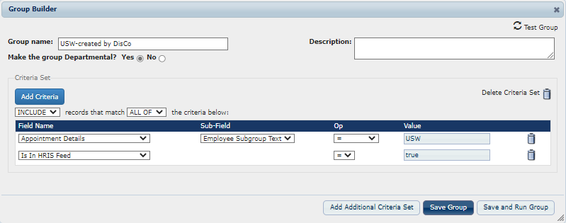
- A yellow band will display Info at the top of the window.
(ie. Info: The group: USW-created by DisCo was successfully updated.)
- Close the Group Builder window by clicking the X in the upper right corner of the blue band.
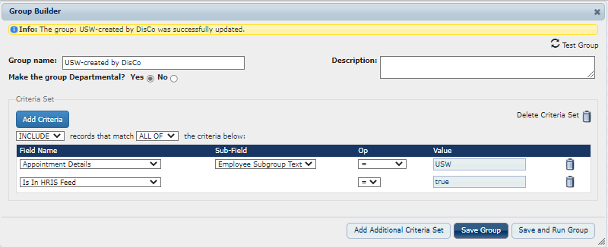
- The Group “USW-created by DisCo“ will now be displayed under Departmental Groups.
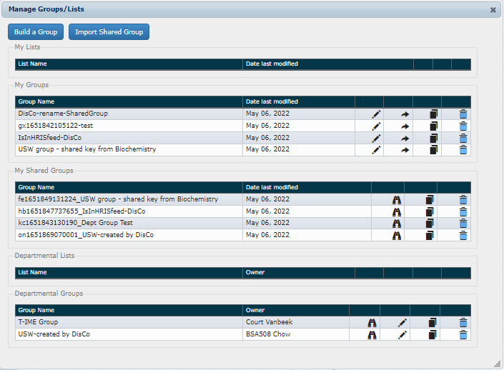
Do NOT delete Groups. If deleted, the Shared Group key will no longer work for FOCUS users to Import your Shared Group.

IMPORTANT NOTE: If the creator of the shared group deletes it from their My Shared Groups, then the shared key code will no longer work when attempting to "Import Shared Group". For users that had imported the shared group (before it was deleted) then they will not be affected since it has already been created in their FOCUS account. If the group still exists in the creator’s account under My Groups, then the creator can repeat the steps to generate a new Shared Group key. The new key is different from the previous one and users must use the new key to Import the Shared Group.

Lists

Create a List
The following example creates a list containing the members of the “Advancement Committee“. Start by selecting the first member and entering the list name.
On the Home Page:
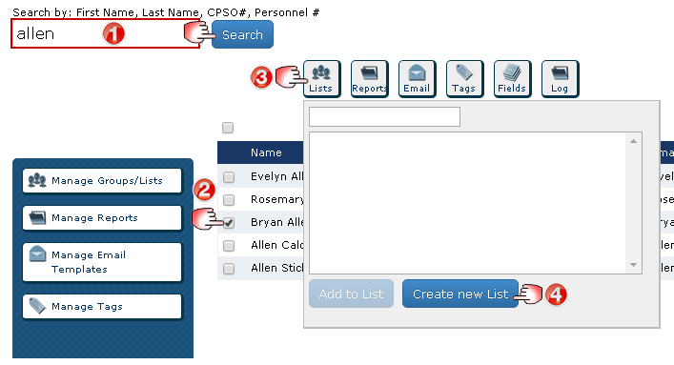

Create List with Selected Profiles window opens:
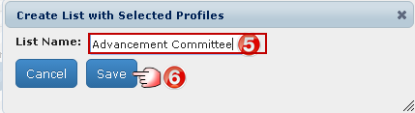
- Search for the first individual to be added to the list.
- Select the individual.
- Click the Lists action button, pop up window appears.
- Click Create New List, pop up window appears.
- Enter the list name (in this case “Advancement Committee”).
- Click Save (returns you to the home page).

On the Home Page, add the remaining members:
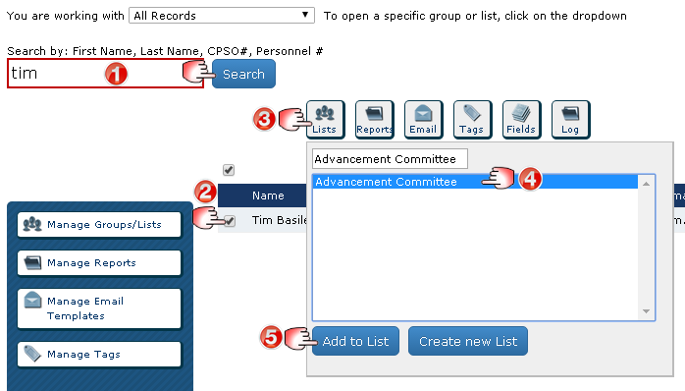
- Search for the next individual you want to add to the list.
- Select the individual.
- Click the Lists action button, pop up window appears.
- Select the list you want to add them to (in this case “Advancement Committee”).
- Click Add to List.
Continue Step 1 through 5 until all individuals are added to the list.

Finished Example: Home Page with Advancement Committee List opened. 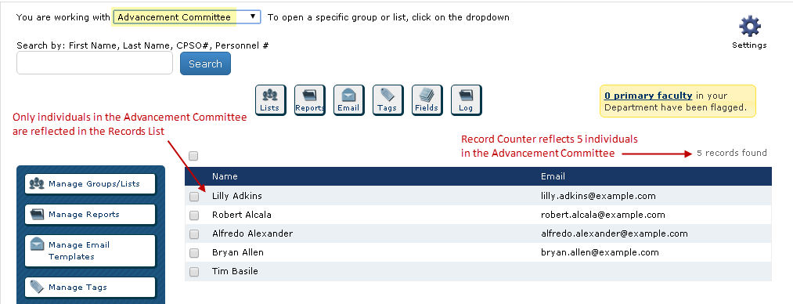

Manage Lists
Along with creating a List, you can view, copy, edit, delete and make a list available to your department users.
On the Home Page:
Manage Groups/Lists window opens:
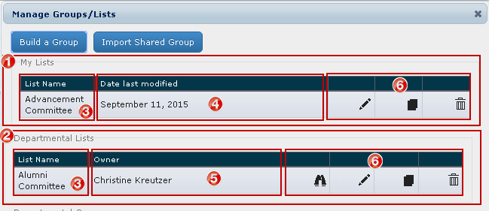
- My Lists: Lists you created that only you can access unless you make them a “Departmental List”.
- Departmental Lists: Lists available to all Focus users in your department.
- List Name: Name of the List.
- Date Last Modified: Last date any changes were made to the List and it was saved.
- Owner: User that created the list.
- Management Functions:
- Click View to see the details of a list someone else created (only applicable to those appearing under “Departmental Lists”).
- Click Edit to edit the contents of an existing List.
- Click Copy to create a copy of an existing List.
- Click Delete to permanently delete an existing List (you will be asked to confirm this).
Note: Most users are limited to editing and deleting lists appearing under “My Lists”. Only users with specific access can edit and delete lists appearing under “Departmental Lists”.

Edit Lists (Rename, Delete Records, etc.)
The following example changes the list name and makes it available to all Department users.
On the Home Page:
Manage Groups/Lists window opens:
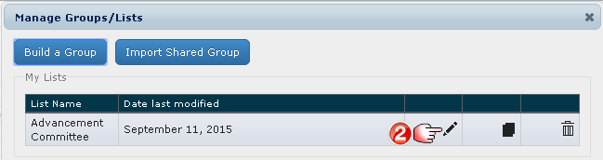
Edit List window opens:
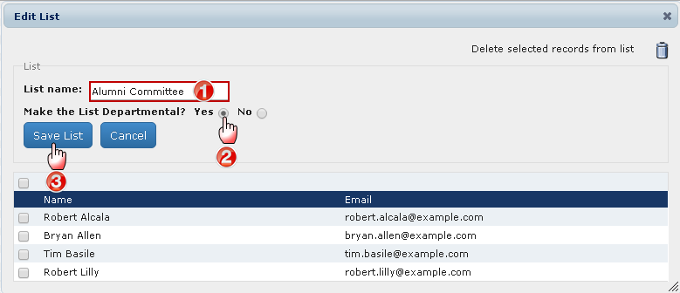

- Change the List Name to Alumni Committee (this overwrites the existing name).
- Click Yes to make the List available to other users in your department.
- Click Save List to save the changes (this overwrites the original). Close the windows and return to the Home Page, or Cancel to exit without saving.

Example :
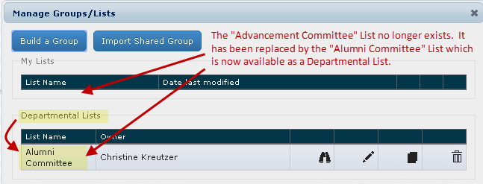

The following example deletes an individual from a list.
On the Home Page:
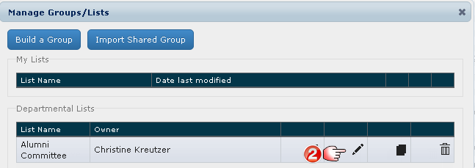
Edit List window opens:
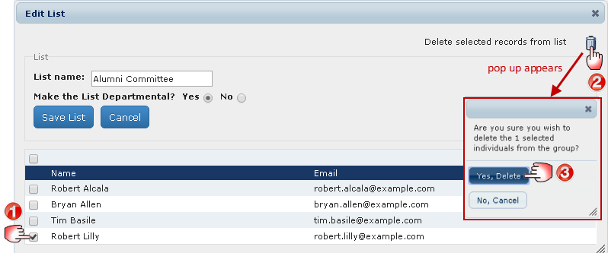
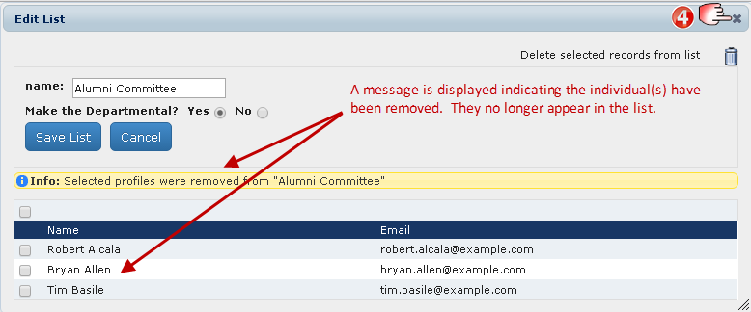

- Select the individual(s) you want to remove from the list.
- Click the Delete Icon, a pop up window appears asking you to confirm deletion of the selected individual(s).
- Click Yes, Delete (the deletion will occur whether or not you click on Save List or Cancel).
- Click here to close the window and return to the Home Page.

Reporting
The Reports action button allows you to select and report on specific data within Focus and open it in excel. Reports can be saved as a template and run on any Group. Reports have many uses:
- Adhoc requests needed on a one-time-only basis. These are created, run once and not saved (e.g. someone wants a quick list of all faculty affiliated at Mt. Sinai hospital, including their current rank and date the rank was effective).
- Recurring events or processes used on a cyclical basis. These are created, saved and run on the same Group at specific times (e.g. an annual list of faculty who need to be reviewed because their appointments are coming to an end).
- Templates to be applied to different Groups/Lists. These are created, saved and run on the required Groups/List when needed (e.g. download of contact information).

Note: Reports act as templates that produce data for whatever Group/List is open at the time a report is run, regardless of what Group/List was open at the time the report was created. For example, you create one report for producing mailing labels and run it on any group you need mailing labels for.

Create a Report
The following example creates and saves a Report containing the name and current rank of faculty. Save the Report as a template named“Faculty Rank”.
On the Home Page:
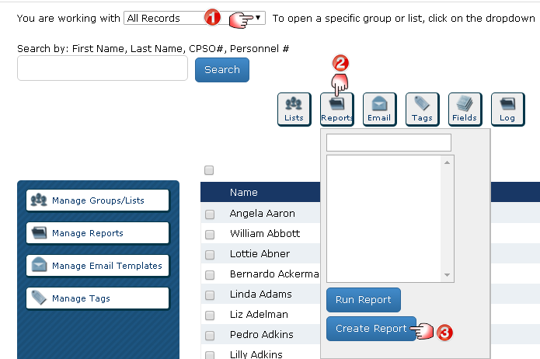
- Select the Group you want to report on (this example uses the default “All Records”).
- Click the Reports action button, a pop up appears.
- Click Create Report.

Create Report window opens:
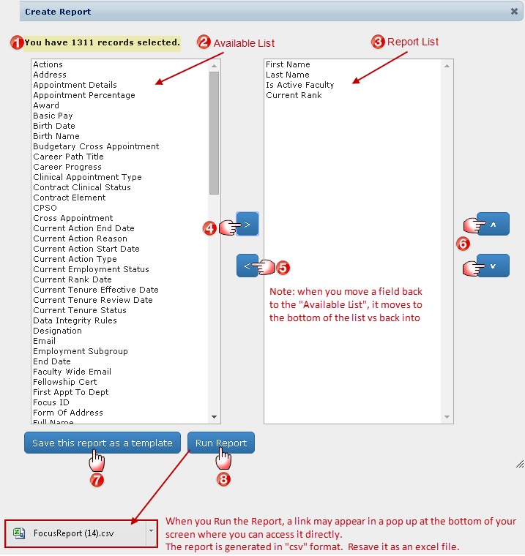
- Indicates the number of records you are working with based on the Group/List opened on the Home Page (in this example, the “All Records” Group is opened and there are 1,311 records).
- The left box (Available List) contains the fields available to include in your Report.
- The right box (Report List) contains the fields you have chosen to include in your Report.
- Select a field from the Available List and click the Right Arrow to move it to the Report List.
- Select a field from the Report List and click the Left Arrow to remove it from the report and move it back to the Available List.
(Tip: Select multiple fields by holding down the Ctrl button as you click on them.)
- Change the order of the fields within the Report List. Select the field you want to move and click the up/down arrows to move it within the list.
- Click Save This Report as a Template and enter a name. The Report is saved in Focus as a template that you canaccess using the Reports action button on the Home Page. You can run the report on any Group/List at any time.
- Click Run Report. The report is generated and saved as a downloaded file in “csv” format that can be opened in Excel. It is suggested you save it in Excel format. The data generated is based on the individuals associated with the Group/List opened on the Home Page.

Note: The location of the Report is based on where your browser is set to save downloaded files. Contact Discovery Commons if you aren’t sure where these files are stored and need help locating it.
Sample Excel Report (some formatting has been applied)
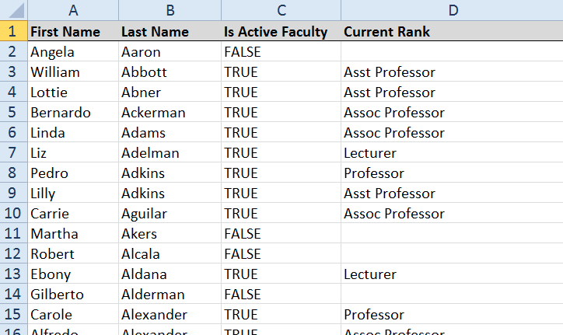

Run an Existing Report
The following example Runs and Opens an existing Report called “Email List” on the Group “All Records”.
On the Home Page:
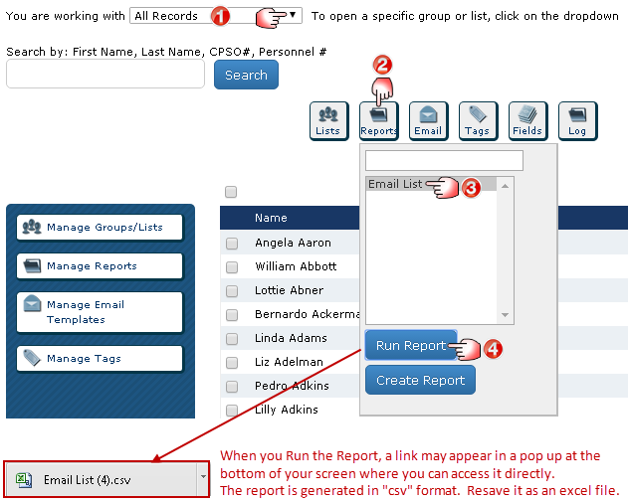
- Select the Group/List you want to work with (this example uses “All Records”).
- Click the Reports action button.
- Click an Existing Report (this example opens the Email List).
- Click Run Report. The Report is generated and saved as a downloaded file in “csv” format that can be opened in Excel. It is suggested you save it in Excel format.

Note: The location of the Report is based on where your browser is set to save downloaded files. Contact Discovery Commons if you aren’t sure where these files are stored and need help locating it.
Sample Excel Report (some formatting has been applied)
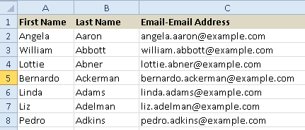

Manage Reports
Along with creating a Report, you can view, copy, edit, delete and make a report available to your department users.
On the Home Page:
Manage Reports window opens:
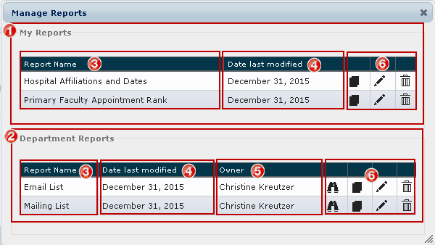

- My Reports: Reports you created that no one else can access unless you make them a “Department Report”.
- Department Reports: Reports made available to anyone in your department with Focus access (this is controlled when you “Edit” a List).
- Report Name: name of the Report.
- Date Last Modified: last date the Report was saved with changes.
- Owner: user that created the Report.
- Management Functions:
- Click View to see the details of a Departmental Report someone else created (only applicable to those appearing under “Departmental Reports”).
- Click Copy to create a copy of an existing Report.
- Click Edit to make changes to an existing Report.
- Click Delete to permanently delete an existing Report (you will be asked to confirm this).
Notes: Most users are limited to editing and deleting Reports appearing under “My Reports”. Only users with specific access can edit and delete reports appearing under “Departmental Reports”.
Departmental Reports containing sensitive and/or confidential data will run for all users, however, the confidential/sensitive fields will only produce real data if the user access permits it (e.g. birthdates and personnel numbers will be displayed as “access denied”).

Copy and Edit Reports
Useful if you want to create a Report that is similar to an existing one and you don’t want to start from scratch.
The following example adds additional information (primary department and primary appointment type) to an existing Report named “Faculty Rank”. The new Report is called “Faculty Rank_Primary Appt” and will be available for all department users to run.
On the Home Page:
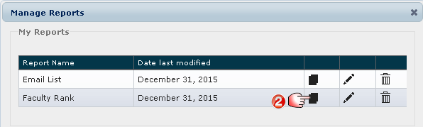
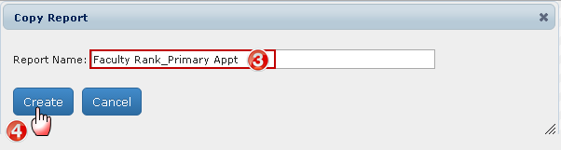
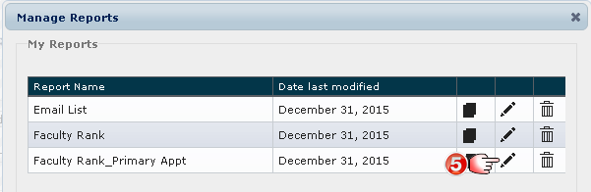
- Click Manage Reports.
- Click the Copy Icon beside the Report you want to copy (in this example, “Faculty Rank”).
- Enter the new Report Name (in this example, “Faculty Rank_ Primary Appt”).
- Click Create. A pop up opens confirming the new Report has been created. Close the window and you will return to Manage Reports.
- Click the Edit Icon beside the new Report (in this example, “Faculty Rank_Primary Appt”).

Edit Report window opens:
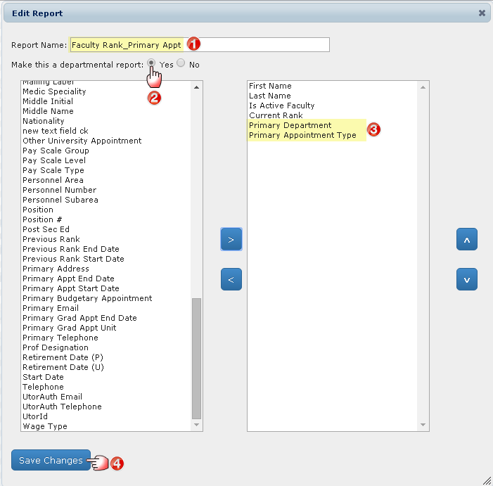
- The new Report Name is displayed.
- Click Yes to make this Report available to other users in your department.
- Add the fields “Primary Department” and “Primary Appointment Type” to the Report List.
- Click Save Changes and confirmation will appear. Close the window.

Example:
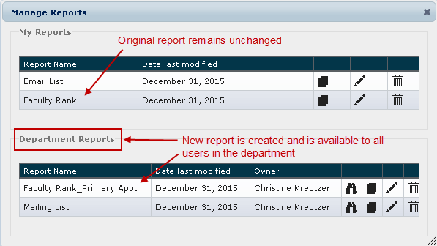

Run the new Report which now includes the fields “Primary Department” and “Primary Appointment Type”.
Sample Excel Report (some formatting has been applied)
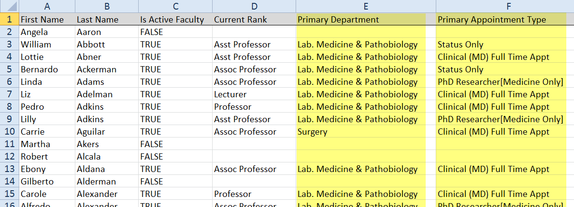

Email
NOTE: This function is restricted to specific users. If you don’t have this access and feel it is necessary for your role, see your Department Manager.
All emails are created as templates that can be sent to selected individuals or entire Groups/Lists. Emails can be personalized and include attachments. They can also be made “Departmental” for other users to access.
Before using the email feature for the first time, set up your personal email setting.
On the Home Page:
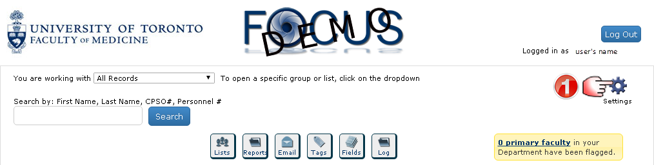
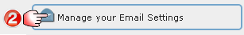
Manage Email window opens:
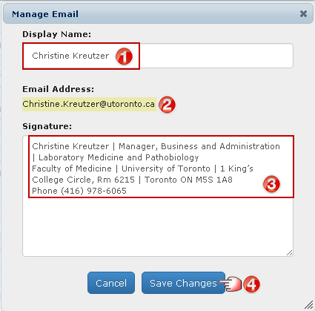
- Enter Your Name (the way you want it displayed in the emails you send).
- Your Email Address appears as it was entered when your user access was created. If it doesn’t appear or there is an error, see your Focus Department Administrator or contact the HR office if you are the administrator.
- Enter your Signature as you want it to appear in your sent emails.
- Close all windows and return to the Home Page.

Understanding Email Templates in Focus
- When you use Focus to send emails, you are creating an Email Template that is used to generate the email(s). The template allows you to insert variables and “customize” the email for each recipient.

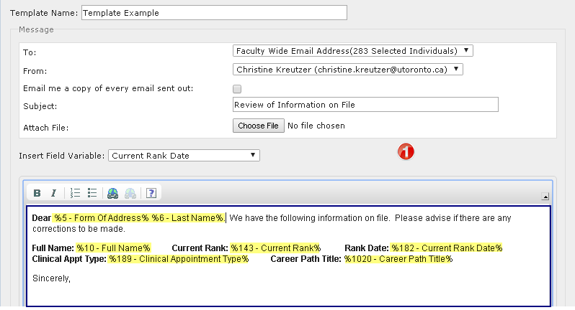

- Whether you have selected one indiviudal or a group of individuals to email, each individual will receive their own email, whether or not you have customized it with variables. You are not sending one email to a group of individuals.

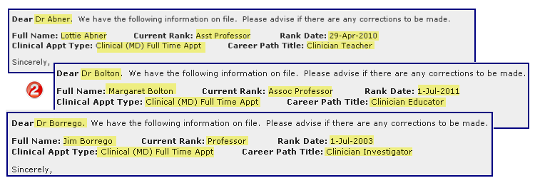

- As the user who is sending the email, you are automatically emailed a copy of the Email Template along with an attached “CSV” file containing a list of the selected individuals whom the email was sent to.

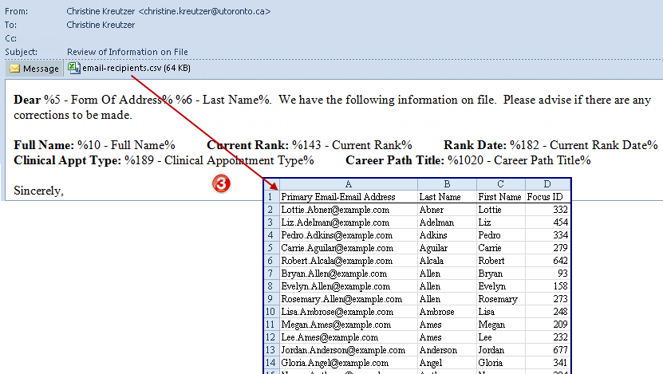

- If you click on “Email me a copy of every email sent out:”, you will be cc’d on EVERY email sent (in the example below, you would receive copies of all 283 emails).

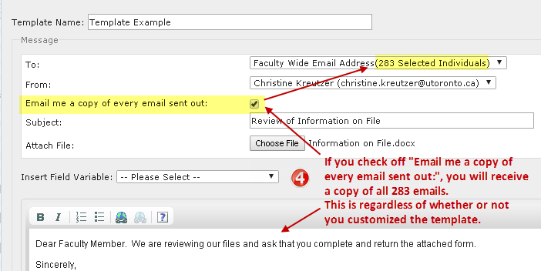

Create Email Templates
The following example creates an email template for departmental use for the purpose of inviting individuals/groups to special seminars. The email invite is personalized with the recipient’s first name.
On the Home Page:
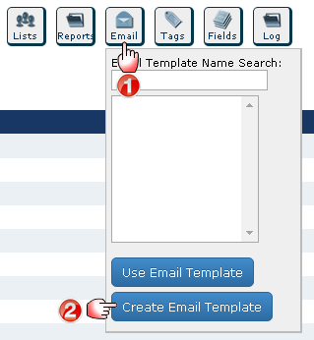
Email Template window opens:
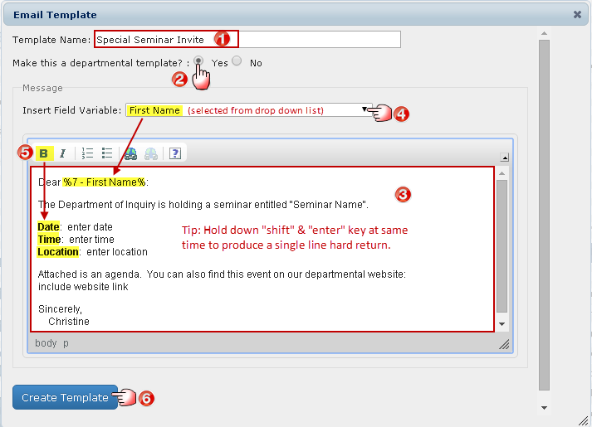
- Enter the Template Name.
- Click Yes to make the Email Template available to all department users.
- Type your message. Personalize the email with the recipient’s first name (variable). Within the message, place your cursor where you want the variable to appear (e.g. after the word “Dear”). Click the drop down and select the field you want to insert (in this example, “First Name”).
IMPORTANT: The variable appears in code within % signs – do not make changes to the code as this would result in an error. You may have as many variables in your email as needed. Confidential HR Information (e.g. personnel number, birth date, etc.) are not available for use in email templates.
- Format the email with bold, italics, numbering and bullets and add website links where applicable.
- Click Create Template.

Choosing the Email Source (Types of Email Addresses Stored on Focus)
When sending emails, you will have the choise of using either the:
- Faculty Wide Email Address: uses the email set as “primary” by the primary department, or, if there is no primary indicated, uses the email stored on HRIS
OR
- Primary Email Address: if no primary is indcated, then it will default to the email stored on HRIS

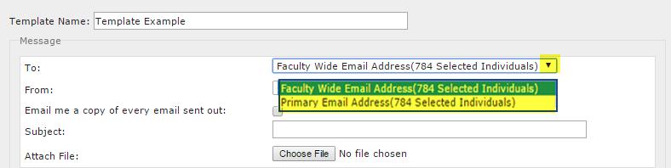
Email Addresses stored on Individual Records:
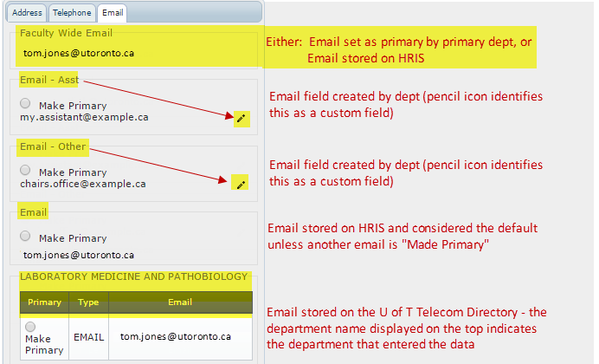

Email example, #1:
Sends an email to Tom Jones using the Faculty-Wide Email Address. There is no email that has been made primary.
- On the Email Template, “Faculty Wide Email Address” is selected
- Uses Faculty Wide Email
- The email will be sent to “tom.jones@utoronto.ca”.

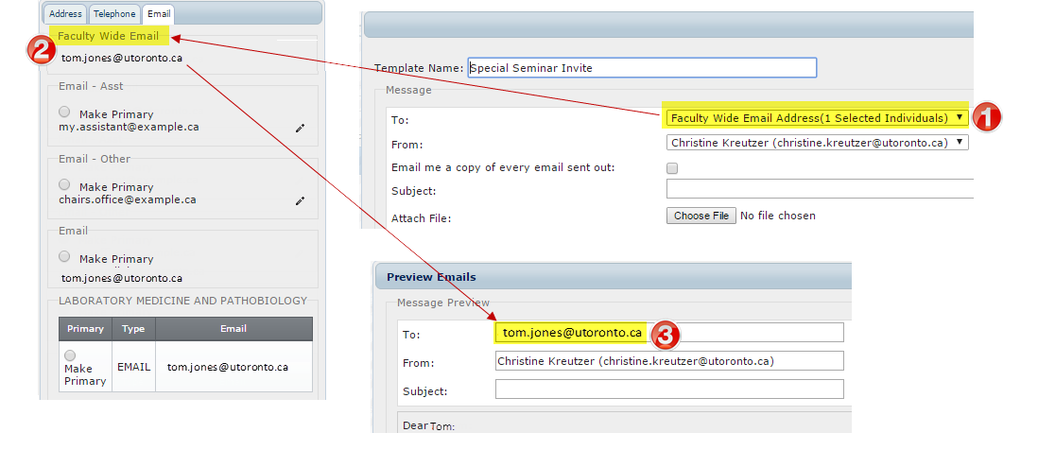
Email example, #2 sending an Email to Tom Jones:
Sends an email to Tom Jones using the Primary Email Address. There is no email that has been made primary.
1. On the Email Template, “Primary Email Address” is selected
2. Uses Email when no other email is marked as primary
3. The email will be sent to “tom.jones@utoronto.ca”.

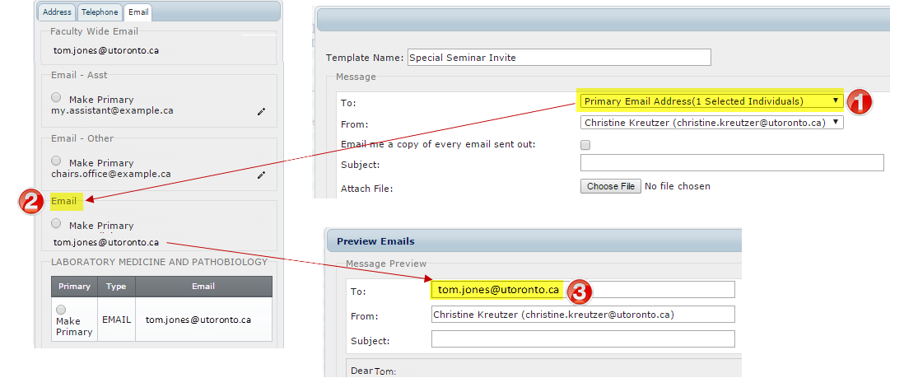

Email example, #3 sending an Email to Tom Jones:
Sends an email to Tom Jones using the Primary Email Address. There is an email that has been made primary.
1. On the Email Template, “P:rimary Email Address” is selected
2. Uses Email when no other email is marked as primary
3. The email will be sent to “tom.jones@utoronto.ca”.

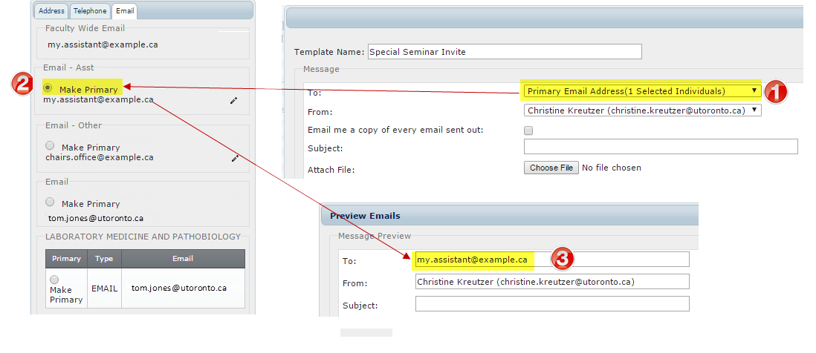

Use and Send Email Templates
The following example uses the email template “Special Seminar Invite” and invites specific administrative staff to an upcoming seminar. The agenda, an existing Word document, will be attached to the email.
On the Home Page:
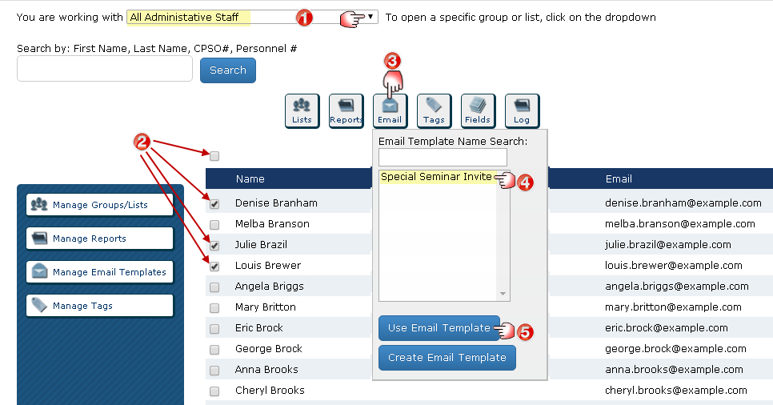
- Select the Group/List you want to work with (this example uses “Administrative Staff Appointed”).
- Select the individuals you want to invite.
- Click the Email action button.
- Select an existing Email Template (this example opens “Special Seminar Invite”).
- Click Use Email Template.

TIP: If you want to select all individuals in a list, click on the main checkbox above the names and the individuals displayed on the screen will be selected along with a prompt to “Click here to select all records”. To clear the selection, click on the checkbox again.

Email Template window opens:
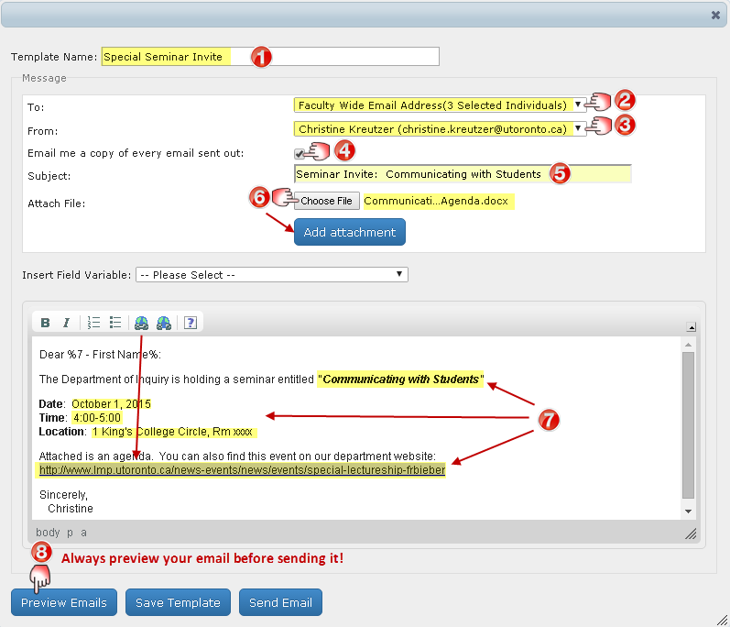
- The Email Template Name appears.
- To: Click the drop down to select “Faculty Wide Email Addresses” (the Focus default) or “Primary Email Addresses” as the source to be used for the recipient’s email addresses.
IMPORTANT: when more than one email exists for an individual, the department must determine which is the primary email and indicate this in each record. The number of intended recipients is also identified based on all the individuals, or the individiuals you selected, within the opened Group/List on the Home Page.
- From: As the logged in user, your email appears as the default, however, you can choose to send the email from the “Departmental Sender” by clicking on the drop down.
Advanced Feature: The Departmental Sender feature is managed under Settings on the Home Page.
- Send me a copy of every email sent out: Click here if you want to receive a copy of every email (in this example, you would receive a copy of all 15 personalized emails)
- Subject: Enter a meaningful subject line.
- Attach File(s): Click Choose File and select the document (in this case the agenda). You can add multiple attachments, one at a time.
- Email Content: Update the seminar details (in this example: the seminar name, date, time and location and a weblink to the event).
- Click Preview Emails to see a sample of the email as it would appear to each recipient.
CAUTION: It is highly recommended that you preview a number of emails as this will allow you to see any possible errors prior to sending the email.

Preview Emails window opens:
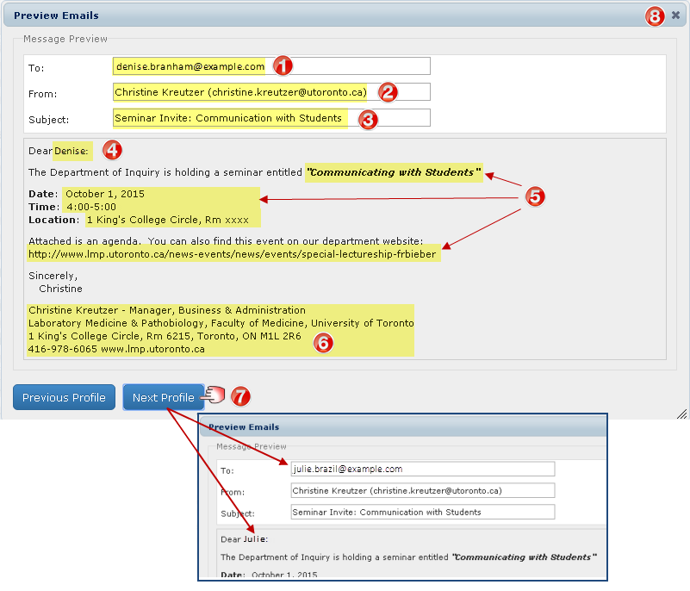
- Email Address of the first recipient is displayed.
- Sender is indicated.
- Subject appears.
- First Name of the recipient appears (this is where the field variable “first name” was inserted).
- Content of the email reflects the changes made (seminar title, date, time, address & weblink).
- Signature of Sender is now included.
- Click on Next Profile and Previous Profile to see the email as it would appear to each recipient.
- Close the window and return to the Email Template window.
Email Template window opens:
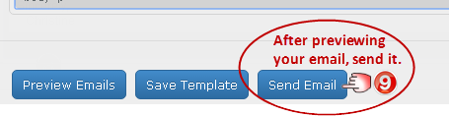
- Click Send Email. Confirmation appears indicating the “Email was sent to the selected individual(s).
IMPORTANT NOTE: Do not click on Save Template unless you want to save over the original template.

Sample Email Template Emailed to the User
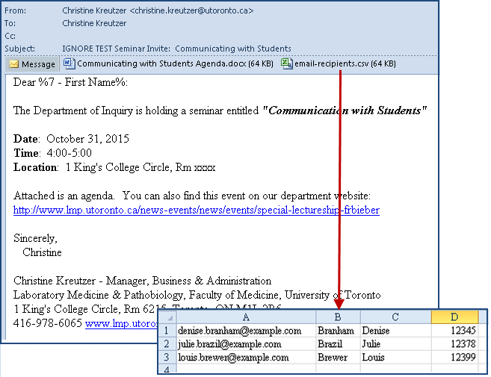
Sample Email Received by the Recipient
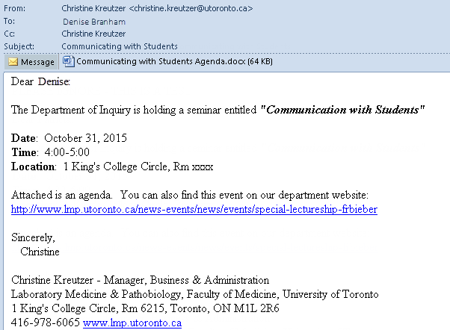
IMPORTANT NOTE:
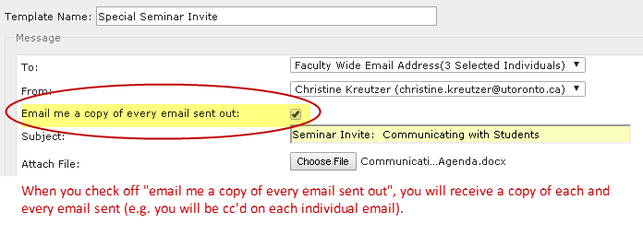
When you check off “Email me a copy of every email sent out:”, you will receive a copy of each and every email sent. For example, if you have 100 active faaculty in your department and you send the email to a Group containing all your active faculty, you would be cc’d on all 100 emails.

Manage Administrative Users

User Access
When the Temerty Faculty of Medicine HR office provided your department with access to Focus, they set up the Department Manager / Business Officer as a “Department Administrator”.
Department Administrator: has full departmental access to all records and functionality within Focus, including the ability to set up and maintain all other departmental users.
Basic User: has access to faculty records only. They cannot see or report on confidential or sensitive data and are unable to use advanced features such as email.
Additional Access includes the ability to:
- See Dept Sensitive Data: see custom fields that have been marked as 'sensitive'.
- Edit Custom Data: edit custom data created by the department.
- See Staff: access staff (USW / PM / Confidential / Research Associates) in addition to Faculty Records.
- Use Email: send email using Focus.
- Manage Data: customize the record layout; manage custom fields; and manage “departmental” email settings, groups, lists, reports, and email templates.

Restricted Access (access to Confidential data) Set up and maintained by the Temerty Faculty of Medicine HR Office based on requests made by Department Managers/Business Officers (usually limited to those who already have access to this information through HRIS). Includes the ability to view, report, and group on:
- Pnum: Personnel Number.
- UTORid: UTORid.
- HRIS: HRIS Restricted Fields (e.g. birth date, personnel number, UTORid, etc.)

Add Users
On the Home Page:
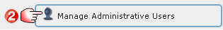
Manage Administrative Users window opens:
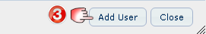

Add User window opens:
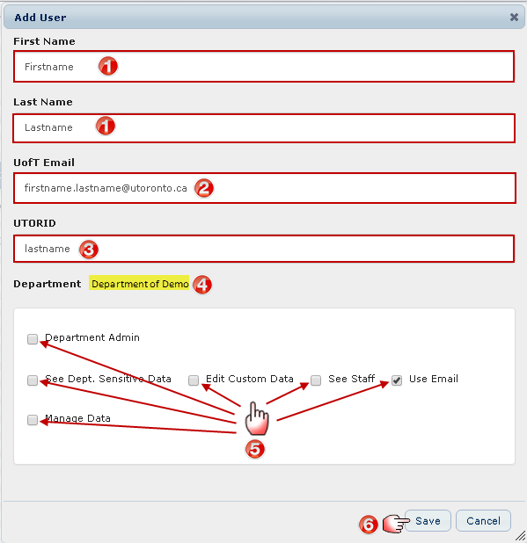
- Enter the user’s First and Last Name.
- Enter the user’s U of T Email (must be a “utoronto” email).
- Enter the user’s UTORID (required in order for the user to log into Focus).
- Department Name is displayed.
- Select any Additional Access the user is to be given. (See list of access types and descriptions above.)
- Click Save (the window will close and a message will appear “User created successfully”),
or Click Cancel to stop the process and return to the “Manage Administrative Users” window.

Edit / Delete Users
On the Home Page:
Manage Administrative Users window opens:
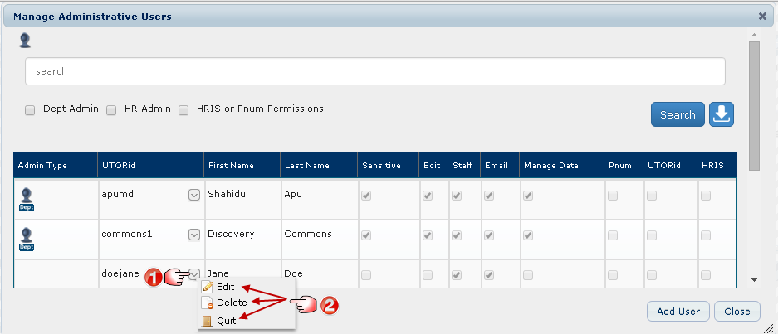
- Locate the user you want to edit/delete and click the Checkbox next to their name.
- A box appears, click the option you want to perform:
- Click Edit and a window will open allowing you to make changes to their access.
- Click Delete and you will be asked to confirm the deletion.
- Click Quit to cancel.

Search For and Report On Users
On the Home Page:
Manage Administrative Users window opens:
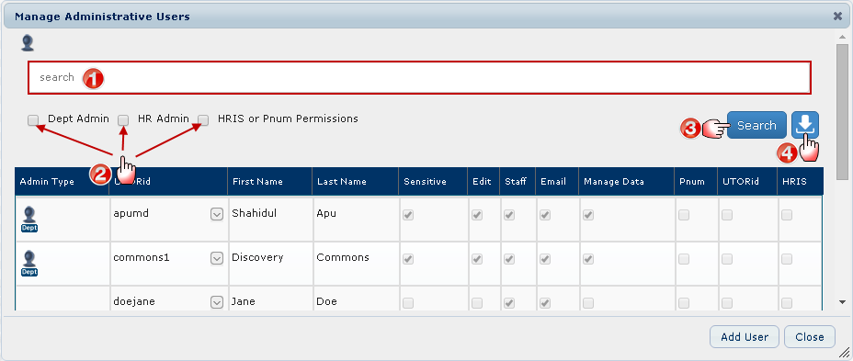
- Search for users by entering the first letter, or first few letters, of their last name(s) in the Search Bar.
- Narrow your search by selecting specific Access Levels.
- Click Search to produce a list of users who meet the criteria.
- Click here to produce a report of users and their access based on what you have selected on this window. Tip: This is useful for large departments with many users.

FOCUS – User Groups and Permissions Matrix

Glossary
CLTA | Contractually Limited Term Appointment
custom field | a new field (not fed from HRIS) created by a user with manage data feature rights
custom record | a profile of a person whose record was not fed from HRIS. Department users with manage data feature rights can create custom records.
faculty | clinicians and non-clinicians with appointment(s) in the TFoM
feature rights | permission to use specific functions or see specific groups
TFoM | Temerty Faculty of Medicine
FWU | Faculty Wide Unit – with specific criteria, allows access to faculty records and, if granted, staff records, from all departments in the FoM
HRIS Restricted Data | Data to which access must be explicitly granted to an individual user (Birth Date, Personnel Number, Nationality, Start Date, Permanent residence (home address), UTORid)
OUA | Other University Appointments – a container in FOCUS for TFoM faculty records
Pnum | personnel number
Sensitive | refers to the custom field setting “Sensitive”- controls visibility of the field values in custom fields
staff | non-faculty employees (ie. PM, USW, CUPE, Casual, Teaching Assistants, Research Associates)
User Session Log | FOCUS login activity records for a department or FWU of user accounts that logged in, date and time of login, and their IP addresses

User Types
There are five user types. A user can be assigned to only one of them.
- Basic user (this is the default, it does not show an icon in FOCUS)
- FoM Contact List User (this is a faculty wide unit account with very limited information access)
- Dept Admin
- HR Admin
- Sys Admin
Each of these user groups are assigned a set of default feature rights (rights to use or see specific functions) and more feature rights can be added individually.
Default Access and Feature Rights: (Automatically granted to all User Types except for FoM Contact List user)
- All faculty within the applied department or FWU
- The data inside the Other University Appointments container
- Medic Specialty
- The data inside the Appointment Details container (This includes Job, Job Description (job level may be indicated), Payroll (interval), Work Contract)
- Grad Appt
- Contract Elements
- Career Progress
- Actions
- Tenure and Rank
- Post Secondary
- Prof Designation
- Awards
- First Name, Last Name, Office Address, Telephone and Email
- End Date
- Custom records

Additional Access and Feature Rights: (may be a default for a User Type or explicitly granted to an individual user (see table below))
- View Faculty records (End Date field is visible)
- View Staff records (End Date field is visible)
- View all HRIS Restricted Data (includes: Birth Date, Pnum, UTORid, Nationality, Start Date, Permanent residence)
- View HRIS Restricted Data but limit to UTORid
- View HRIS Restricted Data but limit to Pnum
- Send Email
- Assign Sensitive, Edit, Staff, Email, or Manage Data
- Assign Dept Admin role
- Assign HR Admin role
- Assign FoM Contact List role
- Assign HRIS Restricted Data Access, UTORid, Pnum
- Manage Data (when this right is granted, items 13-20 are also granted)
- View User Session Log (Basic users (if granted this right) can only see login session records for their own account; Dept Admins can see login session records for all users from their dept or FWU; HR Admins (if granted this right) can see login session records for all users across all depts and FWUs; Sys Admins can see login session records for all users across all depts and FWUs)
- Customize Department Display
- View Email Status
- Manage your Email Settings (personal email signature)
- Manage Department Email Settings (department email signature)
- Add a Custom Record (custom records are visible to user accounts in the same department). The custom records function is not available in FWUs.
- Manage Fields (ie. add, edit, set sensitive, delete custom fields)
- Manage Login Group / List

Access and Feature Rights default settings

Dept  or FWU | 1 | 2 | 3 | 4 | 5 | 6 | 7 | 8 | 9 | 10 | 11 | 12 | 13 | 14 | 15 | 16 | 17 | 18 | 19 | 20
User Group Roles | View Faculty records  (End Date field is visible) | View Staff records  (End Date field is visible) | View all HRIS Rest. Data  includes: Birth Date, Pnum, UTORid, Nationality, Start Date, Permanent residence | View HRIS Rest. Data but limit to UTORid | View HRIS Rest. Data but limit to Pnum | Send Email | Assign Sensitive, Edit, Staff, Email, or Manage Data | Assign Dept Admin role | Assign HR Admin role | Assign FoM Contact List role | Assign HRIS Rest. Data Access, UTORid, Pnum | Manage Data  (when granted, this enables items #13-20) | View User Session Log | Customize Dept Display | View Email Status | Manage your Email Settings  (personal email signature) | Manage Dept Email Settings  (dept email signature) | Add a Custom Record  (visible to all users in the same dept.)  Not available in FWUs. | Manage Fields  (ie. add, edit, set sensitive, delete custom fields, delete custom record) | Manage Login Group / List
Basic User | Yes | If  granted | If  granted | If  granted | If  granted | If  granted | No | No | No | No | No | If  granted | If  granted | If  granted | If  granted | Yes | If  granted | If  granted | If  granted | If  granted
FoM Contact List | Yes –End date is not visible. | Yes – End date is not visible. | No | No | No | No | No | No | No | No | No | No | No | No | No | No | No | No | No | No
Dept Admin | Yes | Yes | If  granted | If  granted | If  granted | Yes | Yes | Yes | No | No | No | Yes | Yes | Yes | Yes | Yes | Yes | Yes | Yes | Yes
HR Admin | Yes | If  granted | If  granted | If  granted | If  granted | If  granted | If  granted | Yes | Yes | Yes | Yes | If  granted | If  granted | If  granted | If  granted | Yes | If  granted | If  granted | If  granted | If  granted
Sys Admin | Yes | Yes | Yes | No | No | Yes | Yes | Yes | Yes | Yes | No | Yes | Yes | Yes | Yes | Yes | Yes | Yes | No | Yes

FoM Contact List User: This user access type provides limited access to generate faculty wide contact lists. The Search by function is available to lookup people by First Name, Last Name, CPSO# or Personnel #, but only displays the Name and Email fields. (Note: Only HR Admin or Sys Admin can create FoM Contact List User accounts, Departmental Administrators cannot.) The following fields are exportable to an XLS file:

- Last Name
- First Name
- Known As
- Form of Address
- Email Faculty Wide
- TFOM Academic Unit
- Clinical Appointment Type
- Is Status-Only
- Is Adjunct-Only
- Personnel Subarea

Faculty Wide Units (FWU)
A user account can be assigned access to the records in either a department or a FWU (not both). Access and feature rights for User Group roles is the same whether the user is assigned to records in either a department or FWU, the same default settings will be applied (except for the custom records function that is not available to FWUs). The difference is the filtering of access to records when assigned to a department or FWU. For example, if assigned to a department records will include all personnel with any faculty appointment type in their specified department. If assigned to a FWU the records will include personnel from across all departments within the TFoM but only those meeting the set criteria.

FWUs differ from Groups in that user accounts can be assigned to a FWU. Within their department or FWU a user can create sub-Groups.

Faculty Wide Unit | Scope | Criteria
Clinical Affairs | Able to view Clinical Full-time, Clinical Part-time, and Clinical Adjunct faculty records from all departments. | [OUA -> Appointment Type Text = Clinical (MD) Full Time Appt] OR  [OUA -> Appointment Type Text = Clinical (MD) Part Time Appt] OR  [OUA -> Appointment Type Text = Clinical (MD) Adjunct Appt] OR  [OUA -> Appointment Type Text = Clinical (MD) Full Time Equivalent]
FoM Contact List | Able to view limited faculty and staff records across all departments in the FoM. | [Is Active Faculty = TRUE] OR [Is Active Staff = TRUE]
FoM HR | Able to view all faculty records across all departments in the TFoM. Individual users may be granted access to staff records. | [Personnel Number != null]
FoM Research Office | Able to view faculty holding an OUA, Tenured/Tenure Stream, Teaching Stream, or CLTA appointment from all departments. | [OUA Table != null] OR [isTenured/Tenure Stream = TRUE] OR [Is Teaching Stream = TRUE] OR [Is CLTA = TRUE]
GLSE | Able to view all Active Faculty records. | [Is Active Faculty] = True
OIME | Able to view Clinical Full-time, Clinical Part-time, and Clinical Adjunct faculty records from all departments. | [OUA -> Appointment Type Text = Clinical (MD) Full Time Appt] OR  [OUA -> Appointment Type Text = Clinical (MD) Part Time Appt] OR  [OUA -> Appointment Type Text = Clinical (MD) Adjunct Appt] OR  [OUA -> Appointment Type Text = Clinical (MD) Full Time Equivalent]
PGME | Able to view Clinical Full-time, Clinical Part-time, and Clinical Adjunct faculty records from all departments. | [OUA -> Appointment Type Text = Clinical (MD) Full Time Appt] OR  [OUA -> Appointment Type Text = Clinical (MD) Part Time Appt] OR  [OUA -> Appointment Type Text = Clinical (MD) Adjunct Appt] OR  [OUA -> Appointment Type Text = Clinical (MD) Full Time Equivalent]
Rehab Sector | Able to view records for faculty who hold appointments in any of the three Rehab Departments (includes historical records).  - Occupational Sciences and Occupational Therapies (OSOT)  - Physical Therapy (PT)  - Speech Language Pathology (SLP) | [Appointment Details -> Org Unit Text = OSOT] OR  [Appointment Details -> Org Unit Text = PT] OR  [Appointment Details -> Org Unit Text = SLP] OR  [Grad Appt -> Graduate Unit Text = OSOT] OR  [Grad Appt -> Graduate Unit Text = PT] OR  [Grad Appt -> Graduate Unit Text = SLP] OR  [OUA -> Organization Unit Text = OSOT] OR  [OUA -> Organization Unit Text = PT] OR  [OUA -> Organization Unit Text = SLP]
UME | Able to view faculty holding Other University Appointment, or Primary Appointment, or Tenured/Tenure Stream, or Teaching Stream, or CLTA | [OtherUnivAppointments != null] OR [Primary Appointment Type != null] OR [isTenured/Tenure Stream = TRUE] OR [Is Teaching Stream = TRUE] OR [Is CLTA = TRUE]

End

